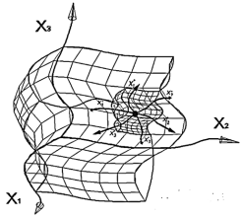
Fully geometrized physics from the
standpoint of the Algebra of signatures
(Alsigna)

Mikhail Batanov, Ph.D., Associate Professor,
Department 207, Moscow Aviation Institute Moscow, Russia
+7 (903)725-89-66, alsignat@yandex.ru , ORCID 0000-0002-8179-6113, www.alsignat.narod.ru

In a sequence of articles entitled "Fully geometrized physics from the standpoint of the Algebra of signatures" proposed:

- The principles of the full geometrized of physics and the basics of Algebra of signature;
- Extended Einstein vacuum equations and their hierarchical solutions;
- Fundamentals of vacuum dynamics and prospects of development of "zero" (vacuum) technologies.
- Metric-dynamic models of all particles in the Standard model:
"electron" and "positron", "quarks" and "antiquarians" of all colors and generations, " protons " and "antiproton", "neutron" and "neutrino" of different varieties;
- Fundamentals of quantum geometry and derivation of the Schrödinger equation;
- Metric-dynamic models of all known types of force interactions: "electromagnetic", "weak",
"nuclear" and " gravitational". Nature of gravity.
- Comparison of the Algebra of signatures with the theory of superstrings.

We offer you the possibility of creating a fully geometrized physics, is developing my on the basis of the axioms of the Algebra of signatures (Alsigna), identifies specific solutions to the following problems of modern physics:
- explains the possibility of existence of the world in the absence of asymmetry between the matter and antimatter. That is, in this work, the number of "particles" completely coincides with the number of "antiparticles", while the world does not annihilate, because particles and anti-particles are in difficult-related States;
- metrico-dynamic (i.e. fully geometrized) models of all elementary "particles" that make up the Standard model, with the exception of Higgs boson, are presented. At this stage of research it is difficult to say whether, in the framework of Alsigna to design of the metric-dynamic model of the Higgs boson, but it is already clear that to explain the inert properties of the local vacuum formations do not require introduction of any additional particle or field;
- second, third and other generations of leptons and quarks are explained as excited States of the first generation of leptons and quarks;
- a unified, fully geometrized, hierarchical model of the Universe was obtained, which includes both macro-objects (the universe, metagalaxies, galaxies, stars and planets) and micro-objects (biological cells, elementary "particle", proto-quarks, etc.). The relationship between the various members of this hierarchy is shown;
- the metric-dynamic nature of gravity is explained, and the reason for the principle difference between gravity and other types of force interactions is shown;
- the fully geometrized models of all known force interactions are given: electromagnetic, weak, strong and gravitational;
- a hypothesis on the metric-dynamic cause of the expansion of the Universe is proposed;
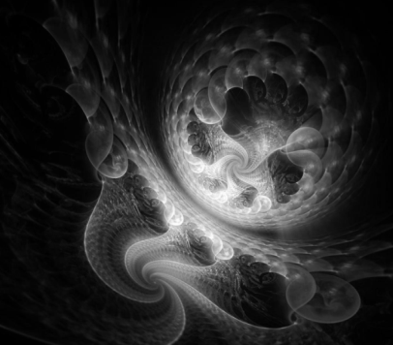
- a derivation of the Schrödinger equation is proposed. The geometric-statistical meaning of Planck constant is revealed. The foundations of quantum geometry and statistical topology are laid;
- discussed possibilities: the gap "vacuum" freeze "vacuum" evaporation "vacuum" knock "vacuum" and the implementation of many other vacuum effects;
- created the preconditions for the development of the vacuum (zero) technologies, such as the formation of macroscopic wormhole to move in space, the endless seal channels, the repulsion from the "vacuum" energy from the "vacuum" and many other;
- efforts aimed at the full unification of the world constants, and, most importantly, at the complete eradication of the heuristic concept of "mass", as well as all derived from the" mass "of the concepts:" force"," energy "impulse", "temperature", etc. are Selected metric-dynamic analogues of these concepts. For example, the concept of "mass" is replaced by a dimensionless concept of "inertia"; the concept of "force" - by "actual acceleration"; "energy" and "temperature" are replaced by "intensity", etc.in this case, the dimensions of all newly introduced physical quantities do not contain the dimension of "kilogram". Without solving this problem, we will not be able to create a fully geometrized physics, because heuristic concept of "mass" and its volumetric dimension introduced "kilos" in principle can not characterize the metric-dynamic properties of space. Laid the foundations of the "Vacuum Biophysics", "Ethical Vacuum" and "Vacuum Without danger (of Liability)".
- reveal the analogy between the Algebra of signatures with the theory of superstrings.
These results were achieved thanks to the introduction of only two modifications to the General theory of relativity by Albert Einstein:
1. Instead of considering one 4-dimensional curved space, for example, with a signature (+ – – –), we consider a set (or superposition) of sixteen 4-spaces with all possible signatures:
.
2. Not one lambda term is added to Einstein's vacuum equation, but an infinite number of lambda terms:
provided
However, each item of this work is just the beginning, indicating a separate direction for further extensive research in this direction.
The above Declaration achievements requires evidence. But there is no sense in convincing the justice of the above-just go back to these lines after reading this work.
The above Declaration achievements Alsigna requires evidence. But there is no sense in convincing the justice of the above – just go back to these lines after reading this work

alsignat@yandex.ru

