**Longitudinal and transverse quantization of the "vacuum".**

**Fundamentals of the Algebra of Signatures**

Mikhail Batanov[1], Ph.D., Associate Professor,

Department 207, Moscow Aviation Institute

Moscow, Russia

**Abstract:** This work fits into a framework of a program, elucidated in [1, 2, 3], of the geometrization of physics, as set in motion by the mathematical works of William Kingdon Clifford and continued into Einstein’s theory of General Relativity as well as the theories of John Archibald Wheeler. It discusses the physical and mathematical foundations of vacuum light-geometry and the Algebra of Signatures. The vacuum is investigated by probing it with mutually perpendicular monochromatic rays of light with different wavelengths. The result is a hierarchy of nested 3-D light landscapes “*mn***-**vacua”). We consider a locally uncurved and curved state of a vacuum region on the basis of the mathematical theory known as the Algebra of Signatures. A “vacuum condition” is formulated, based on the definition of the “vacuum balance”. Inert properties of the *mn***-**vacuum are considered. A kinematic basis for the possibility of discontinuities in a local neighborhood of a *mn***-**vacuum is introduced. On the basis of the foundations of the Algebra of Signatures described in [2, 3], metric-dynamic models of all elementary particles included in the Standard Model are obtained. In this paper new concepts are introduced, some of them with correspondingly new terminology. Therefore, at the end of the article a glossary of new terms is provided.

**Keywords:** vacuum, light-geometry, emptiness, spin-tensor, signature, stignature, metric, affine space, metric space, geometrized physics.

**1. Technical post-Newtonian vacuum**

When you fight monsters, beware that you do not become a monster yourself. And if you look at the Abyss for a long time, then the Abyss peers at you.

*F. Nietzsche*

*“Jenseits Gut und Böse”*

*(Beyond Good and Evil)*

In modern physics, a vacuum (from the Latin *vacuus*, meaning *empty*) is an extremely complex object, represented as a superposition of multiple layers of quantum zero-point oscillations (scalar, vector, spin, tensor, etc.) fields, or as a tapestry of extremely tightly wound superstrings.

In this paper, we first return to the idea of ​​an technically absolutely pure vacuum, as an empty space in which there are no material particles.

To distinguish the objective empty space (that is, an absolutely pure Newtonian vacuum) from the various vacua of modern theories, for brevity we will call it a “vacuum” (with quotation marks).

**Definition 1.1** *A “vacuum” is a real 3-dimensional empty space without particles, which is outside the consciousness of the observer.*

As a result of the development of light-geometry and the Algebra of Signatures (AS) (see Appendix), the “vacuum” model will become more and more complicated until many analogies are found with Einstein's vacuum, Dirac’s vacuum, Wheeler’s vacuum, De Sitter vacuum, Turner-Vilček

vacuum, vacuum of quantum field theory and the secondary vacuum of superstring theory.

**2. Longitudinal flat bundles in** ***mn****-***vacuum**

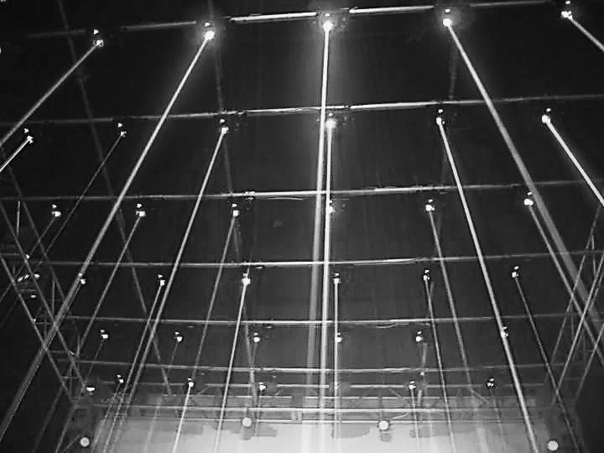

**Fig.** **2.1.** Stationary laser beams rendered visible using a spray (see <https://heatmusic.ru/product/ls-systems-beam-green/> )

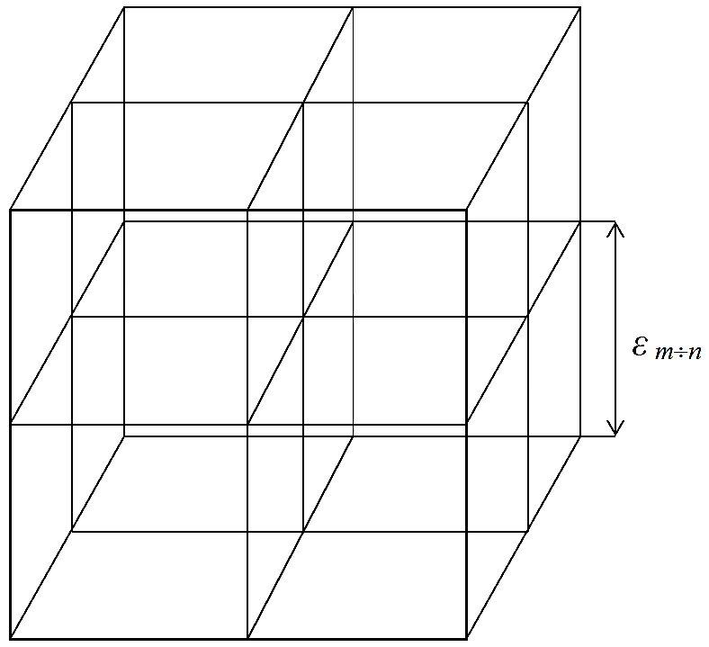

**Fig.** **2.2.** The 3-dimensional lattice in a "vacuum", which consists of mutually orthogonal fixed beams of monochromatic light of wavelength *mn* , where the length of an edge of the cubic cell *εmn* is approximately 102 ∙*mn*

First, consider a 3-dimensional volume of the “vacuum”, in which there is no curvature.

We use the experimental fact that in a “vacuum”, light beams (electromagnetic waves, i.e., photons) propagate at a constant speed *c.*

If the “vacuum” does not change, then the line through which a photon passes (resulting in a ray of light) remains unchanged (Figure 2.1).

**Definition 2.1** *A beam or ray of light at time t is a fixed line in the “vacuum”, along which a photon has passed in the time interval from the moment t*0 *of its emission to t.*

We divide the entire wavelength ** range of electromagnetic (light) waves into sub-intervals from 10*m* cm to 10*m*+1 cm, where *m* ranges over the natural numbers. Such an interval will be denoted by “Δ* ** *10*m*  10*m*+1 cm”, or simply “Δ* ** *10*m*  10*n* ” where it is assumed (or stated for emphasis) that *n* = *m* + 1 and that the units are centimeters.

*εmn*

If one sends monochromatic rays of light of wavelength *mn* (the range 10*m* cm <*λmn* <10*n* cm where *n* = *m* + 1) through a volume of a “vacuum” from three mutually perpendicular directions, then the screen can “visualize” a 3-dimensional stationary light grid (Figures 2.1, 2.2) with the edge length, denoted *εmn* , of the cubic cell equaling approximately *λmn*. This 3-dimensional net will by convention be called a 3-D light landscape or *λmn*-vacuum.

**Definition 2.2** *A mn-vacuum is a 3-D landscape in a “vacuum” which consists of a stationary intersection of monochromatic rays of light of wavelength* *range* 10*m* cm <*λmn* < 10*n* cm*, where n* = *m* +*1 (Figures 2.1 and 2.2).* *The thickness of the light rays, in comparison with the volume of the “vacuum” under investigation, tends to zero, so that* *the condition of applicability of geometrical optics is fulfilled.*

Sequentially analyzing the probed volume of “vacuum” monochromatic rays of light of wavelengths of all sub-bands 10*m* cm <*λmn* < 10*n* cm*,* we obtain an infinite number of nested *λmn*-vacua (Figure 2.3).

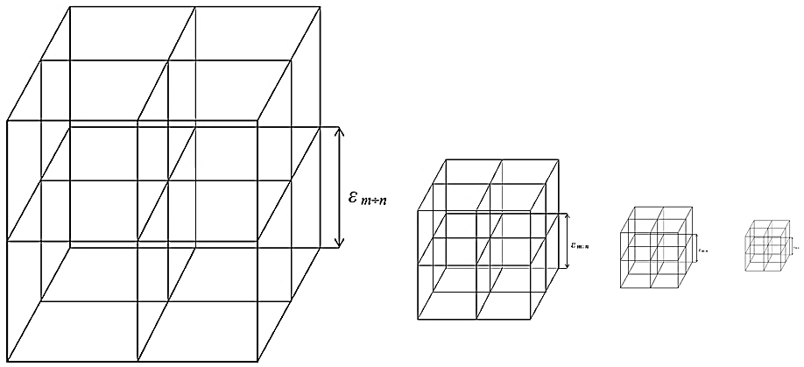

**Fig.** **2.3.** Discrete set of 3-D light landscapes *mn-*vacua) of the same 3-dimensional

portion of a "vacuum," where *mn* > **(*m+*1)(*n+* 1) > **(*m+*2)(*n+* 2) > **(*m+*3)(*n+* 3) > **(*m+*4)(*n+* 4)...

If *λmn* > *λ(m+*1)(*n+*1) ,then the sizes of the cubic cells of the 3-Dlight landscapes *(λmn-vacuа)*obey *εmn* > *ε(m+*1)(*n+*1).

**Definition 2.3** *A longitudinal bundle in a “vacuum”* *is* *a representation of an empty 3 - dimensional space consisting of an endless sequence of discrete nested* *λmn-vacuа* *(3-D light landscapes).*

**3. Lidar method of investigation of the “vacuum”**

The rays of light in a “vacuum” are not visible, so the human eye also does not record monochromatic rays of light formed in a *λmn-*vacuum. Nevertheless, it can be visualized if, for example, aerosol particles are sprayed on laser light paths (Figure 2.1).

A more correct method of investigating the metric-dynamic properties of a “vacuum” is electromagnetic carrier signals with wavelength *λmn.*

Let the pulse of the electromagnetic signal, beamed by the lidar, propagate in the investigated section of the “vacuum” to the reflector, then be reflected from it in the opposite direction (Figure 3.1), and finally the reflected signal enters the aperture of the lidar.

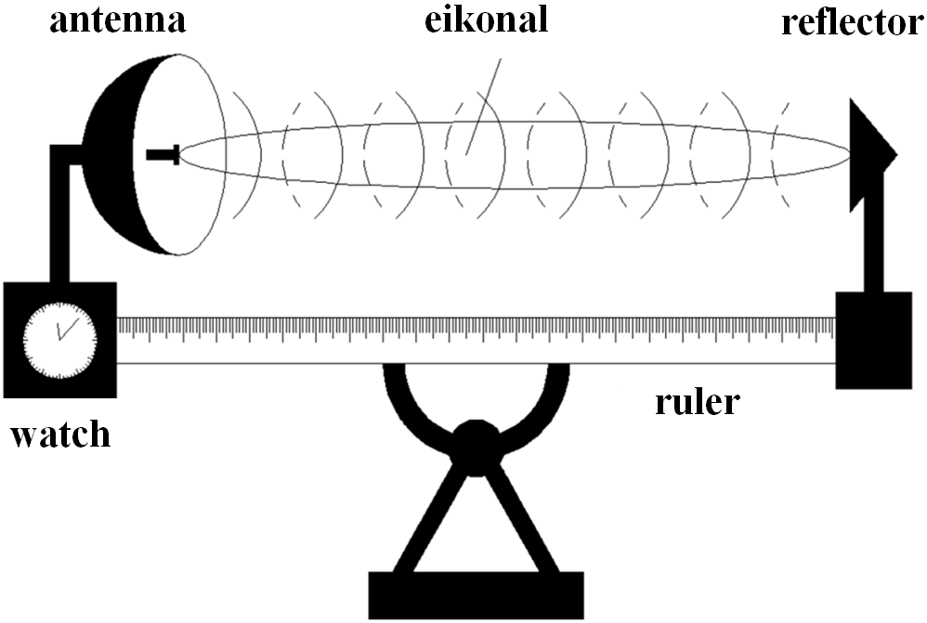

**Fig.** **3.1.** Laser scanning unit (Lidar) for probing a section of a "vacuum"

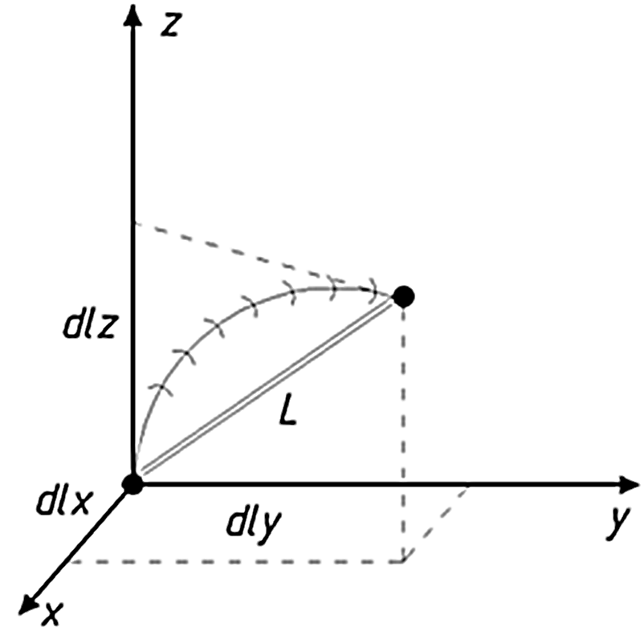

**Fig.** **3.2.** The propagation of a light beam along a curved portion of a "vacuum"

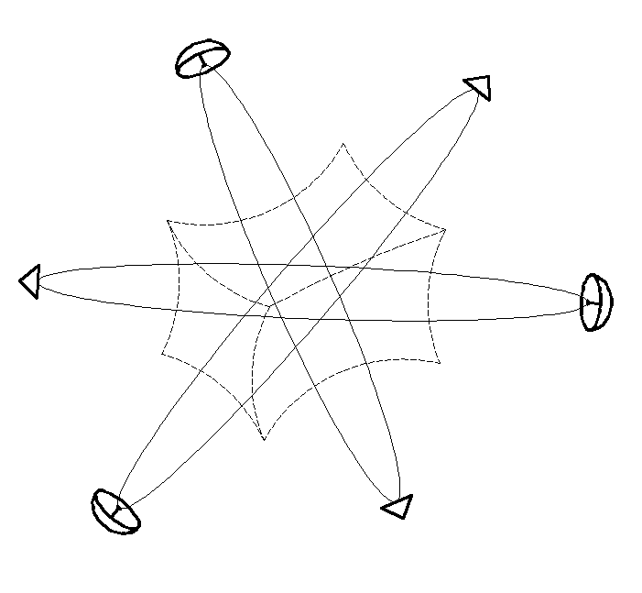

**Fig.** **3.3.** Scanning of the volume of the "vacuum" under investigation from three mutually perpendicular directions

The time interval *dt* = *t*2  *t*1 elapsed from the time *t*1 of the emission of a pulse until the moment *t*2 of the reception of the reflected signal is recorded by a precision clock.

Knowing the period of time *dt,* and assuming that the speed of light in a “vacuum” is a fundamental constant, it is easy to calculate the length of the path along which the light beam propagates from the antenna of the transceiver to the reflector by the formula

 (3.1)

Suppose, too, that the distance measured with a ruler (Figure 3.1, 3.2) equals *L*.

If *dl* = *L,* then this can be interpreted as a rectilinear propagation of the laser beam from the transmitter to the reflector and back.

If *dl ≠* *L*, then with fully adjusted lidar, this may correspond to one of the following cases:

a) the monitoring portion of the “vacuum” is bent, so that the light beam propagates along a geodesic line in the curved 3-D landscape (Figure 3.2);

b) in the volume under investigation there is a current (motion) of the “vacuum”, which carries the ray of light away from the direct path;

c) there is both a curvature and a “vacuum” flow in this area. vature of the “vacuum”. For a more complete definition of its metric-dynamic properties, it is necessary to probe this section at least from three mutually perpendicular directions (Figure 3.3).

**4. Features of the lidar method**

The lidar method of sounding the “vacuum” contains two fundamental aspects that will later influence the development of light-geometry.

First, note the important fact that the time interval *dt,* measured by the clock of lidar (Figure 3.1), is not related to the region of the “vacuum” which is probed, since this region of the “vacuum” is located between the antenna aperture and the reflector, and the clocks are outside of this site. In other words, in the lidar method, time is an attribute of an outside observer, rather than an explored section of the “vacuum”. This means that the metric-dynamic state of the local section of the “vacuum” is determined by its curvature and/or motion, and not by a change in the flow of time, as it is treated in Einstein’s General Theory of Relativity (GR).

Secondly, it follows from the lidar method that the properties of the surrounding region have at least two conjugate 4-dimensional sides: “external” and “internal”.

Let us explain this statement by way of an example. The basic lidar equation (3.1) can be represented in the form

, (4.1)

where *dlr* is the distance traveled by the light beam in the forward direction (from the antenna to the reflector of the lidar, Figure 3.1.);*dlb* is the distance traveled by the light beam in the opposite direction.

That is, in the lidar method, there are inevitably two beams: direct and reverse. They correspond to two conjugate sides: *external* and *internal.*

During the time interval *dt*, the light beam travels a distance

*cdt = dl*, (4.2)

where *dl =* (*dx*2 *+ dy*2 *+ dz*2)½  is the length element in 3-dimensional “vacuum”.

rom (4.2) follows the expression

*c*2*dt*2 *= dx*2*+ dy*2 *+ dz*2.(4.3)

In turn, (4.3) is possible to write down in two ways:

*ds*(–)2 = *c*2*dt*2 – *dx*2 – *dy*2 – *dz*2 = 0, (4.4)

*ds*(+)2 = – *c*2*dt*2 + *dx*2 + *dy*2 + *dz*2= 0, (4.5)

respectively, to direct the beam (or *the outer* side) and the returning light (or the *internal* side).

The sum of the squares of the intervals (4.4) and (4.5) is equal to true zero:

½(*ds*(–)2 + *ds*(+)2) = *ds*(–)2 + *ds*(+)2 = (*c*2*dt*2 – *dx*2 – *dy*2 – *dz*2) + (– *c*2*dt*2 + *dx*2 + *dy*2 + *dz*2)= Ɵ. (4.6)

This circumstance makes it possible to remove one of the main problems of quantum field theory: the infinity of the energy of a physical vacuum, since in this case, the zero-point energy of each anti-oscillator corresponds to the zero-point energy of a corresponding harmonic oscillator.

**Definition 4.1.** *“True zero” is defined as:* Ɵ = 0 – 0. (4.7)

In a local region, oscillators and anti-oscillators can be shifted in phase or differ in amplitude and polarization, and therefore continuous fluctuations of the photon-anti-photonic vacuum condensate are possible at every point of space; however, on the average, in a given region of the “vacuum”, they completely annihilate one another.

**5. Geodetic line in a *λmn*-vacuum**

Monochromatic light rays with different wavelengths *λmn* propagate “in a vacuum” with the same speed of light obeying the same laws of electrodynamics.

Therefore, if the investigated section of the “vacuum” is not curved, then all 3-D light landscapes (*λmn*-vacuа) will differ from one other only by the length *εmn* of the edge of the cubic cell≈ 102*λmn* (Figure 2.2).

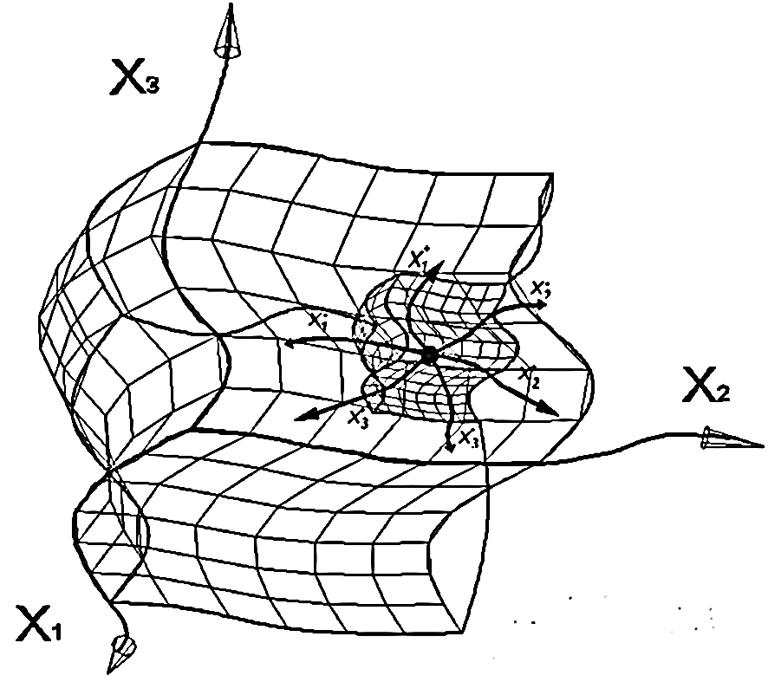

**Fig.** **5.1.** A *mn* *-* vacuum embedded in a *fd* *-*vacuum, where *mn*  *mn*

However, if the “vacuum” is twisted, all *λmn-*vacua will differ from one other due to the fact that the light rays with different wavelengths have different thicknesses. Each 3-D light landscape (*λmn-*vacuum) is unique (Figure 5.1), as all the irregularities of the “vacuum” are averaged within the thickness of the light beam.

This conclusion is theoretically justified by the laws of geometrical optics, which take into account the resolving power of optical instruments [14, 17], and are confirmed by experimental data (Figure 5.2).

A *λmn-*vacuum is only a 3-D slice of a given curved “vacuum” region (Figure 5.1). For a more complete description of the curved section of the “vacuum”, it is necessary to obtain a set of *λmn*-vacuum nested in one another.

In order not to lose information on a curved section of the “vacuum”, a sampling of the *λmn-*vacuum must satisfy the Nyquist theorem (also known as the Nyquist Sampling Theorem, the Nyquist-Shannon Sampling Theorem or the Shannon Sampling Theorem, and in Russia as the Kotelnikov Theorem). In fact, this theorem is a condition of the “vacuum” quantization of nested 3-D light landscapes.

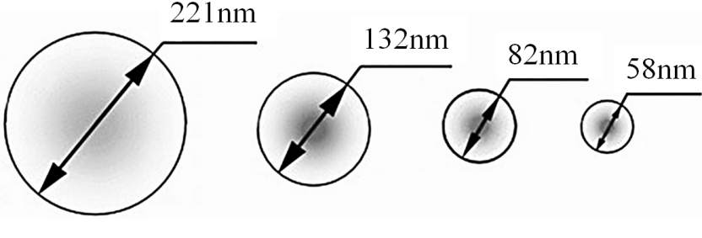

*λ =* 650 nm *λ =* 390 nm *λ =* 240 nm *λ =* 170 nm

**Fig. 5.2.** Experimental data on the laser beam thickness as a function of the wavelength **

of monochromatic beams ([https://tech.onliner.by/2006/03/29/blu_ray_about](https://translate.google.com/translate?hl=en&prev=_t&sl=ru&tl=en&u=https://tech.onliner.by/2006/03/29/blu_ray_about))

Given the properties of propagation of rays of light (electromagnetic eikonal waves), we conclude that a curved 3*-*D light landscape (*λmn-*vacuum) is detected in the “vacuum” only when the wavelength of the monochromatic probe light rays *λmn* is much smaller than the size of the curvature. In this case, the geometrical optics approximation *λmn* → 0 is applicable, so that the rays of light can be regarded as infinitely thin lines of light traversing the 3-D landscape (*λmn***-**vacuum) (Figure 5.1).

Therefore, for example, to illuminate a 3-D landscape at the level of fluctuations of the quark-gluon vacuum condensate with characteristic curvatures in scales of 10–13 – 10–15 cm, it is necessary to use beams of light with wavelengths *λmn* > 10–17 cm.

**6. Sixteen rotating 4-bases**

We return to the ideal (uncurved) portion of one of the *λmn-*vacua (Figure 6.1).

In an uncurved region of a “vacuum”, the 3-D light landscape differ from each other only in the cubic cell edge length *mn* ≈ 102·*λmn,* so this item refers to the description of any of the *λmn-*vacua.

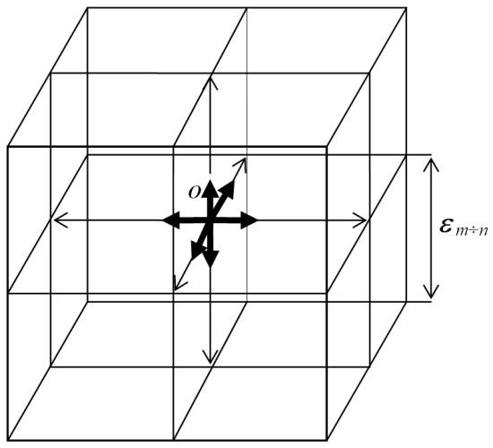We calculate how orthogonal 3-bases originate at the central point *O* of the given volume, the *λmn-*vacuum (Figure 6.1).

*εmn*

**Fig.** **6.1.** Uncurved local luminous portion of a 3-D light landscape (*mn-*vacuum), consisting of

monochromatic rays of light of wavelength *mn.* The cells of such a 3-dimensional light grid

are perfect cubes with an edge length *mn* of approximately 102·*mn*

In an uncurved region of “vacuum”, the 3-D light landscape differ from each other only in the cubic cell edge length *mn* ≈ 102·*λmn ,* so this item refers to the description of any of the *λmn-*vacua.

We calculate how orthogonal 3-bases originate at the central point *O* of the given volume, that is, the *λmn-*vacuum (Figure 6.1).

**Definition 6.1** *An* *orthogonal 3*-*basis consists of* *three mutually perpendicular unit vectors emanating from a common point.*

If we classify 3-bases with respect to the same origin (point *O* in Figure 6.1) by taking into account their different directions, it turns out that they number 16 (Figure 6.2 a, b).

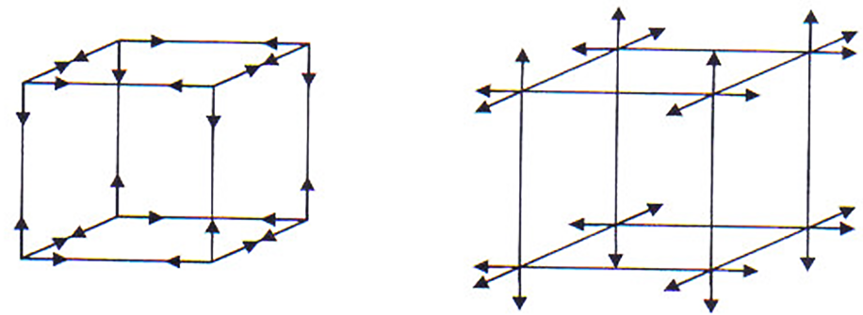



а*)* eight internal 3-bases b) eight external 3-bases c) adjacent cubic cells

**Fig.** **6.2.** Sixteen 3-bases about a central point *O* in the

section of “vacuum” under investigation

Of these, eight 3-bases belong to the cubic cell itself (Figure 6.2 a), and the eight opposite 3-antibases belong to adjacent cubic cells (Figure 6.2 b, c).

Any movement in the “vacuum” must be accompanied by a similar anti-movement, this is called the “vacuum condition” in the framework of the Algebra of Signatures (Definition 12.2). So if one 3-basis (together with the cubic cell) rotates clockwise (Figure 6.2c), then this is possible only if the adjacent cubic cell (along with the 3-antibasis) likewise rotates counterclockwise, since there is no point of support in the “vacuum”.

In connection with the foregoing, it is convenient to add all the 3-bases (Figure 6.2a) along the fourth time axis, and add the fourth opposite anti-axis time to the eight 3-antibases (Figure 6.2b).

Thus, at the point *O,* a *λmn*-vacuum (Figure 6.1) has 8 + 8 = 16 orthogonal 4*-*bases, as shown in Figure 6.3.

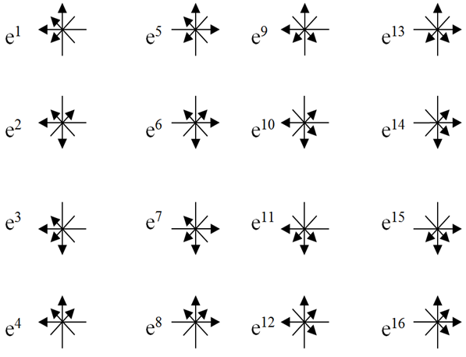

**Fig.6.3.** Sixteen 4-bases about the point *O* obtained by adding a temporal axis

to each of the eight 3-bases and eight 3-antibases

Sixteen 4*-*bases (Figure 6.3) can be obtained within a local “vacuum” area using the lidar sensing method. In Section 3, it was shown that for a determination of the metric-dynamic properties of the “vacuum” in the neighborhood of point *O*, lidar signals (monochromatic light rays) should come from at least three mutually perpendicular directions (Figure 3.3).

Let point *O* be the origin for six monochromatic rays of light with circular polarization (two oncoming beams of light with three mutually perpendicular directions, as in Figure 6.4).

For example, consider a pair of opposing light beams propagating towards each other along the *x*-axis (Figure 6.4). Let the polarization of the light beam under consideration be given by the electric field vector **E***x*(+)*,* and the polarization anti-light by the electric field vector **E***x*. These vectors are described by the complex expressions [9]:

, (6.1)

, (6.2)

whereby *Ezm*(+) is the projection vector of **E***x*(+) onto the *z*-axis*;* *Eym*(+) is the projection vector **E***x*(+) onto the *y*-axis*;* *Ezm* is the projection vector **E***x* onto the *z*-axis*;* *Eym* is the projection vector **E***x* onto the *y*-axis*,* where: ** is the angular frequency of the light; *kx* is the wave vector projection onto the *x*-axis; *xz*(+), *xy*(+) are the phase orthogonal components of a wave propagating in the forward *x*-axis direction; *xz*, *xy* are the phase orthogonal components of a wave propagating in the opposite *x*-axis direction.

Of the six rotating electric field vectors shown in Figures 6.4 and 6.5, we can form 16 rotating 3-bases. Of these, eight 3*-*bases are rotated in a clockwise direction; eight other 3*-*bases are rotated counterclockwise as shown in Figure 6.3.

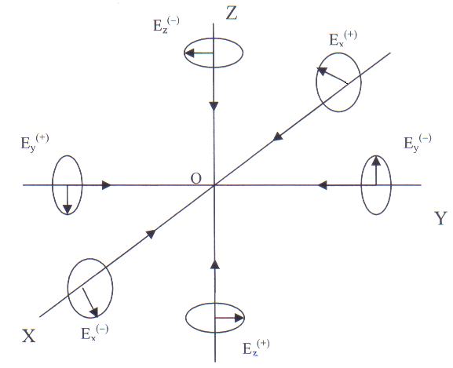

**Fig.** **6.4.** Polarization of light and anti-light rays coming to a point fromthree mutually

perpendicular directions

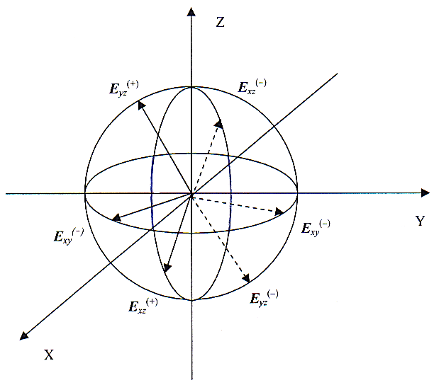

**Fig.6.5.** Two 3-bases, consisting of vectors of electric fields **E***x*(+), **E***y*(+), **E***z*(+) and

**E***x*(), **E***y***()**,**E**z**(**) rotating in opposite directions around the point *O*

Let us briefly explain how the fourth axial time axis was introduced into each 3-basis. If the frequencies of all three probe monochromatic rays arriving at the point *O* under investigation (Figure 6.4) with the three orthogonal directions being the same *x = y = z*, then their electric vector **E***i*(±) at this point is rotated with the same angular velocity

*              x*.(6.3)

Together these three electric field vectors **E***i*(±) form an orthogonal 3-basis of an electric field, constantly rotating at an angular velocity of (6.3), which implies the need to maintain the axis of time * /* *= t.*

Thus, the lidar sensing method of a “vacuum” in the neighborhood of a given point *O* leads to the same sixteen 4-bases as shown in Figure 6.3. But in this case the reference vectors with 4-bases make up the electric field vector **E***i*(±).

**7. Subcont and antisubcont**

An important aspect of the theory developed here is the assertion that the object of research is the three-dimensional volume of the “vacuum” (Figure 2.2). From this postulate follows the basic formula of affine light geometry (4.2)

*cdt = dl =* *(dx*2 *+ dy*2 *+ dz*2)½ = |**i***dx+* **j***dy**+***k***dz*|, (7.1)

where **i***,* **j***,* **k** are the standard mutually perpendicular unit vectors, and the basic formula of metric light geometry (4.3) is

*c*2*dt*2 *= dx*2 *+ dy*2 *+ dz*2 (7.2)

the transformation of which leads to a system of two conjugate metrics (4.4) and (4.5):

*ds*(–)2 = *c*2*dt*2 – *dx*2 – *dy*2 – *dz*2 = *dx*02 – *dx*12 – *dx*22 – *dx*32 = 0 with signature (+ – – –); (7.3) *ds*(+)2 = – *c*2*dt*2 + *dx*2 + *dy*2 + *dz*2 = – *dx*02 + *dx*12 + *dx*22 + *dx*32 = 0 with signature (– + + +). (7.4)

From this system of equations follows two “technical” conclusions:

1. The quadratic forms (7.3) and (7.4) can be interpreted as a single metric of two four-dimensional sides of the same 4 + 4 = 8 = 23 *-* dimensional metric space, which will be called a “23*-mn-*vacuum region“.

**Definition 7.1** *A* 2*k-λmn-vacuum region is an auxiliary logical “structure”, meaning a space with 2k* *mathematical measurements (where k = 3, 4, 5, ... ,* *which are “realized” out of a “vacuum” by probing it with direct and inverse monochromatic rays of light with a wavelength* *mn.* *The simplest 23-λmn-vacuum region has two “sides”:*

* a 4-dimensional space with the Minkowski metric (7.3) and the signature    ;*

* a 4-dimensional Minkowski metric anti-space with (7.4) and the signature ( + + +).*

Algorithms of the transition from formal parameters to 2*k* mathematical measurements of the physical quantities characterizing the 3-dimensional volume of a “vacuum” are discussed below.

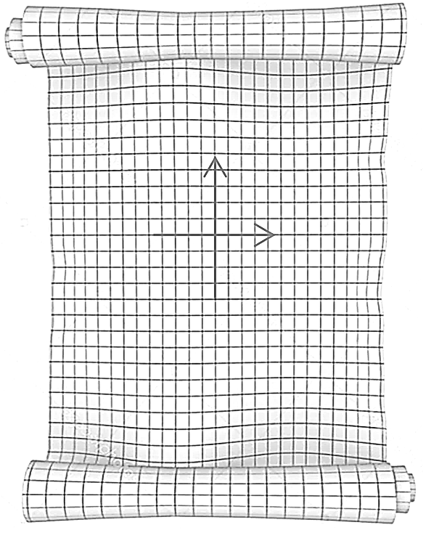

**Fig.** **7.1.** Curved double-sided

surface of a sheet of paper

Although a 23*-λmn-vacuum region* is a purely logical 4 + 4 = 8 *-* dimensional structure, the physical consequences can be deduced from this. We explain this using the following 2 + 2 = 4 *-* dimensional example.

On a sheet of paper (whose thickness can be ignored)

there are two 2*-*dimensional pages (Figure 7.1). Therefore a sheet of paper can be regarded as an analogue of a 2 + 2 = 4 *-*dimensional region.

If the paper is not deformed, then both sides in terms of geometry are virtually identical.

However, if the sheet is bent, then on one of its 2- dimensional sides all its elementary areas will widen slightly, and on the other, conjugate, 2-dimensional side, all elementary areas will slightly shrink.

Similarly in the curved portion of the “vacuum”, according to the “vacuum condition”, they occur simultaneously as local compression and rarefaction regions, which automatically takes into account the “bilateral” view of its 4 + 4 = 8 *-* dimensional metric space.

Taking into account the thickness of the sheet of paper, then as part of this characterization there arises an elementary cube, situated between the two sides of the sheet.

In this case, as will be shown below, it will be necessary to consider the continuous region with 4×16 = 8×8 = 64 mathematical dimensions. To continue with an even finer consideration for a 16 × 16 = 256-dimensional region, or even further to higher dimensions, it is necessary to regard a 2*k* -dimensional mathematical space (where *k* → ∞).

Thus, in light-geometry, a “vacuum” has only three physical spatial dimensions and, associated with an observer, one temporal dimension, as well as 2*k* mathematical (i.e., formal or technical) measurements, where *k =* 2, 3, ... , ∞; all this depends on the consideration of the subtleties of the given volume of the “vacuum”.

When the problem can be reduced to a two-sided consideration of a 23*-λmn*-vacuum region, then for clarity it serves to introduce the following notation:

**7.2 Definition** *The**“outer” side of a 23-λmn-vacuum region (or subcont) is a 4-dimensional region, local metric-dynamic properties of which are given by the metric*

*ds*(+ – – –)2 = *gij*(–)*dxidxj with the signature* (+ – – –), (7.5)

*where* (7.6)

*which is the metric tensor of the “outer” side of the* 23*-mn*-*vacuum region (or subcont).*

*When*

 (7.7)

*then a “subcont” is synonymous with the 4-dimensional space with the Minkowski metric (7.3) and the signature*    .

**7.3 Definition** *The**“internal” side of a 23-λmn-vacuum region (or antisubcont) is a 4 - dimensional region, the local metric-dynamic properties of which are given by the metric*

*ds*(– + + +)2 = *gij*(+)*dxidxj*, *with signature* (– + + +), (7.8)

*where*  (7.9)

*which is the metric tensor of the “external” side 23-λmn-vacuum region (or antisubcont).*

*When*

 (7.10)

*the “antisubcont” is synonymous with the 4-dimensional Minkowski metric antispace described by (7.4) and the signature ( + + +).*

To shorten the exposition, we assigned terms to the two auxiliary concepts which were introduced in Definitions 7.2 and 7.3.

**Definition 7.4** A*subcont (abbreviation of “substantial continuum”) is a hypothetical continuous elastic-plastic 4-dimensional pseudospace, whereby its local metric-dynamic properties are given by the metric (7.5).*

**Definition 7.5** *An antisubcont (abbreviation of “anti-substantial continuum”) is a hypothetical continuous elastic-plastic 4-dimensional pseudospace, whereby its local metric-dynamic properties are given by the metric (7.8).*

The concepts *subcont* and *antisubcont* are auxiliary concepts of pseudo-4-dimensionality that are synonymous with, respectively, *outer* and *inner* sides of a 23*-mn-*vacuum region. These concepts are introduced only for convenience in order to regard various elastic-plastic processes occurring in the “vacuum”.

**8. Algebra of stignatures**

The physical basis of a light-geometry “vacuum” were considered above. Next we will primarily be concerned with the formal mathematical and geometrical aspects of this theory.

So as to not further complicate the formal mathematical apparatus of the Algebra of Signatures, it should be remembered that the geodetic lines of the given 3-D light landscape (or *mn -* vacuum) are infinitely thin monochromatic light beams having wavelengths *mn*.

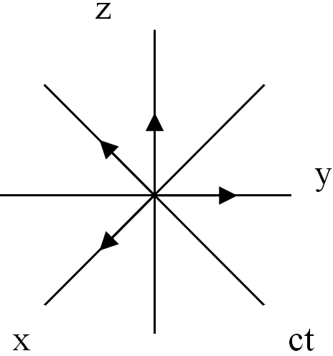

**Fig.** **8.1.** Base with stignature

{+ + + +}

Thus the main subject of an infinitely small 3-D cubic cell *mn-*vacuum in the vicinity of the point *O* (Fig 6.1, 6.2.), each corner of which is connected by two rotatable 4-bases, is shown in Figure 6.3.

Each of the sixteen 4-bases imparts the direction of the axes in 4-dimensional affine space with special characteristics, which together will be referred to as the associated *stignature*.

To introduce a description of *stignature* affine space, we first define the concept of *base*. We choose from the sixteen 4-bases shown in Figure 6.3 a preferred 4-basis **e***i*(5) (**e**0(5), **e**1(5), **e**2(5), **e**3(5)) (Figure 8.1) and conditionally accept that the directions of all its unit basis vectors are positive

**e***i*(5)(**e**0(5),**e**1(5),**e**2(5),**e**3(5)) = (+1, +1,+ 1, +1) → {+ + + +}. (8.1)

Here we introduce a shorthand notation {+ + + +}, which will be called a “stignature” affinity (vector) space defined by the above 4-basis, hereafter designated **e**(5).

**Definition 8.1** *A “base” is one of the sixteen 4-bases, as shown in Figure 6.3, in which the direction of all 4-unit vectors are denoted as positive, so the base always has stignature* {+ *+ + +*}*.*

An arbitrarily chosen “base” (4-basis **e**(5)) of all the 4-bases shown in Figure 6.3 have the following signs:

Table 8.1

|  |  |
| --- | --- |
| *4-basis Stignature* | *4-basis Stignature* |
| **e***i*(1) (**e**0(1), **e**1(1), **e**2(1), **e**3(1)) =  = (1, 1, –1, 1) → {+ + – +}  **e***i*(2) (**e**0(2), **e**1(2), **e**2(2), **e**3(2)) =  = (1, –1, –1, –1) → {+ – – –}  **e***i*(3) (**e**0(3), **e**1(3), **e**2(3), **e**3(3)) =  = (1, 1, –1, –1) → {+ + – –}  **e***i*(4) (**e**0(4), **e**1(4), **e**2(4), **e**3(4)) =  = (1, –1, –1, 1) → {+ – – +}  **e***i*(5) (***e***0(5), **e**1(5), **e**2(5), **e**3(5)) =  = (1, 1, 1, 1) → {+ + + +}  **e***i*(6) (**e**0(6), **e**1(6), **e**2(6), **e**3(6)) =  = (1, –1, 1, –1) → {+ – + –}  **e***i*(7) (**e**0(7), **e**1(7), **e**2(7), **e**3(7)) =  = (1, 1, 1, –1) → {+ + + –}  **e***i*(8) (**e**0(8), **e**1(8), **e**2(8), **e**3(8)) =  = (1, –1, 1, 1) → {+ – + +} | **e***i*(9) (**e**0(9), **e**1(9), **e**2(9), **e**3(9)) =  = (–1, 1, –1, 1) → {– + – +}    **e***i*(10) (**e**0(10), **e**1(10), **e**2(10), **e**3(10)) =  = (–1, 1, –1, –1) → {– – – –}    **e***i*(11) (**e**0(11), **e**1(11), **e**2(11), **e**3(11)) =  = (–1, 1, –1, –1) → {– + – –}  **e***i*(12) (**e**0(12), **e**1(12), **e**2(12), **e**3(12)) =  = (–1, –1, –1, 1) → {– – – +}  **e***i*(13) (**e**0(13), **e**1(13), **e**2(13), **e**3(13)) =  = (–1, 1, 1, 1) → {– + + +}  **e***i*(14) (**e**0(14), **e**1(14), **e**2(14), **e**3(14)) =  = (–1, –1, 1, –1) → {– – + –}  **e***i*(15) (**e**0(15), **e**1(15), **e**2(15), **e**3(15)) =  = (–1, 1, 1 –1) → {– + + –}  **e***i*(16) (**e**0(16), **e**1(16), **e**2(16), **e**3(16)) =  = (–1, –1, 1, 1) → {– – + +} |

**Definition 8.2** A *“stignature 4-base” is a set of characters corresponding to the directions of its reference vectors with respect to the directions of the reference “base vectors“.*

All *stignatures* in Table. 8.1 can be combined into a 16-component matrix:

 . (8.2)

This matrix represents a single mathematical object with unique properties. Here are some of them:

1. The sum of all 16-stignature and (8.2) equals the zero stignature

{+ + – +} + {+ – – –} + {+ + – –} + {+ – – +} +

+ {+ + + +} + {+ – + –} + {+ + + –} + {+ – + +} + (8.3)

+ {– + – +} + {– – – – } + {– + – –} + {– – – +} +

+ {– + + +} + {– – + –} + {– + + –} + {– – + +} = {0000}.

2. The sum of all 64 characters included in the matrix (8.2) is equal to zero (32 “+” 32 + “” = 0).

3. There are four possible combinations of binary characters:

, (8.4)

or in the form of a transposed binary characters :

. (8.5)

Various combinations of binary characters form realizations with stignature 16:

(8.6)



4. Using the Kronecker product, the square of the matrix with two rows of binary signatures forms a matrix composed of sixteen stignatures (8.2):

 (8.7)

where  is the symbol for the Kronecker product.

5. If the matrix (8.6) is assigned units, then we get a double-row matrix

 (8.8)

and

 (8.9)

Eight of them:

 (8.10)

are Hadamard matrices, as they satisfy

 (8.11)

When employing Kronecker graphs, any of the matrices (8.10) again produces a Hadamard matrix *H*(*n*), satisfying the following condition:

 (8.12)

where the *I* - diagonal unit matrix of dimension *n* is:

 (8.13)

For example,

 (8.14)

 (8.15)

and so on according to the algorithm

*Н*(2)⊗*k* = *Н*(2*k*) = *Н*(2)⊗ *Н*(2)⊗*k-*1 = *Н*(2)⊗ *Н*(2*k-*1). (8.16)

5. The “base”, shown in Figure 8.1, is selected arbitrarily. If you select a different “base” out of the 4 bases, as shown in Figure 6.3, the signs in the stignature matrix (8.2) will be swapped, but its properties do not change. This kind of related individual invariance properties of the *mn-*vacuum will be discussed later.

6. Sixteen 4-bases (given in Figure 6.3 and Table 8.1) correspond to the 16 types of “color” quaternions: (8.17)

|  |  |
| --- | --- |
| *z*1 = *x*0 + *ix*1 + *jx*2 + *kx*3 {+ + + +}  *z*2 = –*x*0 –*ix*1 – *jx*2+ *kx*3 {– – – +}    *z*3 = *x*0 – *ix*1 – *jx*2+ *kx*3 {+ – – +}  *z*4 = –*x*0 – *ix*1+ *jx*2–*kx*3 {– – + –}  *z*5 = *x*0 +*ix*1 – *jx*2 –*kx*3 {+ + – –}  *z*6 = –*x*0 + *ix*1 – *jx*2–*kx*3 {– + – –}  *z*7 = *x*0 – *ix*1+ *jx*2 – *kx*3 {+ – + –}  *z*8 = –*x*0+*ix*1 + *jx*2 + *k*d*x*3 {– + + +} | {– – – –} *z*9 = –*x*0 – *ix*1 – *jx*2 – *kx*3  {+ + + –} *z*10 = *x*0 + *ix*1 + *jx*2 – *kx*3  {– + + –} *z*11= – *x*0 + *ix*1+ *jx*2– *kx*3  {+ + – +} *z*12= *x*0 + *ix*1 – *jx*2 + *kx*3  {– – + +} *z*13= –*x*0 – *ix*1 + *jx*2+ *kx*3  {+ – + +} *z*14= *x*0 – *ix*1 + *jx*2 + *kx*3  {– + – +} *z*15 = –*x*0 + *ix*1– *jx*2+ *kx*3  {+ – – –} *z*16 = *x*0 – *ix*1 – *jx*2 – *kx*3 |

In [2, 5] it is shown that “color” quaternion correspond to the “color” of QCD. By direct calculation it is easy to see that the sum of all 16 types of “color” quaternions (8.17) is equal to zero

** (8.18)

that is, a superposition of all types of “color” quaternions is balanced with respect to zero.

7.The stignature matrix (8.2) can be presented in the form of the sum of diagonal and antisymmetric matriсes

 (8.19)

8. Let such a matrix, composed of four elements labeled *a*, *b*, *c*, *d* be written as

, (8.20)

Multiplication of a matrix of the form (8.20) with one of the Hadamard matrices (8.14) gives a matrix composed of linear forms with various stignatures (8.21)



**Definition No. 8.3** *"The Yi-Ching analogy" represents an analogy between the Algebra of Stignature and the "Yi-Ching" (the Chinese "Book of Changes").*

*- In the Book of Changes there are two fundamentals: «––» (Yang) and «– –» (Yin); Algebra of Stignature contains two signs: «+» (plus) and «–» (minus).*

*- In the Book of Changes there are 8 trigrams (Fig. 8.2a); in Algebra of Stignature we have eight 3-bases (Fig. 6.2a) and/or eight 3-antibases (Fig. 6.2b).*

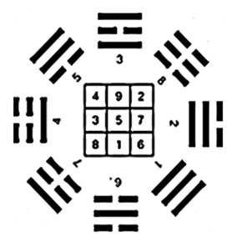

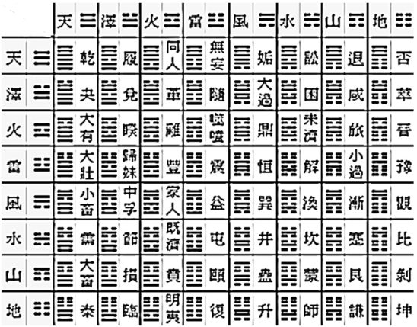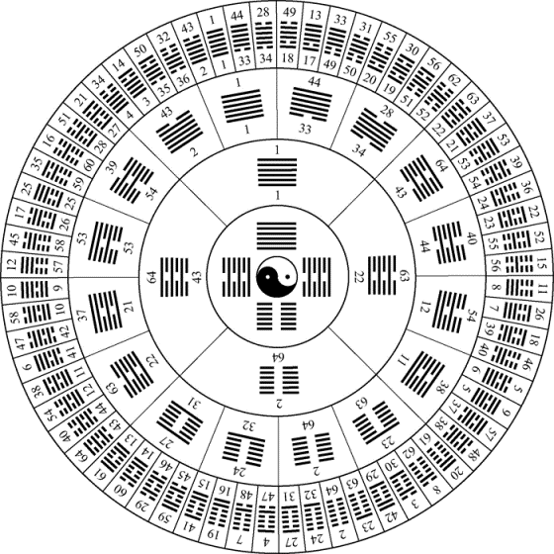

*а) b) c)*

***Fig. 8.2.*** *The eight trigrams and sixty four hexagrams of the Chinese Book of Changes*

[*http://hong-gia-ushu.ru/vu-chi/traktat-vo-kyk-vu-chi-avtor-li-khong-tai*](http://hong-gia-ushu.ru/vu-chi/traktat-vo-kyk-vu-chi-avtor-li-khong-tai)

*- In the Book of Changes the combinations of two trigrams give 64 hexagrams (Fig. 8.2 b, c); in Algebra of Stignature we have 64 combinations (addition or multiplication) of each of the 3-bases with each of the 3-antibases.*

*- The dialectics of the Book of Changes is based on combinations of the two opposite principles «––» (Yang) and «– –» (Yin):*

*old Yang old Yin young Yang young Yin*

|  |  |  |  |
| --- | --- | --- | --- |
| ──  ── | ─ ─  ─ ─ | ──  ─ ─ | ─ ─  ── |
| *Heat*  *Summer*  *Fire*  *…* | *Cold*  *Winter*  *Earth*  *…* | *Warmly*  *Spring*  *Water*  *…* | *Cool*  *Fall*  *Air*  … |

*Similarly, in the Algebra of Stignatures the four binary combinations of signs* «+» *и* «*–*» *(8.5) are possible:*  {+ +} {– –} {+ –} {– +}.

**9. Stignature spectral analysis**

We point out the possible use of the Algebra of Stignatures to empower spectral analysis.

Recall that in quantum physics, there is a procedure proceeding from the coordinate to the momentum representation. Let there be a function of space and time *ρ* (*ct,x,y,z*). This function is represented as a product of two “amplitudes”

*ρ*(*сt,x,y,z*) = *φ*(*сt,x,y,z*)·*φ*(*сt,x,y,z*). (9.1)

Further, two Fourier transformations are performed

, (9.2)

 (9.3)

where

*p* = 2*η/ –* generalized frequency; (9.4)

* –* wavelength;

*η –* coefficient of proportionality (in quantum mechanics *η = ħ =* the reduced Plank constant);

*dΩ = cdtdxdydz –* elemental 4-dimensional volume of space;

*ω –* angular frequency;

**k** *–* wave vector;

ехр{*i*( *ω t –* **k***⋅* **r**)} = ехр{*i*(2*π /λ*) (*сt – x – y – z*)} : direct wave;(9.5)

ехр{*i*(*–ω t +* **k***⋅* **r**)} = ехр{*i* (2*π /λ*) (*– сt+x+y+z*)} : reflected wave. (9.6)

A pulse (spectral) representation of the function *ρ*(*ct,x,y,z*) is obtained by the product of the two amplitudes (9.2) and (9.3)

. (9.7)

The spectral representation giving a balance of zero is thus achieved

(*сt – x – y – z*) + (*– сt + x + y + z*) = 0, (9.8)

which can be written as

{+ *–* *–* *–*}

{– + + +}

{0 0 0 0} (9.9)

We now formulate the foundations of the spectral analysis of stignatures.

In analogy to the procedure (9.1) to (9.7), we represent the function *ρ*(*ct,x,y,z*) as the product of the “amplitudes”

*ρ*(*сt,x,y,z*)=*φ*1(*сt,x,y,z*) *φ*2(*сt,x,y,z*) *φ*3(*сt,x,y,z*)×…×*φ*8(*сt,x,y,z*) =. (9.10)

Instead of the imaginary unit *i*, present in the integrals (9.2) and (9.3), we consider the eight objects *ζr* (where *r* = 1, 2, 3, ... , 8), which satisfy the relations in a anticommutative Clifford algebra:

*ζm ζk* + *ζk**ζm* = 2*δkm* , (9.11)

where *δkm* is the Kronecker delta (*δkm* = 0 when *m*  *k* and *δkm* = 1 when *m* = *k*).

Satisfying these requirements, for example, is the following set of 8 × 8 matrices of type:

|  |  |
| --- | --- |
|  |  |

(9.12)

In this case, *δkm* in (9.11) is the unit 8 × 8 matrix:

 (9.13)

Feasible eight Fourier transforms would be

, (9.14)

, (9.15)

, (9.16)

, (9.17)

, (9.18)

, (9.19)

, (9.20)

. (9.21)

where the objects *ζm* (9.12) perform the function of imaginary Clifford units.

We then find eight complex conjugate Fourier transforms:

, (9.22)

, (9.23)

, (9.24)

, (9.25)

, (9.26)

, (9.27)

, (9.28)

. (9.29)

In analogy with Equation (9.6), spectral representation of the stignature of the function *ρ*(*ct,x,y,z*) is obtained by analysis of the eight amplitudes (9.14) to (9.21) and their eight complex conjugate amplitudes (9.22) to (10.29).

. (9.30)

In this case there are 16 types of “color” waves (helices) with the corresponding stignatures

|  |  |
| --- | --- |
| ехр{*ζ*12*π /λ* ( *сt* + *x* + *y* + *z*)}  ехр{*ζ*22*π /λ* (– *сt* –*x* – *y*+ *z*)}  ехр{*ζ*32*π /λ* ( *сt* – *x* – *y*+ *z*)}  ехр{*ζ*42*π /λ* (–*сt*– *x* + *y* – *z*)}  ехр{*ζ*5 2*π /λ* ( *сt*+ *x* – *y* – *z*)}  ехр{*ζ*62*π /λ* (– *сt* + *x* – *y* – *z*)}  ехр{*ζ*72*π /λ* ( *сt* – *x* + *y* – *z*)}  ехр{*ζ*82*π /λ* (– *сt+* *x* + *y* +*z*)}  ехр{*ζ*1 2*π /λ* (– *сt* –*x* – *y* – *z*)}  ехр{*ζ*22*π /λ* ( *сt* + *x* + *y* – *z*)}  ехр{*ζ*32*π /λ* (– *сt* + *x* + *y*– *z*)}  ехр{*ζ*42*π /λ* ( *сt* + *x* – *y* + *z*)}  ехр (*ζ*5 2*π /λ*(– *сt*– *x*+ *y* + *z*)}  ехр{*ζ*6 2*π /λ* ( *сt* – *x* + *y* + *z*)}  ехр{*ζ*72*π /λ* (– *сt* + *x*– *y* + *z*)}  ехр{*ζ*82*π /λ* ( *сt* – *x* – *y* – *z*)} | {+ + + +}  {– – – +}  {+ – – +}  {– – + –}  {+ + – –}  {– + – –}  {+ – + –}  {– + + +}  {– – – –}  {+ + + –}  {– + + –}  {+ + – +}  {– – + +}  {+ – + +}  {– + – +}  {+ – – –}  {0 0 0 0}+ |

(9.31)

with analogous rankings

|  |  |  |  |
| --- | --- | --- | --- |
| {+ + + +}  {– – – +}  {+ – – +}  {– – + –}  {+ + – –}  {– + – –}  {+ – + –}  {– + + +}  {0 0 0 0)+ | +  +  +  +  +  +  +  + | {– – – –}  {+ + + –}  {– + + –}  {+ + – +}  {– – + +}  {+ – + +}  {– + – +}  {+ – – –}  {0 0 0 0)+ | = 0  = 0  = 0  = 0 (9.32)  = 0  = 0  = 0  = 0  = 0 . |

Thus, the spectral*-*stignature analysis is balanced with respect to zero.

In an attempt to construct the theory using invariant local phase rotations (i.e. local gauge transformations), it was shown in [2, 5] that

*ei*α(– *сt+**x* + *y* +*z*) = *e ζ*12*π /λ* (*сt* + *x* + *y* + *z*)×*е* *ζ*22*π /λ* (– *сt* –*x* – *y* + *z*) × *е* *ζ*32*π /λ* (*сt* – *x* – *y* + *z*) ×*е ζ*42*π /λ* (–*сt* – *x* + *y* – *z*) ×

× *е* *ζ*5 2*π /λ* (*сt* + *x* – *y* – *z*) ×*е* *ζ*62*π /λ* (– *сt* + *x* – *y* – *z*) × *е* *ζ*72*π /λ* (*сt* – *x* + *y* – *z*),

*ei*α( *сt* – *x* – *y* –*z*) = *e*–*ζ*12*π /λ* (*сt* + *x* + *y* + *z*)×*е*–*ζ*22*π /λ* (– *сt* –*x* – *y* + *z*) × *е*–*ζ*32*π /λ* (*сt* – *x* – *y* + *z*) ×*е*–*ζ*42*π /λ* (–*сt* – *x* + *y* – *z*) ×

× *е*–*ζ*5 2*π /λ* (*сt* + *x* – *y* – *z*) ×*е*–*ζ*62*π /λ* (– *сt* + *x* – *y* – *z*) × *е* –*ζ*72*π /λ* (*сt* – *x* + *y* – *z*) (9.33)  

a further development along these lines would be worthwhile as it might lead to a geometrized vacuum of QCD.

**10. Algebra of Signatures**

We proceed from affine geometry to metrics. For example, consider the affine (vector) space with the 4-basis **e***i* (7) (**e**0(7), **e**1(7), **e**2(7), **e**3(7)) (Fig. 6.3) with stignature {*+ + + * }.

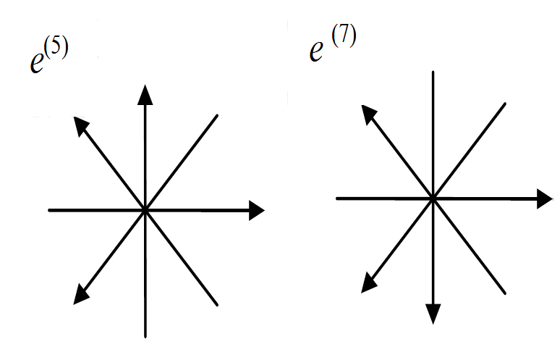

а) {*+ + + +*} b) {*+ + + –*}

**Fig.** **10.1.** Two 4-bases with

different stignatures

We define this 4-vector space

*d***s**(7) *=* **e***i*(7)*dxi*(7) = **e**0(7)*dx*0(7)+ **e**1(7)*dx*1(7)+ **e**2(7)*dx*2(7)+ **e**3(7)*dx*3(7),

(10.1)

where *dxi*(7) is the *i*-th projection of the 4-vector *d***s**(7) onto the axis *xi*(7), the direction of which is determined by the basis vector **e***i*(7).

Consider another 4-vector

*d***s**(5) *=* **e***i*(5)*dxi*(5)= **e**0(5)*dx*0(5)+ **e**1(5)*dx*1(5)+ **e**2(5)*dx*2(5)+ **e**3(5)*dx*3(5), (10.2)

defined in an affine coordinate system *x*0(5), *x*1(5), *x*2(5), *x*3(5)  with the 4-basis **e***i*(5) (**e**0(5), **e**1(5), **e**2(5), **e**3(5)) (Figure 6.3), with stignature {*+ + + +*}. We find the inner product of 4-vectors (10.1) and (10.2)

*ds*(5,7) 2  = *d***s**(5)*d***s**(7) *=* **e***i*(5)**e***j*(7)*dxi**dxj*=

*=***e**0(5)**e**0(7)*dx*0*dx*0+**e**1(5)**e**0(7)*dx*1*dx*0+**e**2(5)**e**0(7)*dx*2*dx*0+**e**3(5)**e**0(7)*dx*3*dx*0+

*+* **e**0(5)**e**1(7)*dx*0*dx*1+**e**1(5)**e**1(7)*dx*1*dx*1+**e**2(5)**e**1(7)*dx*2*dx*1+**e**3(5)**e**1(7)*dx*3*dx*1+

*+***e**0(5)**e**2(7)*dx*0*dx*2+**e**1(5)**e**2(7)*dx*1*dx*2+**e**2(5)**e**2(7)*dx*2*dx*2+**e**3(5)**e**2(7)*dx*3*dx*2+(10.3)

*+***e**0(5)**e**3(7)*dx*0*dx*3+**e**1(5)**e**3(7)*dx*1*dx*3+**e**2(5)**e**3(7)*dx*2*dx*3+**e**3(5)**e**3(7)*dx*3*dx*3.

For this case, the inner products of the basis vectors **e***i*(5)**e***j*(7) are:

when *i* = *j,* ***e***0(5)***e***0(7) = 1, ***e*** 1(5) ***e***1(7) = 1, **e**2(5) **e**2(7) = 1, **e**3(5)**e**3(7) = 1; if *i* ≠ *j* then**e***i*(5)**e***j*(7) = 0.

The expression (10.3) then appears as a quadratic form

*ds*(5,7)2 = *dx*0*dx*0+ *dx*1*dx*1+ *dx*2*dx*2– *dx*3*dx*3= *dx*02 + *dx*12 + *dx*22 – *dx*32 (10.4)

with signature (+ + + ).

**Definition 10.1** *A “signature” is an ordered set of signs of the corresponding coefficients of an associated quadratic form.*

To determine the signature of a metric space with the metric (10.4), instead of performing a inner product of vectors (10.3) of a stignature of 4-bases, it is possible to multiply the vectors from Figure 10.1, as follows:

{*+ + + +*}

{*+ + + –*} (10.5)

(*+ + + –*)×

where the multiplication sign is produced by the following rules. The “numerators” (i.e., above the line) of (10.5) are multiplied by the signs located in a single column, and the result of this multiplication is written in the “denominator” (below the line) of the same column. The multiplication of signs obeys the following arithmetic rules:

{+} × {+} = {+}; {–} × {+} = {–}; (10.6)

I {+} × {–} = {–}; {–} × {–} = {+},

for “vacuum”

{+} × {+} = {+}; {–} × {+} = {–}; (10.7)

H {+} × {–} = {+}; {–} × {–} = {–},

for non-commutative “vacuum”

{+} × {+} = {–}; {–} × {+} = {–}; (10.8)

V {+} × {–} = {+}; {–} × {–} = {+},

for non-commutative “anti-vacuum”

{+} × {+} = {–}; {–} × {+} = {+}; (10.9)

H′ {+} × {–} = {+}; {–} × {–} = {–}.

for “anti-vacuum”

In this work, generally only multiplication signs will be used (10.6) for a “vacuum”. However, it should be remembered that a more coherent theory would contain all four possible types of “vacuum” with the multiplication rules (10.6) to (10.9) and four possible factorials of zero: 0! = 1, 0! = 1, 0! = *i*, 0! =  *i*, such that

1/4(0! + 0! + 0! + 0!) = (1–1) + *i*(1–1) =0 + *i*0 = Ѳ – the complex conjugate true zero

0! 0! 0! 0! = 0!4 = 1·(–1)·*i*·(–*i*) =– 1. (10.10)

Since the arithmetic in (10.5) are carried out in columns (and/or ranks), similar expressions will be called  *ranked* (*“rank”* in the sense of order in a system).

Ranking of division of stignatures in a “vacuum” obey the multiplication rules (10.6) determined by the following arithmetic rules:

{+} : {+} = {+}; {–}: {+} = {–};

{+} : {–} = {–}; {–}: {–} = {+}. (10.11)

In this case, with the designated stignature ranks, the results would follow similarly to the above

{*– + – +*}

{*+ + + –*}

(*– + – –*): (10.12)

whereby here “ranked” means division by the rules (10.11).

**Definition 10.2** *“Ranking”* *denotes* *an expression that defines the arithmetic operation with stignatures of affine (linear) forms or with signatures of quadratic forms. The signs in the denominator after the brackets are ordered (...)*+/× *indicating what operation is performed with the characters in ordered columns and /or rows: (...)+ indicates addition, (...)  indicates subtraction (...): indicates division and (...)× indicates multiplication.*

The set (8.2) of stignatures whose elements are

** (10.13)

forms two separate Abelian groups, one over ranked multiplication operation, and one over the ranked division operation. This indicates the presence of underlying symmetries in the foundations of the light-geometry developed here.

Proceeding in a manner analogous to the treatment of the vectors *d****s***(5) and *d****s***(7) (10.3)*,* using scalar product pairwise among vectors from all 16 affine 4-spaces with the bases as shown in Figure 6.3, we get 16 × 16 = 256 metric 4-subspaces

*ds*(*аb*)2 = **e***i*(*а*)**e***j*(*b*)*dxi*(*а*)*dxj*(*b*),(10.14)

where *a* = 1,2,3, ... , 16; *b* = 1,2,3, ... , 16.

Signatures of 16 × 16 = 256 metric 4-subspaces can be determined, similarly to (10.8), by respective multiplications of ranked stignature bases:

|  |  |  |  |
| --- | --- | --- | --- |
| {+ – + +} {+ + + –}  (+ – + *–*)× | {+ + + +} {+ – + –}  (+ – + –)× | {– + + +} {+ + + –}  (– + + –)× | {+ + + +} {– + + –}  (– + + –)× |
| {+ – – +} {+ + + –}  (+ – – –)× | {+ + – +} {– + + –}  (– + – –)× | {– + + +} {– + + –}  (+ + + –)× | {+ – + –} {+ – + –}  (+ + + +)× |
| {+ – – –} {+ + + –}  (+ – – +)× | {+ + – +} {– + – –}  (– + + –)× | {– + – +} {– – + –}  (+ – – –)× | {+ – + +} {+ – + –}  (+ + + –)× |
| … | … | … | … |
| {+ + + –} {– – + –}  (– – + +)× | {– + – –} {+ – + –}  (– – – +)× | {– + + –} {+ – + –}  (– – + –)× | {+ – – +} {– + + –}  (– – – –)× |

(10.15)

Point *O* (Figure 6.1) belongs simultaneously to all of these 256 metric 4-subspace signatures (10.15), so it is a place where they intersect. It will be shown that the metric 4-subspaces have various topologies.

A set of 256 metric 4-subspaces (4-cards) forms a single “atlas” with intersection at point *O*, and the total number of mathematical dimensions is 256 × 4 = 1024.

The mathematical apparatus of the Algebra of Signatures developed here can be classified as a multi-dimensional theory. But light-geometry can be constructed in such a way that all the extra (auxiliary) mathematical measurements are reduced to three physical measurements of the “vacuum” and one temporal dimension, whereby the temporal dimension is associated with an observer.

The Algebra of Signatures (AS) is suitable for this, largely coinciding with the local (tetrad) formalism made reference to earlier, developed by E. Cartan, R. Vaytsenbek, T. Levy-Chivita, G. Shipov [15] and is often used in the framework of Einstein’s differential geometry theory of “absolute parallelism” [16, 18].

The difference between AS and the tetrad method in general relativity (GR) is that at each point of the 3-dimensional manifold (the “vacuum”), not just *two* systems of four reference points (tetrads) and one metric *ds*(*аb*)2 = ***e****i*(*а*)***e****j*(*b*) *dxi*(*а*)*dxj*(*b*) with the signature (*+  * ) or with the signature ( + + +) is given, but rather sixteen 4-bases (or 4-frames, or *tetrads*) (Figure 6.3), whose scalar products form 256 metrics (10.14) with the signatures (10.15).

**11. The first step of compactification**

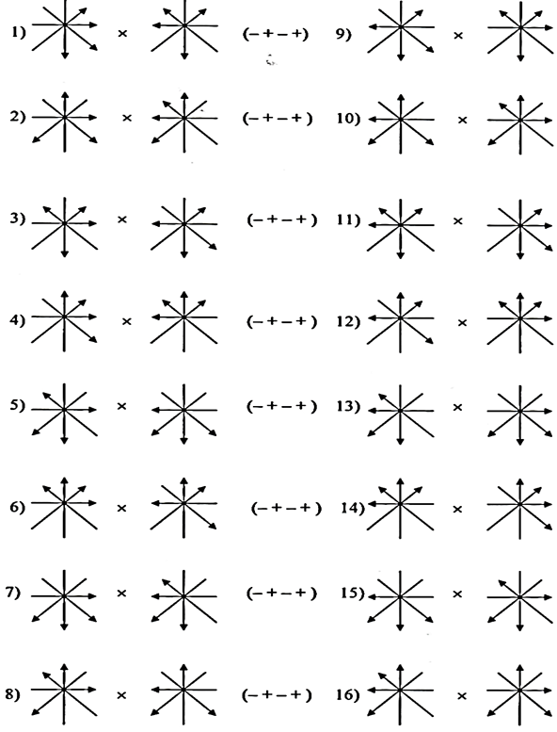

**Fig.** **11.1.** Sixteen scalar products of 4-bases leading to metrics with the same signature ( +  +)

**of additional measurements**

One of the main problems of any multi-dimensional theory is compactification (aka Folding) of additional mathematical measurements to the observed three spatial and one temporal dimensions. The Algebra of Signatures faces a similar problem.

Note that the 16 types of scalar products of 4-bases, as shown, for example, in Figure 11.1, result in sixteen quadratic forms (metrics) (see also 10.14) with the same signature ( +  +).

After averaging metrics with identical signatures out of 256 subspaces, we end up with only 256/16 = 16 types of 4-space with the metrics:

|  |  |
| --- | --- |
| *d* сигнатурами.ких протяженностей с различными сигнатурами.*s*(+ + + +)2 =*dx*02 + *dx*12 + *dx*22 + *dx*32= 0  *ds*(– – – +)2 = – *dx*02 – *dx*12 – *dx*22 + *dx*32 = 0  *ds*(+ – – +)2 = *dx*02 – *dx*12 – *dx*22 + *dx*32 = 0  *ds*(+– – –)2 = *dx*02 – *dx*12 – *dx*22 – *dx*32 = 0  *ds*(– – + –)2 = – *dx*02 – *dx*12 + *dx*22 – *dx*32= 0  *ds*(– + – –)2 = – *dx*02 + *dx*12 – *dx*22 – *dx*32 = 0  *ds*(+ – + –)2 = *dx*02 – *dx*12 + *dx*22 – *dx*32 = 0  *ds*(+ + – –)2 = *dx*02 + *dx*12 – *dx*22 – *dx*32 = 0 | *ds*(– – – – )2 = – *dx*02 – *dx*12 – *dx*22 – *dx*32 = 0  *ds*(+ + + –)2 =*dx*02 + *dx*12 + *dx*22 – *dx*32 = 0  *ds* (– + + –)2 = – *dx*02 + *dx*12 + *dx*22 – *dx*32 = 0  *ds*(– + + +)2 =– *dx*02 +*d x*12 + *dx*22 + *dx*32 = 0  *ds*(+ + – +)2 = *dx*02 + *dx*12 – *dx*22 + *dx*32 = 0  *ds*(+ – + +)2 = *dx*02 – *dx*12+ *dx*22 + *dx*32 = 0  *ds*(– + – +)2 = – *dx*02 + *dx*12 – *dx*22 + *dx*32 = 0  *ds*(– – + +)2 =– *dx*02 – *dx*12 + *dx*22 + *dx*32 = 0 |

(11.1)

with the corresponding signatures



As a result of this averaging, we need only 4 × 16 = 64 mathematical measurements. By classifying metric spaces with the metric (11.1) from Felix Klein [8], these can be divided into three topological classes:

**Level 1:** 4-space, whose signatures are composed of four identical characters [8]:

*x*02  + *x*12 +*x*22 +*x*32 = 0 (+ + + +) (11.2)

– *x*02 – *x*12 – *x*22 – *x*32 = 0 (*–* *–* *–* *–*)

forming a so-called zero-metric 4-space. In these spaces, there is only one valid point, located at the beginning of the light cone. All other terms describing these spaces are imaginary. In fact, the first of expressions (11.2) does not describe a length, but rather a single point (a “dot”), and the second describes an antidot.

**Level 2:** 4-space, whose signatures are composed of two positive and two negative signs [8]:

*x*02 – *x*12 – *x*22 + *x*32 = 0 (+ *–* *–* +)

*x*02 + *x*12 – *x*22 – *x*32 = 0 (+ + *–* *–*)

*x*02 – *x*12 + *x*22 – *x*32 = 0 (+ *–* + *–*)

– *x*02 + *x*12 + *x*22 – *x*32 = 0 (*–* + + *–*)

– *x*02 – *x*12 +*x*22 + *x*32 = 0 (*–* *–* + +)

– *x*02 + *x*12 – *x*22 + *x*32 = 0 (*–* + *–* +) (11.3)

which represents a variety of options for 3-dimensional tori.

**Level 3:** 4-space, the signature of which consist of three identical signs and the opposite one:

– *x*02  –*x*12 – *x*22 + *x*32 = 0 (*–* *–* *–* +)

– *x*02 – *x*12 + *x*22 – *x*32 = 0 (*–* *–* + *–*)

– *x*02 + *x*12 – *x*22 – *x*32 = 0 (*–* + *–* *–*)

*x*02 – *x*12 – *x*22 – *x*32 = 0 (+ *–* *–* *–*)

*x*02 + *x*12 + *x*22 – *x*32 = 0 (+ + + *–*)

*x*02 + *x*12 – *x*22 + *x*32 = 0 (+ + *–* +)

*x*02 – *x*12 + *x*22 + *x*32 = 0 (+ *–* + +)

– *x*02 + *x*12 + *x*22 + *x*32 = 0 (*–* + + +) (11.4)

rendering 3-dimensional oval surfaces: ellipsoids, elliptic paraboloid, hyperboloids of two sheets.

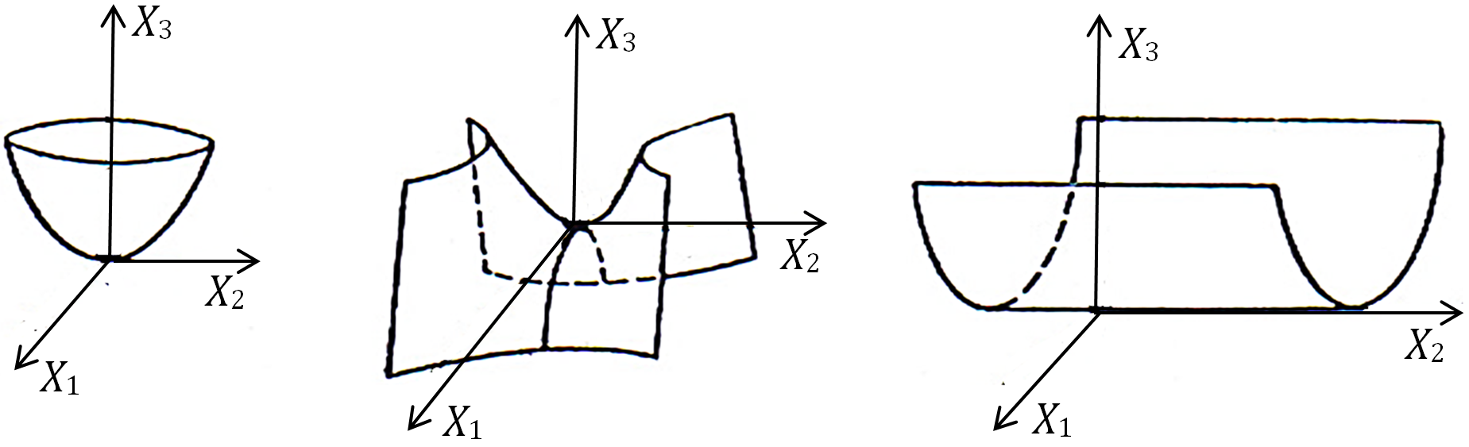

a) sign (+ +);b) sign (**–** +); c) sign (+ 0)

*x*3 = *x*12 + *x*22*x*3 = *x*22 **–** *x*12*x*3 = *x*12

parabolic saddle U-shaped

surface surface surface

**Fig.** **11.2.** Illustration of the connection between the signature of a 2-dimensional space and its topology [8]

A simplified illustration of signatures of 2-dimensional space with the corresponding topologies is shown in Figure 11.2. From this figure it can be seen that the signature of the quadratic form is uniquely related to the topology described by its 2-dimensional representation.

Sixteen types of signatures (11.2) to (11.4) corresponding to the 16 types of metric space topologies form an matrix

 (11.5)

properties of which coincide with the properties of the matrix stignature (8.2).

**Definition 11.1** *The* ***“****Chess analogy” refers to the similarity between the Algebra of Signatures (AS) with the world of chess.*

*On a checkerboard there are 8× 8 cells = 64: 32 white and 32 black. Also in the matrix signatures (11.5) there are 64 characters, 32 of them plus “+” and 32 minus “”.*

*At the beginning of the game on a chess board there are 32 chess pieces present: 16 white and 16 black. Also within the Algebra of Signatures at each point mn-vacuum there are sixteen 4-bases, which consist of rotating electric field vectors (Figure 6.6), i.e. “light figures”, and sixteen 4-bases associated with the corners of the cubic cell of a 3-D landscape (Figure 6.2), i.e. “darkness figures”.*

*In addition, the signature (topology) of 16 types of metric spaces (11.2) to (11.4) is similar to that of chess pieces (Figure 11.3.):*

*– zero to two topologies (11.2) correspond to the “king” and “queen”;*

*– six toroidal topologies (11.3) correspond to the three pairs of chess*

*figures: 2 “bishops”, 2 “knights” and 2 “rooks”;*

*– eight oval topologies (11.4) correspond to the eight “pawns”.*

|  |  |  |  |  |  |  |  |
| --- | --- | --- | --- | --- | --- | --- | --- |
| (+ *–* + +)  pawn | (*–* *–* *–* +)  pawn | (+ + *–* +)  pawn | (+ *–* *–* *–*)  pawn | (+ + + *–*)  pawn | (*–* + + +)  pawn | (*–* *–* + *–*)  pawn | (*–* + *–* *–*) pawn |
| (*–* *–* + +) rook | (+ *–* + *–*) bishop | (*–* + + *–*) knight | (+ + + +) queen | (*–* *–* *–* *–*) king | (+ *–* *–* +) knight | (*–* + *–* +)  bishop | (+ + *–* *–*) rook |

***Fig.******11.3.*** *Comparison of signatures (topologies) of metric spaces with chess pieces*

We should note that by addition (and subtraction) of signs, according to the rules:

|  |  |
| --- | --- |
| {+} + {+} = {+}; {–} + {+} = {0};  {+} + {–} = {0}; {–} + {–} = {–}, | {+} – {+} = {0}; {–} – {+} = {0};  {+} – {–} = {+}; {–} – {–} = {0}, |

signatures (11.5) are a part of a wider group, consisting of 16+64+1=81 signatures:

|  |  |  |  |  |  |  |  |
| --- | --- | --- | --- | --- | --- | --- | --- |
| (+ + + +)  (+ + + 0)  (+ + 0 0)  (+ 0 0 0)  (0 0 0 0) | (0 + + +)  (0 0 + +)  (0 0 0 +)  (+ 0 + +)  (+ + 0 +) | (+ + + 0)  (+ 0 + 0)  (0 + 0 +)  (+ 0 0 +)  (0 + + 0) | (*– –* *–* *–*)  (*– –* *–* 0)  (*– –* 0 0)  (*–* 0 0 0)  (0 0 0 0) | (0 *–* *–* *–*)  (0 0 *–* *–*)  (0 0 0 *–*)  (*–* 0 *–* *–*)  (*– –* 0 *–*) | (*– – –* 0)  (*–* 0 *–* 0)  (0 *–* 0 *–*)  (*–* 0 0 *–*)  (0 *–* *–* 0) | …  … … …  … | (*– + –* 0)  (*–* 0 *+* 0) (11.6)  (0 *+* 0 *–*)  (*–* 0 0 *+*)  (0 *–* *+* 0) |

among them 16 signatures without zero, 64 signatures with zero and one zero signature (0000).

The signature implicitly takes part in the operations which are carried out with the help of the antisymmetric unit tensor (using the Levi-Civita symbol) $ε_{123…n}$ in *n*-dimensional space, defined as

$ε_{123…n}=\left\{\begin{aligned}+1 if even permutation of 1,2,3,…,n; \\ -1 if odd permutation of 1,2,3,…,n; \\ 0 if any index is repeated . \\ \end{aligned}\right.$ (11.7)

For a tensor $ε_{123…n}$ the following identity is valid, with indirect participation of a signature:

$ε_{123…n}ε^{123…n}={\left(-1\right)}^{S}\left|\begin{matrix}\begin{matrix}δ_{1}^{1} & δ_{1}^{2}\end{matrix} & ⋯ & δ_{1}^{n} \\ \begin{matrix}δ_{2}^{1} & δ_{2}^{2}\end{matrix} & ⋯ & δ_{2}^{n} \\ \begin{matrix}\begin{matrix}δ_{3}^{1} \\ \begin{matrix}⋮ \\ δ_{n}^{1}\end{matrix}\end{matrix} & \begin{matrix}δ_{3}^{2} \\ \begin{matrix}⋮ \\ δ_{n}^{2}\end{matrix}\end{matrix}\end{matrix} & \begin{matrix}⋯ \\ \begin{matrix}⋱ \\ ⋯\end{matrix}\end{matrix} & \begin{matrix}δ_{3}^{n} \\ \begin{matrix}⋮ \\ δ_{n}^{n}\end{matrix}\end{matrix}\end{matrix}\right|$, (11.8)

where *S* is the number of negative signs in the signature of the metric of the space in question.

**Definition 11.2** *The**Algebra of Signatures (AS) is an axiomatic system of arithmetic and algebraic operations as part of a complete set of stignatures of affine spaces and signatures of metric spaces. The Algebra of Stignatures is equipped with the basic operation(s) of multiplication (division) and the Algebra of Signatures is equipped with the basic operation(s) of addition (subtraction) of signatures.*

**12. The second step of the compactification of extra dimensions.**

**“Vacuum balance” and “vacuum condition”**

In the second stage for compactification of additional measurements, we define 16 additive superposition metrics (11.1)

*ds*Σ2 *= ds*(+ – – –)2 + *ds*(+ + + +)2 +  *ds*(– – – +)2  + *ds*(+ – – +)2  +

+ *ds*(– – + –)2 + *ds*(+ + – –)2 + *ds*(– + – –)2 + *ds*(+ – + –)2 +

+ *ds*(– + + +)2 +*ds*(– – – – )2 + *ds*(+ + + –)2 + *ds* (– + + –)2 +

+ *ds*(+ + – +)2 +*ds*(– – + +)2 + *ds*(+ – + +)2  + *ds*(– + – +)2 = 0. (12.1)

Indeed, adding the metric (11.1), we obtain

*ds*Σ2 = ( *dx*0*dx*0– *dx*1*dx*1– *dx*2*dx*2– *dx*3*dx*3) + (*dx*0*dx*0+ *dx*1*dx*1+ *dx*2*dx*2+ *dx*3*dx*3) +

+ (– *dx*0*dx*0– *dx*1*dx*1+ *dx*2*dx*2– *dx*3*dx*3) + (*dx*0*dx*0– *dx*1*dx*1– *dx*2*dx*2+*dx*3*d*D*x*3) +

+ (– *dx*0*dx*0– *dx*1*dx*1+ *dx*2*dx*2– *dx*3*dx*3) + (*dx*0*dx*0+ *dx*1*dx*1– *dx*2*dx*2– *dx*3*dx*3) +

+ (– *dx*0*dx*0+ *dx*1*dx*1– *dx*2*dx*2– *dx*3*dx*3) + (*dx*0*dx*0– *dx*1*dx*1+ *dx*2*dx*2– *dx*3*dx*3) +

+ (– *dx*0*dx*0+ *dx*1*dx*1+ *dx*2*dx*2+*dx*3*dx*3) + (– *dx*0*dx*0–*dx*1*dx*1– *dx*2*dx*2–*dx*3*dx*3) +

+ (*dx*0*dx*0+ *dx*1*dx*1+ *dx*2*dx*2– *dx*3*dx*3) + (– *dx*0*dx*0+*dx*1*dx*1+*dx*2*dx*2– *dx*3*dx*3) +

+ (*dx*0*dx*0+ *dx*1*dx*1– *dx*2*dx*2+ *dx*3*dx*3) + (– *dx*0*dx*0– *dx*1*dx*1+ *dx*2*dx*2+*dx*3*dx*3) +

+ (*dx*0*dx*0– *dx*1*dx*1+ *dx*2*dx*2+ *dx*3*dx*3) + (– *dx*0*dx*0+ *dx*1*dx*1– *dx*2*dx*2+ *dx*3*dx*3) = 0. (12.2)

Instead of summing homogeneous terms in the expression (12.2), we can only sum up the signs facing these terms. Therefore, for brevity the expression (12.2) can be represented in an equivalent ranked form:

|  |  |  |  |  |
| --- | --- | --- | --- | --- |
| 0 =  0 =  0 =  0 =  0 =  0 =  0 =  0 =  0 =  0 = | ( 0 0 0 0)  (+ + + +)  (– – – + )  (+ – – + )  (– – + – )  (+ + – – )  (– + – – )  (+ – + – )  (– + + +)  (0 0 0 0) + | +  +  +  +  +  +  +  +  +  + | (0 0 0 0)  (– – – – )  (+ + + – )  (– + + – )  (+ + – +)  (– – + +)  (+ – + +)  (– + – +)  (+ – – –)  (0 0 0 0) + | = 0  = 0  = 0  = 0  = 0  = 0  = 0  = 0  = 0  = 0 . |

(12.3)

Adding signs as ranked by columns (12.3) and as they are ranked between rows, result in zero.

The ranked identity (12.3) is called transversely “split-zero”, the position in the base geometrophysics *mn-*vacuum.

Each point in the “vacuum” has an infinite number of transverse “split-zeros”, each corresponding to a *mn-*vacuum (Figure 12.1).

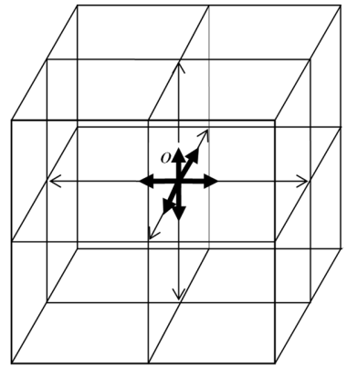

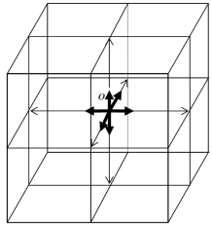

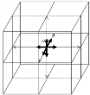

**Fig.** **12.1.** At each point *O* of the "vacuum" there are an infinite number of transversely

"split zeros" of each *mn-*vacuum (longitudinal 3-dimensional layer)

**Definition 12.1** *A transverse “split-zero” is defined at every point of the mn-vacuum ranked expression (12.3).*

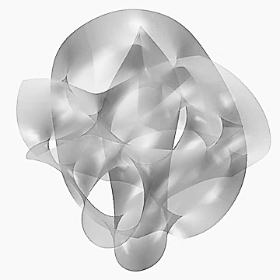

**Fig.** **12.2.** One of the realizations of a 2- dimensional projection of a three - dimensional visualization of a local section of a 10 - dimensional Calabi - Yau manifold [6]

**Definition 12.2** *A longitudinal “split-zero” is defined at every point of a “vacuum” as a complete set of transverse “split-zeros” of all mn-vacuums (Figure 12.1).*

Addition (averaging) metric spaces with sixteen different signatures (topologies) (12.1) leads to Ricci flat space, and is very similar to the 10 - dimensional Calabi-Yau space (Figure 12.2) which is used in string theory.

The second additional step for compactification of (mathematical) measurements leads to their complete reduction. On the other hand, the ranked expression (12.3) is a mathematical formulation of the “vacuum balance”.

**Definition 12.3** *A**“mn-vacuum balance” (or “vacuum balance”) refers to the statement that each point in a mn-vacuum (“vacuum”) is balanced with respect to the “split-zero” form (12.3). That is, at each point in a mn-vacuum (“vacuum”), there is a longitudinally and transversely designated “split- zero”, any deviation from which is associated with the occurrence of mutually opposite manifestations.*

One of the basic axioms of the Algebras of Signatures is the assertion that no action in a *mn-*vacuum can lead to the disruption of the global “*mn-*vacuum balance” (12.3). Therefore “*mn-*vacuum balance” is the basis of “*mn-*vacuum conditions.”

**Definition 12.4** *A**“λmn-vacuum condition” (or “vacuum condition”) is any manifestation in a mn-vacuum (“vacuum”) with mutually opposite characters: wave - anti-wave, convexity - concavity, movement - anti-movement, compression - tension, etc. Local mn-vacuum (“vacuum”) entity and anti-entity quantities can be shifted and rotated relative to each other, but on the average across the λmn-vacuum region they completely compensate for each other's existence, restoring “λmn-vacuum balance“(“vacuum balance“).*

A “vacuum” can be defined on the basis of *“*vacuum conditions*”*.

**Definition 12.5** *A “vacuum” is a complete invariant for all types of spatial and spatio-temporal transformations. That is, what would be mutually-conflicting changes do not occur in a “vacuum”; the average always remains the same.*

The ranked expression (12.3) allows one to applying some operations to a balanced void in a neighborhood around point *O* without breaking the *“*vacuum balance*”*. Such operations include, for example, the symmetric transfer of first columns with inverted signs:

|  |  |  |  |  |
| --- | --- | --- | --- | --- |
| 0 =  – =  + =  – =  + =  – =  + =  – =  + =  0 = | (0 0 0)  ( + + + )  ( – – + )  ( – – + )  ( – + – )  ( + – – )  ( + – – )  ( – + – )  ( + + +)  (0 0 0 ) + | +  +  +  +  +  +  +  +  +  + | (0 0 0)  (– – – )  (+ + – )  (+ + –)  (+ – +)  (– + +)  (– + +)  (+ – +)  (– – – )  (0 0 0)+ | = 0  = +  = –  = +  = –  = +  = –  = +  = –  = 0 |

(12.4)

or the transfer of any of the rows of the numerators, ranked (12.3) in their denominator by inverted signs, for example:

|  |  |  |  |  |
| --- | --- | --- | --- | --- |
| 0 =  0 =  0 =  0 =  0 =  0 =  0 =  0 =  0 = | (0 0 0 0 )  (+ + + + )  (– – – + )  (+ – – + )  (+ + – – )  (– + – – )  (+ – + – )  (– + + +)  (+ + – +)+ | +  +  +  +  +  +  +  +  + | (0 0 0 0)  (– – – – )  (+ + + – )  (– + + – )  (– – + +)  (+ – + +)  (– + – +)  (+ – – –)  (– – + –)+ | = 0  = 0  = 0  = 0  = 0  = 0  = 0  = 0  = 0 |

(12.5)

**13. Dual *mn-*vacuum regions**

The vacuum balanceis not disturbed when one uses the ranks in (12.3) to translate one line from the numerator to the denominator, with the change of signs on the opposite of the rules of arithmetic. For example, the transfer of the ranked signatures ( + + +) and     of the numerators from the ranks in (12.3) to the denominator.

|  |  |  |  |
| --- | --- | --- | --- |
| (+ + + +)  (– – – + )  (+ – – + )  (– – + – )  (+ + – – )  (– + – – )  (+ – + – )  (+ – – – )+ | +  +  +  +  +  +  +  + | (– – – – )  (+ + + – )  (– + + – )  (+ + – +)  (– – + +)  (+ – + +)  (– + – +)  (– + + +)+ | =0  =0  =0  =0  =0  =0  =0  =0 . |

(13.1)

In this case, the signature (+ – – –) of the Minkowski space with the metric (7.3) was obtained in the denominator of the left rank of (13.1)

*ds*   2 = *c*2*dt*2  *dx*2  *dy*2  *dz*2 = *dx*02  *dx*12  *dx*22  *dx*32 = 0 (13.2)

and the denominator of the right ranks with the inverted signature ( + + +) for the Minkowski anti-space from the metric (7.4)

*ds*(– + + +)2 = – *c*2*dt*2 + *dx*2 + *dy*2 + *dz*2 = – *dx*02 + *dx*12 + *dx*22 + *dx*32 = 0. (13.3)

Thus, by addition (or arithmetic average), seven metrics with signatures in the numerator from the left ranks (13.1) can be as defined (7.2) to identify the “outer” side of a 23*-mn-*vacuum region with signature (+   ), or “subcont”; by adding (or arithmetic averaging of) seven metrics with signatures in the numerator of the right ranks (13.1), one can identify the “inner” side of a 23*-mn-*vacuum region with the signature ( + + +), or “antisubcont”.

Thus it is possible to reduce the number of measurements considered to 4 + 4 = 8, and retain the vacuum balance

*ds*(+ – – –)2 + *ds*(– + + +)2 = 0 or (+ – – –) + (– + + +) = (0 0 0 0). (13.4)

As shown in Section 7, the result can be interpreted as the presence in a 23*-mn-*vacuum for two mutually opposite 4-D sides:

– the “outer side” with metric *ds*   2, designated by the term “subcont” (Defn 7.4.);

– the “inner side” with the conjugate metric *ds*( + + +)2, designated “antisubcont” (Def. 7.5).

In any light-geometric problem it should be borne in mind that a *mn-*vacuum region is the result of additive superposition (averaging) at least sixteen 4-dimensional regions with metrics (11.1) and signatures (topologies) (11.5). That is, the number of mathematical measurements should be at least 4 × 16 = 64. However, a number of problems of the “vacuum” model can be reduced to a two-way consideration with 4 + 4 = 8*-*dimensional *λmn-*vacuum region.

The transition from 64 (or 8) to the mathematical measurements 3 physical measurements of the “vacuum” and one temporal dimension of the “observer” will be considered below.

A side consideration is that a 4-D *λmn-*vacuum region in the Algebra of Signatures (AS) is prohibited by the “vacuum condition.” This significantly distinguishes AS from Einstein’s General Relativity.

Thus, it ends up that the Minkowski space with signature     can be represented as a sum (i.e., the additive superposition or averaging) of the 7-metrics of regions for which the signatures of the numerator are ranked left (13.1)

*ds* (+ – – –)2 = *ds*(+ + + +)2 + *ds*(– – – +)2 + *ds*(+ – – +)2 + *ds*(– – + –)2 +

+ *ds*(+ + – –)2 + *ds* (– + – –)2 + *ds*(+ – + –)2, (13.5)

and a Minkowski antispace with signature ( + + +) can be represented as a sum (or averaging) of metric 7-spaces for which the signatures are ranked from the numerator of the right (13.1)

*ds*(– + + +)2 = *ds*(– – – – )2 + *ds*(+ + + –)2 + *ds*(– + + –)2 + *ds*(+ + – +)2 +

+ *ds*(– – + +)2 + *ds*(+ – + +)2 + *ds*(– + – +)2. (13.6)

In expanded form the total metric (13.5) and (13.6) takes the form of corresponding ranks (13.1)

|  |  |
| --- | --- |
| *d* сигнатурами.ких протяженностей с различными сигнатурами.*s*(+ + + +)2 =*dx*02 + *dx*12 + *dx*22 + *dx*32  *ds*(– – – +)2 = – *dx*02 – *dx*12 – *dx*22 + *dx*32  *ds*(+ – – +)2 = *dx*02 – *dx*12 – *dx*22 + *dx*32  *ds*(– – + –)2 = – *dx*02 – *dx*12 + *dx*22 – *dx*32  *ds*(– + – –)2 = – *dx*02 + *dx*12 – *dx*22 – *dx*32  *ds*(+ – + –)2 = *dx*02 – *dx*12 + *dx*22 – *dx*32  *ds*(+ + – –)2 = *dx*02 + *dx*12 – *dx*22 – *dx*32  *ds*(+– – –)2 = *dx*02 – *dx*12 – *dx*22 – *dx*32 | *ds*(– – – – )2 = – *dx*02 – *dx*12 – *dx*22 – *dx*32  *ds*(+ + + –)2 =*dx*02 + *dx*12 + *dx*22 – *dx*32  *ds* (– + + –)2 = – *dx*02 + *dx*12 + *dx*22 – *dx*32  *ds*(+ + – +)2 = *dx*02 + *dx*12 – *dx*22 + *dx*32  *ds*(+ – + +)2 = *dx*02 – *dx*12+ *dx*22 + *dx*32  *ds*(– + – +)2 = – *dx*02 + *dx*12 – *dx*22 + *dx*32  *ds*(– – + +)2 =– *dx*02 – *dx*12 + *dx*22 + *dx*32  *ds*(– + + +)2 =– *dx*02 +*d x*12 + *dx*22 + *dx*32 |

(13.7)

**14. Metrics with respect to spin-tensors**

We return to our consideration of the metric (7.3). For brevity, we omit in this metric differential signs

*s*2 = *x*02 – *x*12 – *x*22 – *x*32. (14.1)

As is known, the quadratic form (14.1) is the determinant of the Hermitian 2 × 2 matrix

 (14.2)

In the theory of spinors, matrices of the form (14.2) are called mixed second-order Hermitian spin tensors [7, 12].

We represent a 2 × 2 matrix (spin tensor) (14.2) in the unfolded state, where

 (14.3) where



is constructed out of a set of Pauli matrices.

In the theory of spinors an *A*4-matrix (14.3) is placed in one-to-one correspondence with quaternion

 (14.4)

under the isomorphism

 (14.5)

Similarly, each quadratic form: (14.6)

|  |  |
| --- | --- |
| *s*(+ + + +)2 = *x*02 + *x*12 + *x*22 + *x*32  *s*(– – – +)2 = – *x*02 – *x*12 – *x*22 + *x*32  *s*(+ – – +)2 = *x*02 – *x*12 – *x*22 + *x*32  *s*(+– – –)2 = *x*02 – *x*12 – *x*22 – *x*32  *s*(– – + –)2 = – *x*02 – *x*12 + *x*22 – *x*32  *s*(– + – –)2 = – *x*02 + *x*12 – *x*22 – *x*32  *s*(+ – + –)2 = *x*02 – *x*12 + *x*22 – *x*32  *s*(+ + – –)2 = *x*02 + *x*12 – *x*22 – *x*32 | *s*(– – – – )2 = – *x*02 – *x*12 – *x*22 – *x*32  *s*(+ + + –)2 = *x*02 + *x*12 + *x*22 – *x*32  *s*(– + + –)2 = – *x*02 + *x*12 + *x*22 – *x*32  *s*(– + + +)2 = – *x*02 + *x*12 + *x*22+ *x*32  *s*(+ + – +)2 = *x*02 + *x*12 – *x*22 + *x*32  *s*(+ – + +)2 = *x*02 – *x*12+ *x*22 + *x*32  *s*(– + – +)2 = – *x*02 + *x*12 – *x*22 + *x*32  *s*(– – + +)2 = – *x*02 – *x*12 + *x*22 + *x*32 |

can be represented as spin tensors or as an *A*4-matrix:

Table 14.1

|  |  |
| --- | --- |
| 1 |  |
| 2 |  |
| 3 |  |
| 4 |  |
| 5 |  |
| 6 |  |
| 7 |  |
| 8 |  |
| 9 |  |
| 10 |  |
| 11 |  |
| 12 |  |
| 13 |  |
| 14 |  |
| 15 |  |
| 16 |  |

Each *A*4*-*matrix of Table. 14.1 is assigned a “color” quaternion of type (8.17), where the imaginary units are used as objects

 (14.7)

which are the Pauli-Cayley spin matrices, which are generators of the Clifford algebra

** (14.8)

Table. 14.1 are only special cases of spin tensor representations of quadratic forms. For example, determinants of thirty five 2 × 2 matrix (Hermitian spin tensors):



(14.9)

are all equal to the same quadratic form  Likewise branch (degenerate) spin tensors represent all 16-quadratic forms, as listed in Table 14.1.

Future articles in this series of articles, together labeled “Alsigna”, will show that any discrete degeneracy (i.e., latent ambiguity or deviation) of the original ideal state of a *mn***-**vacuum from its initial state leads to cleavage (quantization) by a discrete set of disparate states across its transverse and longitudinal layers.

The sixteen types of *A*4**-**matrices are equivalent to 16 “color” quaternions (8.17). For clarity, all types of “color” designated by *A*4**-**matrices are summarized in Table 14.2.

Table 14.2

|  |  |  |
| --- | --- | --- |
| Metric | *А*4-matrix | Stignature |
| *x*02+*x*12+*x*22+ *x*32 |  | {+ + + +} |
| *x*02–*x*12–*x*22 + *x*32 |  | {+ – – +} |
| *x*02+*x*12+*x*22 –*x*32 |  | {+ + + –} |
| *x*02+*x*12–*x*22– *x*32 |  | {+ + – –} |
| –*x*02+*x*12+*x*22–*x*32 |  | {– + + –} |
| *x*02–*x*12–*x*22–*x*32 |  | {+ – – –} |
| *x*02+*x*12–*x*22 + *x*32 |  | {+ + – +} |
| *x*02–*x*12 +*x*22 +*x*32 |  | {+ – + +} |
| –*x*02–*x*12–*x*22+*x*32 |  | {– – – +} |
| –*x*02–*x*12+*x*22 –*x*32 |  | {– – + –} |
| –*x*02+*x*12+*x*22+*x*32 |  | {– + + +} |
| *x*02–*x*12+*x*22–*x*32 |  | {+ – + –} |
| *x*02 +*x*12–*x*22 + *x*32 |  | {– – + +} |
| *x*02 –*x*12+ *x*22 +*x*32 |  | {– + – +} |
| –*x*02+*x*12–*x*22+*x*32 |  | {– + – +} |
| –*x*02 –*x*12–*x*22–*x*32 |  | {– – – –} |

The Algebra of Signatures associates the superposition of affine regions balanced about zero with 16 types of stignatures:

*ds*Σ *=* (– *dx*0 *– dx*1 *– dx*2 *– dx*3) *+* ( *dx*0 *+ dx*1*+ dx*2 *+ dx*3) *+*

*+* (  *dx*0 *+ dx*1*+ dx*2 *– dx*3)  *+*  (– *dx*0 *– dx*1 *– dx*2 *+ dx*3) *+*

*+* (*– dx*0 *+ dx*1*+ dx*2 *– dx*3) *+* ( *dx*0 *– dx*1 *– dx*2 *+ dx*3) *+*

*+* (  *dx*0 *+ dx*1 *– dx*2 *+ dx*3) *+* (*– dx*0 *– dx*1*+ dx*2 *– dx*3) *+*

*+* (– *dx*0 *– dx*1*+ dx2 + dx*3) *+* (  *dx*0 *+ dx*1 *– dx*2 *– dx*3) *+*

*+* ( *dx*0 *– dx*1 *+ dx*2 *+ dx*3) *+* (– *dx*0 *+ dx*1 *– dx*2 *– dx*3) *+*

*+* ( *– dx*0*+ dx*1 *– dx*2*+ dx*3) *+* (  *dx*0 *– dx*1 *+ dx*2 *– dx*3) *+*

*+* (  *dx*0 *– dx*1 *– dx*2 *– dx*3)  *+*  (– *dx*0 *+ dx*1*+ dx*2 *+ dx*3) *=* 0, (14.10)

with one realization of the superposition of 16 *A*4**-**matrices:

 +

+ +

+  +

+  +

+  +

+  +

++

+  +

+ +

+ +

+ +

+ +

+ +

++

+ +

+ (14.11)

Expression (14.11) is equal to a 2 × 2 zero matrix, i.e. conforming to the principle of the “vacuum balance”.

We have here a spin tensor mathematical apparatus suitable for solving a number of problems associated with a multi-vacuum inside the rotational process.

Consider two examples using spin tensors.

**Example 14.1** *Suppose that a column matrix and its Hermitian conjugate matrix s form a string*

 *,* (14.12)

*that describe the state of the spinor.*

*A back projection of the coordinate axes for the case where a metric space has a signature*     *can be determined using spin tensors (14.3)*



(14.13)

**Example 14.2** *Let a forward wave be described by*

, (14.14)

*and its reverse wave*

 (14.15)

*where a+ and a are the forward and reverse wave amplitudes, resp. In general, the complex numbers:*

 (14.16)

*contain information about the phases of the waves φ+ and φ– .*

*Mutually opposing waves (14.14) and (14.15) can be represented as a two-component spinor:*

 (14.17)

*The corresponding Hermitian and its conjugate spinor*

. (14.18)

*Conditions of normalization in this case are expressed by the equation*

 (14.19)

*To find the spin projections (circular polarization) of the light beam on the coordinate axes, we use spin tensors*

 (14.20)

*which is associated with three-dimensional element length*

 (14.21)

*Putting x*1 = *x*2 = *x*3 = 1 *into the expression (14.20), we consider the projection of the spin on the coordinate axes*

(14.22)

*Substituting this expression of the spinors (14.17) and (14.18), we obtain the following three spin projection on the corresponding coordinate axis x*1 **=** *x*, *x*2 *= y*, *x*3 = *z*:

 (14.23)

 (14.24)

 (14.25)

*In the case of a+* = *a* and *φ+ = φ =* 0 *we obtain the following average spin projection (rotating electric field vector) in the coordinate axes XYZ*

,

,

 (14.26)

*Thus, representation of the propagation of a spin conjugate pair of waves leads to the description of the circular polarization without additional hypotheses.*

**15. Dirac “bundle” of the quadratic form**

Consider a Dirac “bundle” of a quadratic form on the metrics

*= dx*02 + *dx*12 + *dx*22 + *dx*32with signature (+ + + +). (15.1)

We represent this metric as a product of two affine (linear) forms

**. (15.2)

Expanding the brackets in this expression, we obtain

** (15.3)

There are at least two options for defining the values of *  * while satisfying the equality expressions (15.1) and (15.3):

1) the method of Clifford aggregates (e.g., quaternion);

2) the Dirac method.

In the first case, the linear shape, in the expression (15.2), is represented as a pair of affine aggregates with terms coined for this application:

** –“mask” of the metric space

with stignature{+ + + +}(see Definition 24.1); (15.4)

** –“interior” of the metric space

with stignature{+ + + +} (see Definition 24.2),(15.5)

where * *-objects satisfying the relative anticommutativity Clifford algebra

*γμγη +γ ηγμ =* 2*δμ η*,  (15.6)

where

** – Kronecker symbols (15.7)

In the second case, the method involves, instead of Dirac’s Kronecker symbol (15.7), the unit matrix

** (15.8)

then the condition (15.6) is satisfied, e.g., the next set of 4 × 4 Dirac-matrices:

 (15.9)

These matrices can be considered as constituting a corresponding Clifford algebra.

In this case, the expression (15.3) acquires a matrix form

** (15.10)

where

(15.11)

Equation (15.10) with (15.8) can be represented as

** (15.12)

Returning to the quadratic form (15.1) and its Dirac bundle (15.10)

** (15.13)

where   (15.14)

We consider all possible options for the expression (15.13). We use the following basis of the sixteen types of *γμ*(*ρ*)-Dirac matrices



(15.15)

Dirac’s method, unlike the method of affine aggregates, allows four metric spaces with four metrics to be “stratified”, appearing as components of the matrix (15.11).

The Algebra of Signatures has considered the quadratic form (13.7) with all possible sixteen signatures. Each of them can also be “stratified” according to the method of Dirac:

** (15.16)

where

*γμ*(*a*)*γη*(*b*) = *bμη* (*ab*), (15.17)

but in this case each *b*(*ab*)is a matrix having the respective signatures:

 (15.18)

Signs are converted to units in the diagonal *b*(*ab*)-matrices, giving the respective character set in signature components of the matrix (11.5).

At this point, for the sake of brevity, the superscripts will temporarily be omitted and instead of “*b*(*ab*)-matrix” we will write “*b-*matrix”.

Let us return to Dirac’s method of “destratification” of a quadratic form (15.10)

** (15.19)

where

 (15.20)

and considered all possible options for its closure.

Each of the sixteen *γμ*(*ρ*)-matrices (15.15) can pick up a second *γχ*(*τ*)-matrix of the same set such that their product is equal to a *b *-matrix (15.20). For example:

 (15.21)

Each *γμ*(*ρ*)-matrix (15.15) can have one of 16 possible stignatures. For example:

 (15.22)

For each of these *γρij* matrices can also choose a second *γ nj*-matrix, the product which leads to a *b*-matrix (15.20). Thus, given the 16 stignatures and the *γμ*(*ρ*)-matrices (15.15), there appear 16 × 16 = 256 *γρij-*matrices.

Each *γρij-matrix* can be converted into one of 16 mixed matrices (15.22). Let us explain this statement with the *γ*1113 matrix as an example:

 (15.23)

When all two hundred fifty six *γρij-*matrices (15.23) are combined, one obtains 163 = 256 × 16 = 4096 *nkγρ ij* matrices from the basis. Consequently, in this case, the *b-*matrix (15.20) can be derived from 4096 products of pairs of *nkγρij -*matrices.

In turn, all sixteen *b -*matrices (15.18) may be specified: 164 = 65,536 different variants of pairs of products of *vcnk γlmij-*matrices.

Similarly, one can continue to build the basis of generalized Dirac *γ*-matrices almost indefinitely.

We call the totality of *vcnkγlmij-*matrices “generalized Dirac matrices”, and the associated *λmn-*vacuum matrices will be called “Dirac *λmn-*vacuum”.

**16. The explosion of mathematical (auxiliary) measurements**

From the ranked expression (12.5), it follows that any pair of metrics of 4-spaces with mutually opposing signatures may be presented in the form of two metric sums of seven regions with the other signatures (topologies), similar to (13.7).

For example, the conjugate pair of metrics *ds*   2 and *ds*(+ +  +)2 with mutually opposite signatures   + ) and (+ +  +) can be expressed by the superposition of seven 4-subspaces with signatures (topology) represented in the ranked numerators (12.5):

*ds*(+ + – +)2 = *dζ* (+ + + +)2 + *dζ* (– + + +)2  + *dζ* (+ – – +)2 + *dζ* (– – – +)2 +

+ *dζ* (+ + – –)2 + *dζ* (– + – –)2 + *dζ* (+ – + –)2. (16.1)

and

*ds*(– – + –)2 = *dζ* (– – – – )2 + *dζ* (+– – –)2 + *dζ* (– + + –)2 + *dζ* (+ + + –)2 +

+ *dζ* (– – + +)2 + *dζ* (+ – + +)2 + *dζ* (– + – +)2. (16.2)

Similarly, the 256 metrics with signatures (10.15) can be isolated from 128 conjugate pairs of metrics, each of which can be expressed by superposition of 7 + 7 = 14 4-dimensional sub-metrics. As a result, the number of mathematical (auxiliary) measurement is already 128 × 14 × 4 = 3584.

In turn, the conjugate pair of sub-metrics can be decomposed further in the same way to 7 + 7 = 14 sub-sub-metrics, and so on; this can continue indefinitely.

In this way, we obtain a theory of relatively balanced “split zeroes” (12.3), in which the “vacuum” is first stratified into an infinite number of nested *λmn*-vacuum (i.e., longitudinal layers of a “vacuum”, see Sections 3 and 4). Then, each of the *λmn*-vacuum split into an infinite number of 4-imensional metrics of sub-regions, sub-sub-regions etc. to infinity, giving us transverse layers of the “vacuum”.

**Definition 16.1** *A transverse bundle “vacuum” is a representation of each local region* *λmn-vacuum as a superposition of 4-dimensional metric sub-regions, sub-sub-regions, etc. with the 64 possible signatures (topologies) (11.6).*

In this article, all the above concerned only one possibility of algebras with signatures developing relative to the 4-basis **e***i*(5) (**e**0(5), **e**1(5), **e**2(5), **e**3(5)), selected as a basis, and the stignature multiplication rule (10.6). Similarly, using all the other 4-bases (Figure 6.3), we get the 16 endless series of embedding outlined in AS. But by virtue of the asymmetry, only 10 of them are necessary.

As long as the local site of the “vacuum” is not warped, all 10 dimensions in this neighborhood are completely identical. However, in the case of curving “vacuum”, the 10 dimensions are differently oriented with respect to curvature, and can be developed in different ways.

**Definition 16.2** *The "Qabbalistic analogy" is a comparison, conceived by the author, to show that the Algebra of Signatures (AS) is identical to the system of the Tree of Ten Sephirot of the Lurian Qabbalah.*

*According to the Lurian Qabbalah, the Name of GOD ה****-****ו****-****ה****-****י (further, instead of letters of Hebrew letters the transliteration H′VHI is used) is revealed in the form of the "Tree of Ten Sephirot" which can be obtained by squaring the square matrix formed by the Letters of this Name:*

 (16.3)

*The components of this matrix correspond to the 10 Sephirot:*

*Table 16.1*

|  |  |  |
| --- | --- | --- |
| *Name letter* | *Matrix Component* (16.3) | *Sephirah* |
| *i*  edge of the Letter Yud | II | *Kether* |
| I | HH | *Hochmah* |
| H | VV | *Binah* |
| V | IV, IH, IH′, VH, VH′, HH′  VI, HI, H′I, HV, H′V, H′H | *Tiphereth \** |
| H′ | H′H′ | *Malkuth* |

*where Sephirah Tiphereth * consists of six dual Sephirot:*

*Chesed (IV = VI) Gvura (IH = HI) Tiphereth (IH′ = H′I)*

*Netzach (VH=HV) Hod (VH′ = VH′) Yesod (HH′ = H′H)*

*A slightly transformed matrix (16.3) can be put into correspondence with a matrix of signatures (11.5)*

 (16.4)

*where* (16.6)



*Tiphereth\**  =  (16.7)

*At the same time, just as each qabbalistic Sephirah consists of an infinite set of sub-Sephirot, so too each signature is the result of superposition of infinite number of sub-signatures [e.g. (16.1) and (16.2)].*

**17. Light-geometry on a curved portion of a “vacuum”**



**Fig.** **17.1.** Deformed cubic

cell of a *mn-*vacuum

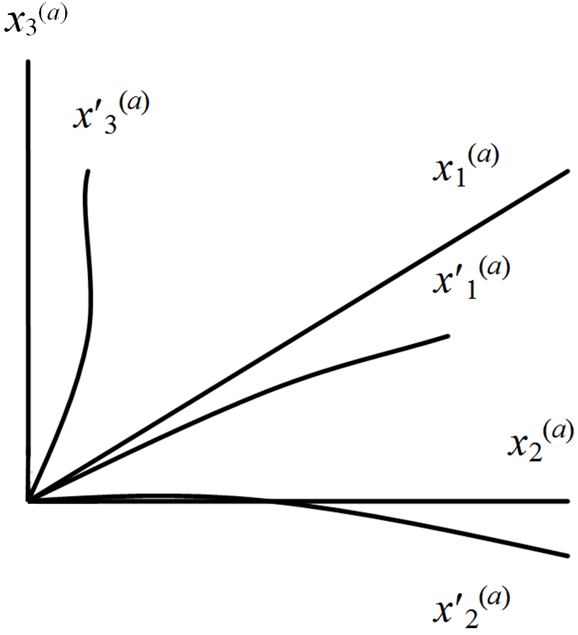

**Fig.** **17.2.** One of the corners of a test cube of a *mn*-vacuum

Consider a 3-dimensional curved portion of a “vacuum”. If the wavelength *λmn* of given monochromatic light beams is much smaller than the dimensions of the “vacuum” irregularities, then this portion of the cubic cell 3-D light landscape (*λmn*-vacuum) is curved (Figure 17.1).

Consider one of eight vertices of a cube in a curved *λmn*-vacuum (Figure 17.1 and 17.2). Replace distorted edges, departing from a given vertex, by the axes of a curvilinear coordinate system *x*0(*a*), *x*1(*a*), *x*2 (*a*), *x*3 (*a*) (Figure 17.2).

The same raw edges of the ideal cube denote a pseudo-Cartesian coordinate system *x*0(*a*), *x*1(*a*), *x*2(*a* ), *x*3(*a*).

The distortion of the edges of the cube under consideration in a *λmn*-vacuum can be decomposed into two components:

1) changing the lengths (compression or expansion) of the axes *x*0(*a*), *x*1(*a*), *x*2 (*a*), *x*3 (*a*) while maintaining the angles between the axes;

2) distorting the angles between the axes *x*0(*a*), *x*1(*a*),*x*2(*a*), *x*3 (*a*) directly, while maintaining their lengths.

We consider affine distortion separately.

1). Suppose that only the lengths of the axes *x*0(*a*), *x*1(*a*), *x*2(*a*), *x*3 (*a*) are changed by the distortion. Then these axes can be expressed by the original ideal cube axis *x*0(*a*), *x*1(*a*), *x*2(*a* ), *x*3(*a*) using the appropriate coordinate transformations:

*x*′0(*а*) = *α*00(*а*)*x*0(*а*) + *α*01(*а*)*x*1(*а*) + *α*02(*а*)*x*2(*а*) + *α*03(*а*)*x*3(*а*);

*x*′1(*а*) = *α*10(*а*)*x*0(*а*) + *α*11(*а*)*x*1(*а*) + *α*12(*а*)*x*2(*а*) + *α*13(*а*)*x*3(*а*);

*x*′2(*а*) = *α*20(*а*)*x*0(*а*) + *α*21(*а*)*x*1(*а*) + *α*22(*а*)*x*2(*а*) + *α*23(*а*)*x*3(*а*);

*x*3′(*а*) = *α*30(*а*)*x*0(*а*) + *α*31(*а*)*x*1(*а*) + *α*32(*а*)*x*2(*а*) + *α*33(*а*)*x*3(*а*) ,(17.1)

where

*αij*(*a*) = *dx*′*i*(*a*)*/dxj*(*a*) (17.2)

using Jacobian transformations or components of tensor elongations.

2) Suppose now that the change only affects the angles between the axes of the coordinate system *x*0(*a*), *x*1(*a*), *x*2 (*a*), *x*3 (*a*), and the lengths along the axes remain unchanged. In this case, it is sufficient to consider a change of angles among the basis vectors **e**0(*a*), **e**1(*a*), **e**2(*a*), **e**3(*a*) in adistorted frame.

From vector analysis, it is known that the basis vectors of a distorted 4-basis **e**0(*a*), **e**1(*a*), **e**2(*a*), **e**3(*a*) can be expressed in terms of the original base vectors **e**0(*a*), **e**1(*a*), **e**2(*a*), **e**3(*a*) in an orthogonal 4-basis via the following system of linear equations:

**e**′0(*a*) = *β*00(*a*) **e**0(*a*) + *β*01(*a*) **e**1(*a*) + *β*02(*a*) **e**2(*a*) + *β*03(*a*) **e**3(*a*);

**e**′1(*a*) = *β*10(*a*) **e**0(*a*) + *β*11(*a*) **e**1(*a*) + *β*12(*a*) **e**2(*a*) + *β*13(*a*) **e**3(*a*);

**e**′2(*a*) = *β*20(*a*) **e**0(*a*) + *β*21(*a*) **e**1(*a*) + *β*22(*a*) **e**2(*a*) + *β*23(*a*) **e**3(*a*);

**e**′3(*a*) = *β*30(*a*) **e**0(*a*) + *β*31(*a*) **e**1(*a*) + *β*32(*a*) **e**2(*a*) + *β*03(*a*) **e**3(*a*), (17.3)

where

*βpm*(*a*) = (**e**′*p*(*a*) ⋅**e***m*(*a*)) = cos(**e**′*p*(*a*) ^**e***m*(*a*)) (17.4)

using the direction cosines.

The systems of equations (17.1) and (17.3) can be represented in a compact form:

*x*′*i*(*a*) = *αij*(*a*) *x j*(*a*) (17.5)

and

**e**′*p*(*a*) = *βpm*(*a*) **e***m*(*a*).(17.6)

The remaining 7 distorted cube corners in a *λmn*-vacuum (Figure 17.1) (or rather the remaining fifteen 4-bases of Figures 6.2 and 6.3) are described similarly.

Consider, for example, the distorted 4-basis vector (10.1)

*d***s***′* (7) *=* **e***′i*(7) *dx′ i* (7).(17.7)

With regard to (17.5) and (17.6), vector (17.7) can be represented as

*d***s***′* (7) *= β pm*(*7*) **e***m*(7)*αpj*(7)*dxj*(7),(17.8)

Similarly, all the vertices of a distorted cube *λmn*-vacuum can be represented by vectors

*d***s***′* (*a*) *= β**pm*(*a*) **e***m*(*a*) *αpj*(*a*)*dxj*(*a*), (17.9)

whereby *a* = 1, 2, ... , 16.

**18. Curved metric 4-space**

For example, consider two vectors (10.1) and (10.2), but given in the 5th and 7th curved affine spaces

*d***s***′* (5)*= βln*(5)**e***n*(5)*αlj*(5)*dxj*,(18.1)

*d***s***′* (7)*= βpm*(7)**e***m*(7)*αpi*(7)*dxi*.(18.2)

We find the inner product of these vectors

*ds′* (7,5)2 = *d***s***′* (*7*)*d***s***′* (*5*) *= βpm*(7)**e***m*(7)*αpi*(7)*βln*(5)**e***n*(5)*αlj*(5)*dxidxj = сij*(7,5)*dxidxj* (18.3)

where

*сij*(*7*,*5*)*=βpm*(7)**e***m*(7)*αpi*(7)*βln*(5)**e***n*(5)*αlj*(5) (18.4)

arecomponents of the metric tensor (7, 5)’th metric 4-space.

Thus, the metric (7, 5)’th metric 4-space which results is

*ds′* (7,5)2 = *сij*(7,5)*dxidxj* (18.5)

from signature (10.5) (*+ + + * ) and the metric tensor

. (18.6)

Similarly, the paired inner product of any two vectors (17.9)

*d***s***′* (*a*)*= βpm*(*a*)**e***m*(*а*)*αpi*(*a*)*dxi* ,(18.7)

*d***s***′* (*b*) *= βln*(*b*)**e***n*(*b*)*αlj*(*b*)*dxj*(18.8)

leads to the formation of an atlas, which consists of 16 × 16 = 256 of all possible 4-dimensional curved sheets (i.e. metric 4-subspaces) with metrics

*ds′* (*a*, *b*)2 = *сij*(*a*, *b*)*dxidxj*,(18.9)

whereby *a* = 1,2, ... ,16; *b =* 1,2, ... ,16, with respective signatures (10.15) and metric tensors

 , (18.10)

where

*сij*(*a*, *b*)*=βpm*(*a*)**e***m*(*a*)*αpi*(*a*)*βln*(*b*)**e***n*(*b*)*αlj*(*b*) (18.11)

arecomponents of the metric tensor (*a*,*b*)’th curved metric 4-subspace.

**19. 4-tensor of deformations**

The classical theory of elasticity, the actual state of the local volume of an elastic-plastic medium generally describes only one space “frozen” in the reference system with its corresponding 4-basis. This leads to the analysis of only one type of quadratic form

*ds′* 2 = *gij dxjdxj*,(19.1)

where *gij* describes themetric tensor components of the local portion of the curved metric length (16 components, but of these only 10 are effective, due to the symmetry *gji = gij* ).

The quadratic form (19.1) is compared with the quadratic form of the original, the ideal state of the same local area of the elasto-plastic medium [13]

*ds*02 = *gij*0*dxidxj*. (19.2)

By subtracting the initial state metric (19.2) from the current state metric (19.1), we get [13]

, (19.3)

where

, (19.4)

which is a 4-tensor deformation.

The representations developed here differ from the classical mechanics of continuous media only in that the investigated section (cube) of an elastic-plastic medium (in this case the *mn*-vacuum) describes a 4-basis, associated with one of the eight corners of the given cube (Figure 17.1), and therefore describes all the sixteen 4-bases (Figure 6.3) (two 4-basis at each vertex of the given cube).

This leads to the fact that instead of one metric type (19.1) in the Algebra of Signatures there appears 256 metrics (18.9)

*ds*(*a*,*b*)2 = *сij*(*a*,*b*)*dxidxj* (19.5)

with the corresponding signatures (10.15) which describe the same region (in particular the “vacuum”) from different sides. In this case the metric-dynamic state of the given volume is described not by these 16 terms (components of the metric tensor *gji*), but rather by 256 × 16 = 4096 components of the 256 tensors from g*ji*(*a*,*b*) (18.11). This achieves not only a significantly more precise description of the scope of the curved elastic-plastic medium (in particular, *mn*-vacuum) in the vicinity of the point *O* (Figure 6.1) but also provides the rationale for the identification of a number of more subtle effects of a vacuum (which will be considered in future articles).

The mathematical apparatus of light-geometry of the Algebra of Signatures (AS) developed for research is not only a “vacuum”, but also any other 3-dimensional continuum in which the wave disturbances (light, sound, phonons) are distributed at a constant speed.

**20. The first step of compactification of curved measurements**

As in Section 11, in the first stage of compactification of additional (auxiliary) curved mathematical measurements, AS proceeds by averaging 4-metric spaces with the same signature.

For example, for the 4-metric with signature ( +  +) (Figure 11.1) we can average the metric tensors

 (20.1)

where *p* corresponds to the 14th signature ( +  +) according to the following reference numbering:

 (20.2)

and the averaged metric

*<ds*(– + – +) 2> = *сij*(14)*dxidxj*. (20.3)

Similarly, because of the 16-fold degeneracy of the metrics 256 (18.9) of curved 4-subspaces we obtain 256 : 16 = 16 averaged metrics with 16 possible signatures

*<ds*(+– – –)2> *<ds*(+ + + +)2> *<ds*(– – – +)2> *<ds*(+ – – +)2 >

*<ds*(– – + –)2> *<ds*(+ + – –)2>*<ds*(– + – –)2> *<ds*(+ – + –)2>

*<ds*(– + + +)2>*<ds*(– – – – )2>  *<ds*(+ + + –)2>*<ds* (– + + –)2>

*<ds*(+ + – +)2>*<ds*(– – + +)2> *<ds*(+ – + +)2> *<ds*(– + – +)2>, (20.4)

where < *·* > denotes averaging.

The additive superposition (i.e., average) of all the 16 averaged metrics (20.4) should, according to the “*λmn-*vacuum condition” (Def. 12.4), be equal to zero

 (20.5)

All 16 × 16 = 256 components of the 16 averaged metric tensors with *сij*(*p*) can be random functions of the observer’s time. But these functions retain a vacuum condition, so must be combined with one other to give the total metric (20.5) which, on average, always remains equal to zero.

Based on the total metric (20.5), one may develop *λmn-*vacuum thermodynamics, considering the complex, near-zero “transfusion” of local *λmn-*vacuum curvatures. They may be considered as representations of *λmn-*vacuum entropy and temperature (that is, the randomness and intensity of local *λmn-*vacuum fluctuations). One can consider the cooling of a *λmn-*vacuum up to “freezing”, or to the contrary its heating up to “evaporation” and many other effects that are similar to the processes occurring in conventional (atomistic) continuous media. Properties of *λmn-*vacuum thermodynamics mainly are related to the processes when the gradients of *λmn-*vacuum fluctuations approach the speed of light: *dcij* (*p*)*/dxa ≈ c* or *dcij*(*p*)*/dxa ≈* 0 *.*

**21. The second step in compactification curved measurements**

Just as was done in Section 13, the expression (20.5) can be reduced to two terms

‹*ds*(–)2›+ ‹*ds*(+)2› = ‹*gij*(+)›*dxidxj*+ ‹*gij*(–)›*dxidxj* = 0, (21.1)

where

 (21.2)

is a quadratic form which is the result of averaging seven metrics of (20.4) with the signatures included in the numerator of the left ranks (13.1);

 (21.3)

is a quadratic form which is the result of averaging seven metrics of (20.4) with the signatures included in the numerator of the right order (13.1).

Thus, from the totality of *mn-*vacuum fluctuations can be identified:

– the averaged “external” side of a 23*-mn-*vacuum region (or averaged subcont) with the averaged metric

*ds*(+ – – –)2 = *ds*(–)2 = *gij*(–)*dxidxj* with signature (+ – – –),(21.4)

where

 (21.5)

* averaged over the “inner” side of 23*-mn-*vacuum region (or averaged antisubcont) with the averaged metric

*ds*(– + + +)2 = *ds*(+)2 = *gij*(+)*dxidxj* with signature (– + + +), (21.6)

where

 . (21.7)

The brackets < *·* > (averaging)in metrics (21.4) to (21.7) are omitted for the sake of clarity and simplicity.

Figure 21.1 shows schematically the averaged double-sided portion of a 23*-mn*-vacuum region, *the outer* side of which (subcont) describes the metric *ds*2 (21.4) while the *inner* side (antisubcont) describes the metric *ds*(+)2 (21.6).

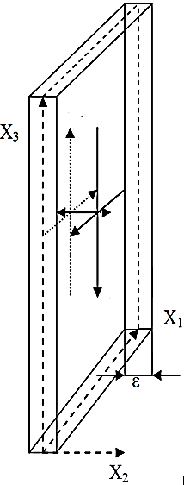

*4-dimensional outer side of* 23*-mn-vacuum region*

*ds*(–)2 = *gij*(–)*dxidxj*,

*signature* (+ – – –)

*4-dimensional inner side of* 23*-mn-vacuum region*

*ds*(+)2 = *gij*(+)*dxidxj* ,

*signature*(– + + +)

**Fig.** **21.1**. A simplified illustration of a section of a double-sided 23*-mn*-vacuum region, the

*outer* side of which describes a 4-metric *ds*()2, while its *inner* side

describes a 4-metric *ds*(+)2, wherebyε→0

**22. The tensor 4-tension of a 23*-mn-*vacuum region**

Let the original uncurved metric-dynamic state of the given portion of the *outer* side of a 23*-mn-*vacuum region (i.e. averaged subcont) be characterized by the averaged metric

*ds*0(–)2 = *gij*0(–)*dxidxj* with signature (+ – – –), (22.1)

and the curved state of the same portion of the averaged metric is given by

*ds*(–)2 = *gij*(–)*dxidxj* with the same signature (+ – – –). (22.2)

Unlike the curved state of the section of subcont, its uncurved state is determined by the difference of the form (19.3)

*ds*(–)2 – *ds*0(–)2 = (*gij*(–) – *gij*0(–)) *dxidxj* = 2*εij*(–)*dxidxj* , (22.3)

where

*εij*(–) = ½ (*gij*(–) – *gij*0(–)) (22.4)

are the 4-tensor deformations of the local area of the subcont.

The relative elongation of the curved portion of the subcont is equal to [13]

, (22.5)

whence

*ds*(–)2 = (1 + *l*(–))2*ds*0(–)2. (22.6)

Substituting (22.6) in (22.3) with (22.4), we have [13]

*εij*(–) = ½ [(1 + *l*(–))2 – 1] *gij*0(–), (22.7)

or, unfolded

*εij*(–) = ½ [(1 + *li*(–))(1 + *lj*(–)) cos*βij*(–) – cos*βij*0(–)] *gij*0(–), (22.8)

where

*ij*0 is the angle between the axes *xi* and *xj* in the coordinate system “frozen” to its original uncurved state of the given subcont portion;

*ij*  is the angle between the axes *xi*  and *xj*  in the distorted frame, “frozen” in the curved state of the same portion of the subcont.

When *ij*0 = **/2, the expression (22.8) takes the form

*εij*(–) = ½ [(1 + *li*(–))(1 + *lj*(–)) cos*βij*(–) – 1] *gij*0(–). (22.9)

For the diagonal components of the 4-tensor deformations *ii* intheexpression (22.9) simplifies to

*εii* (–) = ½ [(1 + *li*(–))2 – 1] *gii*0(–), (22.10)

It follows from [17] that:

 (22.11)

If the deformation of * ij*  is small, by expanding the expression (22.11) along a row, using only the first member of the series, we obtain the relative elongation subcont

. (22.12)

Likewise, the local deformation of the inner side of the portion of the 23*-mn-*vacuum region (average antisubcont) is defined by the expression

*ds*(+)2 – *ds*0(+)2 = (*gij*(+)– *gij*0(+))*dxidxj* = 2*εij*(+)*dxidxj*, (22.13)

where

*εij*(+) = ½(*gij*(+) – *gij*0(+)) (22.14)

are the 4-tensor deformations of the local antisubcont region;

*ds*0(+)2 = *gij*0(+)*dxidxj* with signature (– + + +) (22.15)

is the metric of the uncurved state of the antisubcont;

*ds* (+)2 = *gij*(+)*dxidxj* with the same signature (– + + +) (22.16)

which is a metric of the curved state of the antisubcont region.

The relative elongation of the antisubcont region is given by

. (22.17)

Define the 4-tensor deformations of a double-sided 23*-mn-*vacuum as the average lengths of

*εij*(±) = ½ (*εij*(+) + *εij*(–)) = ½ (*εij*(– + + +) + *εij*(+ – – –)), (22.18)

or, using (22.4) and (22.14)

*εij*(±) = ½ (*gij*(+) + *gij*(–)) – ½ (*gij*0(+)  + *gij*0(–)) = ½ (*gij*(+) + *gij*(–)), (22.19)

since, according to the “vacuum condition” (4.6):

*gij*0(+) + *gij*0(–) = *gij*0(– + + +) + *gij*0(+ – – –) = 0.

The relative elongation of the local portion of the two-sided 23*-λmn*-vacuum region *li*(±) in this case should be calculated using formula

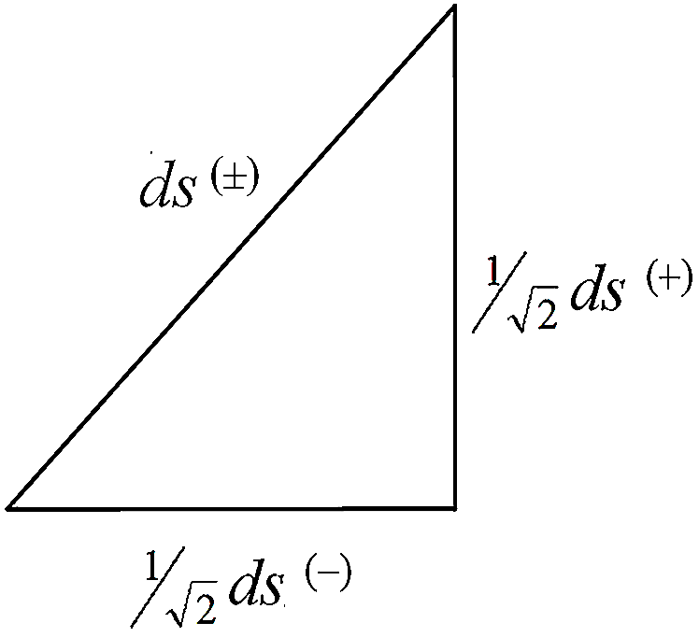

**Fig.** **22.1.** Relationship sections of *ds*() and of *ds*()

\

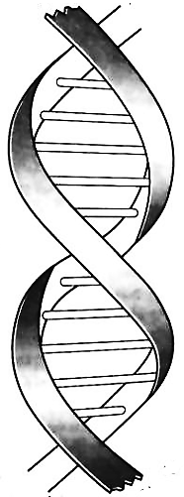

**Fig.** **22.2.** If you project such a double helix onto an appropriate plane, then at the intersection of any two of the resulting curves, the corresponding tangents will be perpendicular to one another

, (22.20)

where



 (22.21)

Since in any case one of the components of *gij*0 or *gij*0(+) is negative, the relative elongation (22.20) may be a complex number.

In this regard, we note the following important fact. If both sides of the expression (22.19) multiplied by *dxidxj*, is obtained by averaging the quadratic form

*ds*(±)2 =(*ds*(–)2*+ ds*(+)2), (22.22)

resembles the Pythagorean theorem *c*2 = *a*2 + *b*2. This means that the line segments ()1/2*ds*(–)and ()1/2*ds*(+) are always mutually perpendicular in relation to each other: *ds*   *ds*(+) (Figure 22.1), and two lines directed in the same direction can be always perpendicular to each other only when they form a double helix (Figure 22.2).

Thus, the average metric (22.22) corresponds to the length “braid”, consisting of two mutually perpendicular coils *s* and *s*(+). In this case, as the average relative elongation (22.20), a portion of the “double helix” can be described by a complex number

*ds* (±)*=*(*ds* (–)*+ids* (+)),(22.23)

which is equal to the square of the module (22.22).

**Definition 22.1** *A k-braid is the result of averaging the metrics with different signatures (where k = the number of averaged metrics, i.e. the number of “threads” in the “braid”).*

In particular, the averaged metric (22.22) is called a 2-braid, since it is “twisted” from the 2 lines (“threads”): *ds* = *ds*    and *ds* = *ds*( + + +) *.*

In the following, going to a deeper level from these 16, the metrico-dynamic properties of the local portion of 26*-mn-*vacuum is characterized by a superposition length (i.e., the additive superposition or averaging) of sixteen 4-metrics with all 16 possible signatures (11.5), i.e. a 16-braid:

*ds*Σ2 = 1/16 (*ds*(+ – – –)2 + *ds*(+ + + +)2 + *ds*(– – – +)2 + *ds*(+ – – +)2 +

+ *ds*(– – + –)2 + *ds*(+ + – –)2 + *ds*(– + – –)2 + *ds*(+ – + –)2 + (22.24)

+ *ds*(– + + +)2 + *ds*(– – – – )2 + *ds*(+ + + –)2 + *ds*(– + + –)2 +

+ *ds*(+ + – +)2 + *ds*(– – + +)2 + *ds*(+ – + +)2 + *ds*(– + – +)2) = 0.

In this case, we have sixteen 4-tensors deformations of all kinds of 4-spaces

 (22.25)

where

*εij*(*p*) = ½ (*сij*(*p*) – *сij*0(*p*)) (22.26)

is the 4-tensor deformations in the *p*-th 4-subspace;

*cij*0 (*p*) – the metric tensor of the uncurved portion of the *p*-th 4-subspace;

*cij* (*p*) – the metric tensor of a curved portion of the same *p*-th 4-subspace.

We consider the 16-sided 4-tensor deformations* ii*(16) on a local portion of a 26*-mn-*vacuum whose length equals

*εij*(16)= 1/16 (*εij* (1)+ *εij* (2)+*εij*(3)+*εij*(4)+*εij*(5)+*εij*(6)+*εij*(7)+*εij*(8)+*εij*(9)+

+*εij*(10)+*εij*(11)+*εij*(12)+*εij*(13)+*εij*(14)+*εij*(15)+*εij*(16)), (22.27)

and the relative elongation of the local portion of the “vacuum” in this case can be calculated by the formula

*li*(16)= *η*1 *li* (1)(16)+ *η*2 *li* (2)(16)+ *η*3 *li* (3)(16)+…+ *η*4 *li* (16)(16), (22.28)

where

. (22.29)

where *ηm* (where *m* = 1, 2, 3, ..., 16) are the orthonormal basis objects satisfying the relation of a anticommutative Clifford algebra

*ηmηn*+ *ηnηm* = 2*δmn,* (22.30)

whereby *δnm* is the unit 16 × 16 matrix.

This portion then consists of sixteen braid “threads”:

*ds*(16)= *η*1 *ds*(+– – –) + *η*2 *ds*(+ + + +) + *η*3 *ds*(– – – +) + *η*4 *ds*(+ – – +)  +

+ *η*5 *ds*(– – + –) + *η*6 *ds*(+ + – –) + *η*7 *ds*(– + – –) + *η*8 *ds*(+ – + –) +

+ *η*9 *ds*(– + + +) +*η*10*ds*(– – – –) + *η*11 *ds*(+ + + –) + *η*12 *ds* (– + + –) +

+ *η*13 *ds*(+ + – +) +*η*14*ds*(– – + +) + *η*15 *ds*(+ – + +) + *η*16 *ds*(– + – +) = 0. (22.31)

If all the linear forms *ds*   , *ds*(+ + + +), ... , *ds*( +  +) can be represented in a diagonal form, then in accordance with (14.11) expression (22.31) can be represented in spin tensor form

*ds*(16)=  +

+ +

+  +

+  +

+  +

+  +

++

+  +

+ +

+ +

+ +

+ +

+ +

++

++

+ (22.32)

There are even deeper, 2*n*-sided levels which arise from consideration of the metric - dynamic properties of “vacuum” (paragraphs 1.2.9, 1.2.13 in [5]). Continuing in this manner, the number of metric tensor components goes to infinity.

**23. The physical interpretation of non-zero components of the metric tensor**

Let the metric-dynamic state of the two 4-dimensional local portion of the 23*-mn-*vacuum have the given metrics (21.4) and (21.6). Then, the non-zero components of the metric tensor (21.5) and (21.7)

 ,  (23.1)

define the local spatial curvature of the 3-dimensional “vacuum” cell. Here the subscripts *α*, *β* correspond to 3-dimensional considerations (*α*, *β* = 1,2,3).

The scalar curvature of a 3-dimensional cell of a “vacuum” in bilateral form is determined by averaging the expression [2]

*R*(±) =(*R*(–)*+R*(+)) , (23.2)

where the scalar curvature of each of the two sides is also determined as in GR

*R*(–) = *g*(–)*αβRαβ*(–)and  *R*(+) = *g*(+)*αβRαβ*(+), (23.3)

where

 (23.4)

which is the Ricci tensor of the external  or internal (+) “side”, respectively, of the “vacuum” cells;

 (23.5)

which are the Christoffel symbols of the external  or internal (+) side respectively, where *gαβ* is respectively *g**αβ* or *g*(+)*αβ*.

The tension of the 3-tensor describing a 3-dimensional “vacuum” cell is given in this case by the averaged expression

*ε αβ* (±) = ½ (*εαβ* (+) + *ε αβ* (–)), (23.6)

where

*εαβ* (–) = ½ (*gαβ*(–) – *g αβ*0(–)), (23.7)

which are the 3-tensor deformations of the outer side “vacuum” cells;

*εαβ* (+) = ½ (*gαβ*(+) – *g αβ*0(+)) (23.8)

which are the 3-tensor deformations of the inner side of the “vacuum” cell.

The theory of local deformation of 3-dimensional regions of the “vacuum” can be developed by analogy with the conventional theory of elasticity (atomistic) of solid elasto-plastic media [13] taking into account the two-way (or 2*n*-sided) properties.

**24. The physical interpretation of zero components of the metric tensor**

To explain the physical meaning of the metric tensor zero components (21.5) and (21.7)

 ,  (24.1)

we use kinematics of the dual of the 23*-mn-*vacuum region.

Let the original (undisturbed and uncurved) state of a 23*-mn-*vacuum be over a given set of metrics (7.3) and (7.4)

 *ds*0(*–*)2*= с*2*dt*2 – *dх*2 – *dy* 2 – *dz* 2 *= ds*(–)′*ds*(–)′′ =  *сdt*′*сdt*′′– *dx*′*dx*′′– *dy*′*dy*′′– *dz*′*dz*′′, (24.2)

*ds*0(+)2*=* – *с*2*dt*2 +*dx*2+ *dy* 2+ *dz*2 *= ds*(+)′*ds*(+)′′ =– *сdt*′*сdt*′′*+ dx*′*dx*′′*+ dy*′*dy*′′*+dz*′*dz*′′, (24.3)

where

*ds*(–)′ = *с**dt*′ + *idx*′+ *jdy*′+ *kdz*′ – *mask of the subcont*; (24.4)

*ds*(–)′′ = *с**dt*′′+ *idx*′′+ *jdy*′′+ *kdz*′′ – *interior of the subcont*; (24.5)

*ds*(+)′ = – *с**dt*′+ *idx*′+ *jdy*′+ *kdz*′ – *mask of the antisubcont*; (24.6)

*ds*(+)′′ = *с**dt*′′– *idx*′′– *jdy*′′– *kdz*′′ – *interior* *of the* *antisubcont,* (24.7)

which are affine aggregates, with the quaternion multiplication table for imaginary units of this type given in Table 24.1.

Table 24.1

|  |  |  |  |
| --- | --- | --- | --- |
|  | *i* | *j* | *k* |
| *i* | *–*1 | *k* | *–j* |
| *j* | *–k* | *–*1 | *i* |
| *k* | *j* | *–i* | *–*1 |

**Definition 24.1** *A**mask of a subcont* is a 4-dimensional affine length interval of type

*ds*  = *c* *dt* + *idx* + *jdy* + *kdz*.

**Definition 24.2** *An interior of a subcont* is a 4-dimensional affine length interval of type

*ds*  = *c* *dt*+ *idx* + *jdy* + *kdz*.

**Definition 24.3** *A mask of an antisubcont* is a 4-dimensional affine length interval of type

*ds*(+)  =  *c* *dt* + *idx* + *jdy* + *kdz*.

**Definition 24.4** *An interior of an antisubcont* is a 4-dimensional affine length interval of type

*ds*(+)  = *c* *dt*  *idx*  *jdy* *kdz*.

We consider four cases:

1). In the first case we have the *mask* and the *interior* of the external and internal sides of the 23*-mn-*vacuum region (i.e. subcont and antisubcont) moving relative to the initial stationary state along the axis *x* with the same speed *vx* , but in different directions. This is formally described by the coordinate transformation:

*t*′ = *t*, *x*′ = *x* + *vx t*, *y*′= *y*, *z*′= *z* – for a *mask*; (24.8)

*t*′′= *t*, *x*′′ = *x* – *vxt*, *y*′′= *y*, *z*′′= *z*  – for an *interior*. (24.9)

Equality of the modules of the velocities *v*x fora*mask* and an *interior* leads to the “vacuum condition”, which requires that every movement in the “vacuum” there is a corresponding antimovement.

Differentiating (24.8) and (24.9), and substituting the results into the differential metrics (24.2) and (24.3), we obtain a set of metrics

 *ds*(–)2= (1+ *vx*2/*с*2)*c*2*dt*2– *dx*2 – *dy*2 – *dz*2; (24.10)

*ds*(+)2= – (1+ *vx*2/*с*2)*c*2*dt*2+ *dx*2+ *dy*2+*dz*2 , (24.11)

describing the kinematics of the joint motion of the exterior and interior sides of a 23*-mn-*vacuum region (subcont and antisubcont) by applying the principle of “vacuum balance”.

*ds*(–)2 + *ds*(+)2 = 0.

2). In the second case, suppose *masks* and *interiors* of asubcont and an antisubcont move relative to their original stationary state in the same direction, along the *x*-axis with the same velocity *vx* . This is formally described in coordinate transformations:

*t*′= *t*, *x*′ = *x* – *vx t*, *y*′= *y*, *z*′= *z* – for a “mask” (24.12)

*t*′′= *t*, *x*′′ = *x* – *vxt*, *y*′′= *y*, *z*′′= *z* – for an “interior” (24.13)

Differentiating (24.12) and (24.12) and substituting the results of differentiation in the metric (24.2) and (24.3), we obtain a set of metrics:

 *ds*(–)2 = (1– *vx*2/*с*2)*c*2*dt*2 + *vxdxdt* + *vxdtdx* – *dx*2 – *dy*2– *dz*2, (24.14)

*ds*(+)2 = – (1– *vx*2/*с*2)*c*2*dt*2 – *vxdxdt* – *vxdxdt* + *dx*2+ *dy*2+ *dz*2. (24.15)

In this case, the vacuum balance is also observed, as *ds*2 + *ds*(+) 2 = 0, but there are additional terms *vxdxdt* which coincide.

The null metric tensor components (24.1) in the second case are in most cases equal to

  (24.16)

3) Let the *mask* and the *interior* of a subcont and an antisubcont (exterior and interior of sides 23*-mn-*vacuum region) rotate about the *z*-axis in the same direction with an angular speed * *. This is described by the change of variables:

*t′ = t*, *x′ = x* cos*Ω t – y* sin*Ω t*, *z′ = z*, *y′= x* sin*Ω t + y* cos*Ω t*, (24.17)

*t′′ = t*, *x′′ = x* cos*Ω t – y* sin*Ω t*,  *z′′ = z*, *y′′ = x* sin*Ω t + y* cos*Ω t*. (24.18)

Differentiating (24.17) and (24.18) and substituting the results in differentiation of the metric (24.2) and (24.3), we obtain the metrics [10]

*ds*(*–*)*2=* [1*– (Ω* 2 */с*2)(*х*2*+у*2)]*с*2*dt*2*+*2*Ω уdxdt – 2Ω хdydt – dx2 – dy2 – dz2*, (24.19)

*ds*(*–*)*2= –* [1*– (Ω* 2 */с*2)(*х*2*+у*2)]*с*2*dt*2*–*2*Ω уdxdt +2Ω хdydt + dx2 + dy2 + dz2*, (24.20)

In cylindrical coordinates,

*ρ* 2*= х*2*+ у*2,  *z = z* , *t = t* , *ϕ =* arctg(*y/x*) – *Ω t*. (24.21)

the metrics (24.19) and (24.20) take the form

 *ds*(*–*)2*=* (1 *– ρ* 2*Ω* 2*/с*2) *с*2*dt*2*– ρ* 2*Ω /с* *dϕdt – ρ* 2*Ω /с* *dtdϕ – dρ* 2 *–ρ* 2*dϕ* 2*–dz*2, (24.22)

*ds*(*+*)2 *= –* (1 *– ρ* 2*Ω* 2*/с*2) *с*2*dt*2*+ρ* 2*Ω /сdϕdt +ρ* 2*Ω /сdtdϕ + dρ* 2 *+ρ* 2*dϕ* 2*+dz2*. (24.23)

The components of the metric tensor (24.1) equal

  (24.24)

4) The case where the *mask* and the *interior of a* subcont and an antisubcont rotate in mutually opposite directions with angular speed * *can also be considered. This is described by the change of variables:

*t′ = t*, *x′ = x* cos*Ω t – y* sin*Ω t*, *z′ = z*, *y′ = x* sin*Ω t + y* cos*Ω t*,(24.25)

*t′′= t*, *x′′ = – x* cos*Ω t + y* sin*Ω t*, *z′′= z*, *y′′ = – x* sin*Ω t – y* cos*Ω t*. (24.26)

and leads to similar results.

From the above examples it is clear that the null metric tensor components are associated with the translational and/or rotational movement of various of sides of a 23*-mn*-vacuum region.

The state of motion of the local 3-dimensional region of the “vacuum” is characterized by the average of the null-metric tensor components

 (24.27)

In all four cases considered, the averaged components of the null metric tensor (24.27) equals to zero . This means that mutually opposite processes can occur inside a portion of the “vacuum”, but in general, this portion remains fixed within the local 3-dimensional region of the “vacuum”.

However, there are cases where the intra-vacuum processes cannot compensate for each other locally, only globally, due to phase shifts. In this case the local 3-dimensional “vacuum” portion may participate (as a whole) in a closed intricate motion. Consider an event at a specific example. Suppose at some site in the “vacuum” there is a kinematic-vacuum process such that

*t*′ = *t*, *x*′ = *x* + *v*1*x t*, *y*′= *y*, *z*′= *z* – for the mask of a subcont; (24.28)

*t*′′= *t*, *x*′′ = *x* – *v*2*x t*, *y*′′= *y*, *z*′′= *z*  – for the interior of a subcont. (24.29)

*t*′ = *t*, *x*′ = *x* + *v*3*x t*, *y*′= *y*, *z*′= *z* – for the mask of an antisubcont; (24.30)

*t*′′= *t*, *x*′′ = *x* – *v*4*x t*, *y*′′= *y*, *z*′′= *z*  – for the interior of an antisubcont, (24.31)

where *v*1 *x* *≠ v*2 *x* *≠ v*3 *x* *≠ v*4 *x*, but the balance of overall observed motion equals

*v*1*x* – *v*2*x + v*3*x* – *v*4*x* = 0. (24.32)

In this case, the outer and inner sides of a 23*-mn-*vacuum region (subcont and antisubcont) are described by a set of metrics

 *ds*(–)2= (1+ *v*1*x**v*2*x*/*с*2)*c*2*dt*2 – *v*1*xdtdx* + *v*2*xdxdt*– *dx*2 – *dy*2 – *dz*2; (24.33)

*ds*(+)2= – (1+ *v*3*x**v*4*x*/*с*2)*c*2*dt*2 + *v*3*xdtdx* – *v*4*xdxdt* *+* *dx*2 + *dy*2 + *dz*2, (24.34)

wherein the non-zero average nul-metric tensor components (24.27) are of the form

*g*00 (±) = (*v*1*x**v*2*x* – *v*3*x**v*4*x*)/2*с*2, *g*01 (±) = (*v*3*x* – *v*1*x*)/2, *g*10 (±) = (*v*2*x* – *v*4*x*)/2, (24.35)

whereby (*v*1*x + v*3*x*)–(*v*2*x + v*4*x*) = 0. (24.36)

This means that some local region of the local 3-dimensional “vacuum” is involved in an intricate movement along the *x*-axis, so the principle of the “vacuum balance” is formally complied with in relation to the total amount of motion (24.32).

**25. Maximum velocity of *mn*-vacuum** **layers**

We ask the question: “Can the sides of a 23*-λmn-*vacuum region have any given speed?”

Consider this question as an example of the metric (24.14)

*ds*(–)2 = (1– *vx*2/*с*2)*c*2*dt*2 + 2*vxdxdt* – *dx*2 – *dy*2– *dz*2. (25.1)

We develop (25.1) by completing the square

 (25.2)

and introduce the notation

 (25.3)

In this notation, the metric (25.1) takes the form

. (25.4)

The physical meaning of the expressions (25.2) to (25.4) is fundamentally different from the axioms of SR and GR of Einstein, so further clarification is required. Einstein's postulate of the constancy of the speed of light in “vacuum” remains unchanged. However, if one of the sides of a 23*-mn-*vacuum region moves as a unit with the speed *vx* [see (24.12) to (24.15)], then for a third-party observer located on the fixed lidar (Figure 3.1.) the direct light beam will propagate with a velocity

 (25.5)

This is similar to the way a stationary observer measures the speed of waves propagating on the river. This observer finds that the velocity of propagation of the surface perturbation depends on the rate of flow of the river, whereas the water relative velocity of propagation of disturbances remains constant and depends only on the properties of water (density, temperature, impurities, etc.).

From the expressions (25.3) we see that, in the cases (24.12) to (24.15), the propagation velocity of the outer side 23*-mn-*vacuum region (subcont) cannot exceed the speed of light. At low speeds (*vx* << *c*) to the casual observer velocity *c'* is somewhat smaller than the speed of light



Thus, in the case of (24.12) to (24.15), despite the fact that the interpretation of the mathematical apparatus of the cited theories are different, the main physical findings remain unchanged.

However, in the case of (24.8) to (24.11), the situation is different. Consider this realization of intra-vacuum processes in an example in which the subcont motion is described by the metric (24.10)

*ds*(–)2 = (1+ *vx*2/*с*2)*c*2*dt*2– *dx*2 – *dy*2 – *dz*2.  (25.6)

In this case, the introduction of the notation

  (25.7)

leads metric (25.6) to the invariant form (25.4), but no restrictions on the counter speed *v*x of the *mask* and *interior* subconts arise. This fact requires a separate detailed consideration because it allows for the possibility of organizing intra-vacuum superluminal communication channels.

**26. Inert layer properties of a *mn*-vacuum**

Returning to the consideration of metrics (24.2) and (24.3)

*ds*(+ – – –)2 = *ds*(–)2 = *c*2*dt*2 – *dx*2 – *dy*2 – *dz*2, (26.1)

*ds*(– + + +)2 = *ds*(+)2 = – *c*2*dt*2 + *dx*2 + *dy*2 + *dz*2 . (26.2)

We bring the quantity *с*2*dt*2 to the right sides of the equations of these metrics, and outside the parentheses:

 (26.3)

, (26.4)

where *v* = (*dx*2 + *dy*2 +*dz*2 )1/2/*dt* = *dl*/*dt* is a3-dimensional velocity.

Extract the root of the two sides of the resulting expressions (26.3) and (26.4). As a result, according to the notations introduced in (24.4) to (24.7), we obtain

 – for the mask of the subcont (26.5)

 – for the interior of the subcont; (26.6)

 – for the mask of the antisubcont; (26.7)

 – for the interior of the antisubcont. (26.8)

For example, consider the 4-dimensional velocity vector of the mask of the *subcont* [10]

*ui*(*–*)*= dxi /ds*(*–*)’. (26.9)

Substituting (5.26) in (9.26) gives 4-velocity components [10]

 . (26.10)

Let a given *mask of the subcont* move only in the direction of the *x*-axis. Then the components of its 4-velocity are given by

. (26.11)

We now define the 4-acceleration mask of the subcont

 (26.12)

and consider only the *x*-component

 , (26.13)

where the value of

 (26.14)

has the dimensions of the *x*-component of the 3-dimensional acceleration.

We differentiate the left side of (26.14)

 (26.15)

and introduce the notation

*dvx/dt = аx*(*–*)*'* . (26.16)

The expression (26.15) takes the form

, (26.17)

where *ax* is the actual acceleration portion of the mask of the subcont, taking into account its inert properties; *and ax**'* is theideal acceleration of the same portion of the mask of the subcont excluding the inert properties.

We represent the expression (26.16) in the form

, (26.18)

where

 . (26.19)

is a dimensionless inertia coefficient that relates the actual and ideal acceleration of the local section of the mask of the subcont under consideration, and shows how the inertia (i.e. resistance to change of the state of motion) of this section changes with the change of its velocity.

From the expression (26.19) it follows that when *vx* = 0, the inertial coefficient *x*(** ) = 1and . This means that the portion of the mask of the subcont offers no resistance to the start of its motion. When *vx* approaches the speed of light as the coefficient of inertia *x* tends to infinity, further acceleration of themask of the subcont becomes impossible.

Equation (26.18) is an analog of a massless version of Newton's second law

*Fx = ma****x****′*, (26.20)

where *Fx* is theforce vector component; *m* is the mass of the body; *ax *is its ideal acceleration component.

Comparing (26.18) and (26.20), we find that in *mn***-**vacuum dynamics, the massless inertia factor (coefficient)* x* of thelocal area corresponding to the mask of the subcont is an analogue of the inertial mass density of a continuous medium in post-Newtonian physics.

Sequential substitution (26.6) to (26.8) in the expression (26.9) can be formulated analogously to the inertia factors* x** *, *x*(+)* *, *x*(+)*  *for the three remaining affine layers of the 23*-mn***-**vacuum region. The total coefficient of inertia of the local portion 23*-mn***-**vacuum is a function of the lengths of all four inertial coefficients

*μх*(*±*)= *f* (*μх*(*–*)*′* , *μх*(*–*)*′′*, *μх*(*+*)*′*, *μх*(*+*)*′′* ). (26.20)

The form of this function will be defined in the exposition of *mn***-**vacuum dynamics in subsequent articles.

**27. Kinematics gap of a local region of the “vacuum”**

For in much wisdom is much grief; and he that increaseth knowledge increaseth sorrow.

*Ecclesiastes 1:18*

The theory of light-geometry of “vacuum” opens up opportunities for the development of “zero” (vacuum) technology. The mathematical apparatus of the Algebra of Signatures (АS) allows one to predict a number of vacuum effects [4, 5] which cannot in principle be predicted by modern physics.

In this article, we consider only the kinematic aspects of the possibility of “rupturing” the “vacuum” of the local area.

We integrate expression (26.14) [11]:

 (27.1)

Integrating (27.1) again and assuming that *x*0 = 0 at *t* = 0, we have the following change in the distance along the axis *x* under accelerated motion of the mask of the subcont:



Let the original (i.e., stationary) state of a local area of a subcont in the given metric (24.2) be

. (27.2)

Uniformly accelerated motion of the portion along the *x*-axis is then thecoordinate transformation formally specified as in [11]:

 (27.3)

Differentiating the coordinates (27.3), and substituting the results of the differentiation into (27.2), we receive the metric [11]:

 (27.4)

describing the movement at constant acceleration of a local section of the subcont (i.e., the inner side of the side of the 23*-λmn***-**vacuum extent the the direction of the x-axis.

If, in the same subcont region, an additional flow with a small but uniform decrease of velocity is created, i.e., negative acceleration

 (27.5)

then, performing calculations similar to (27.1) to (27.4), we obtain a metric

 (27.6)

The mean metric-dynamic state of the local area will be characterized by the average subcont metric

 (27.7)

with signature    . Where we see that in

whereby  or  *|ах|t = c* or|*ах*| = *c /*Δ*t*,(27.8)

the first and second terms in the average metric (27.7) become infinite. This singularity may be interpreted as a “rupture” of the given region of the subcont (i.e., the *outer* side of the 23*-mn*-vacuum region).

The “rupture” of a subcont is a consequence of incomplete action. To complete the “gap” of the local portion of the 23*-mn-*vacuum region, it is necessary to “rupture” its *inner* side, the metric described by (26.2) with the signature ( + + +). For this purpose, in the same region as the antisubcont in a *mn*-vacuum, a similar flow with a small but uniform acceleration is determined by the average of the corresponding metric.

 (27.9)

with signature ( + + +), which “ruptures” in the same conditions

or  *|ах|t = c,* or|*ах*| = *c /*Δ*t*.(27.10)

Averaging the metric (27.7) and (27.9) leads to the implementation of the vacuum conditions

**,**  (27.11)

which, in this situation, is equivalent to Newton's third law, i.e., “reaction equals the negative of the action in equilibrium”

*Fx*(*+*) *– Fx*(–)  = *max*(*+*) *– max*(–) *=* *ax*(*+*) *– ax*(–). (27.12)

That is, the process of the “gap” in a local “vacuum” region is similar to the conventional (atomistic) gap of a solid body in which, essentially, the larger the applied forces, the more precise the resulting acceleration.

It is possible that the “gap” of the “vacuum” conditions described above is formed in collisions of elementary particles in particle accelerators. A strong collision of particles leads to “cracks” in the web of the vacuum, while closing these cracks creates a variety of new “particles” and “anti-particles” (like broken glass shards).

**Conclusions**

The light-geometric Algebra of Signatures should be characterized with the term “empty-metric” of “vacuum” (“empty”) under investigation, and not *Gaia* (ancient Greek. *Γῆ*, *Γᾶ*, *Γαῖα* *-* Earth). However, all the theory developed here is entirely suitable for the study of continuous atomistic media (such as water or solids), with the medium probed not by light rays, but by the sound waves that propagate in these media at constant velocity.

We list the main differences between the Algebra of Signatures (AS) and the theory of General Relativity (GR) proposed by Einstein.

1. GR considers only one metric, such as the signature of     (7.5)

*ds*(+ – – –)2 = *gij*(–)*dxidxj*

and therefore unilateral 4-dimensional space, which in some cases leads to paradox, while the AS takes into account the totality of the 16 metrics (11.1) [or (20.4)]

*ds*(+– – –)2 *ds*(+ + + +)2  *ds*(– – – +)2  *ds*(+ – – +)2

*ds*(– – + –)2 *ds*(+ + – –)2 *ds*(– + – –)2  *ds*(+ – + –)2

*ds*(– + + +)2 *ds*(– – – – )2  *ds*(+ + + –)2 *ds* (– + + –)2

*ds*(+ + – +)2 *ds*(– – + +)2  *ds*(+ – + +)2 *ds*(– + – +)2,

and thus the full set of 16-type 4-dimensional spaces with all the signatures (or topologies) (13.1)

|  |  |  |  |
| --- | --- | --- | --- |
| (+ + + +)  (– – – + )  (+ – – + )  (– – + – )  (+ + – – )  (– + – – )  (+ – + – )  (+ – – – )+ | +  +  +  +  +  +  +  + | (– – – – ) = 0  (+ + + – ) = 0  (– + + – ) = 0  (+ + – +) = 0  (– – + +) = 0  (+ – + +) = 0  (– + – +) = 0  (– + + +)+ = 0 |  |

This approach allows us to identify ways to solve a number of tasks that previously did not respond to analysis. For example, with the proposed metric-dynamic model of the elementary particles of the standard model [2, 3], it becomes possible to solve the problem of the baryon asymmetry of matter; with the proposed technology, the “gap” in a local region of the “vacuum” can be detected [5], it opens up possibilities for a theoretical justification of the use of intra-vacuum currents for moving in space and obtaining energy from the "vacuum", and much more.

2. Within the Algebra of Signatures, time *t* is not an attribute of the local region of a “vacuum”, but rather it characterizes the observer's ability to regulate the duration of sensation. Therefore, unlike in GR, in AS the interval *dt* remains unchanged by the bending of the “vacuum”. Instead of changing the flow of time, a curved portion of the “vacuum” is proposed to take into account the intra-vacuum flow (i.e. shifting layers of the “vacuum”). In Section 24, it was shown that the zero components of the metric tensor (24.1) can be connected with the laminar and turbulent movements of the vacuum-layers. This approach allows us to consider a 3-dimensional “vacuum” as a multilayered solid elasto-plastic medium.

3. Within Algebra of Signatures there is not just one, but four multiplication rules (10.6) to (10.9) for the “vacuum”. Later it will be shown that the commutative and anticommutative properties of the “vacuum” and “antivacuum” allow us to ensure the stability of true emptiness.

4. The auxiliary mathematical space described by Algebra of Signatures supersymmetric, since every point is characterized by commutative and anticommutative numbers.

The auxiliary mathematical spaces of AS are supersymmetric, because at each of their points both commutative and anticommutative operations on sets of numbers are given.

Thus, axiomatic light-geometry “vacuum” practically coincides with the axioms and consequences of Einstein’s GR (locality, causality, Lorentz invariance, the general covariance equations of extremity action, etc.), except for:

- a different relationship to time;

- different interpretations of the zero components of the metric tensors *g*00 and *g*0*i*;

- taking into account all 16 (actually 64) possible signatures;

- supersymmetric events of spaces.

The full formal mathematical apparatus of Algebra of Signatures (AS) (differential multi-signature, multilayer supersymmetric light-geometry) becomes more and more complicated as it approaches the study of the properties of empty infinity. But initially, there are algorithms for collapsing a set of additional (technical) dimensions before describing the metric-dynamic properties of the 3- dimensional volume of the “vacuum”, which can vary during the time as measured by an outside observer.

**Acknowledgements**

My sincere thanks to David Reid for the care of editing and creative translation of this article into English. A number of ideas discussed in this article were expressed in conversations with S.G. Prokhorov and V.P. Hramihin. The author is also grateful to Drs. V.A. Lukyanov, T.S. Morozova and S.V. Przhigodsky for correcting the manuscript of this article.

**Index number of definitions of new terms**

Definitions of new terms may be found in the text under the numbered Definitions noted below:

*Algebra of Signatures (Alsigna)* :⇔ Definition 11.2;

*Alsigna* :⇔ Definition 11.2;

*Antisubcont* :⇔ Definition 7.5;

*Base* :⇔ Definition 8.1;

*Chess analogy* :⇔ Definition 11.1;

*Cross bundle of a “vacuum”* :⇔ Definition 16.1;

*Inner side of a 23-λmn-vacuum region (antisubcont)* :⇔ Definition 7.3;

*Interior of an antisubcont* :⇔ Definition 24.4;

*Interior of a subcont* :⇔ Definition 24.2;

*Yi-Ching analogy* :⇔ Definition 8.3;

*k-braid :*⇔ Definition 22.1;

*Longitudinal separation of a “vacuum”* :⇔ the Definition 2.3;

*Longitudinal “split zero”* :⇔ Definition 12.2;

*Mask of an antisubcont* :⇔ Definition 24.3;

*Mask of a subcont* :⇔ Definition 24.1;

*Newtonian vacuum (“vacuum”)* :⇔ Definition 1.1;

*Orthogonal three-basis* :⇔ Definition 6.1;

*Outer side 23-λmn-vacuum region (subcont)* :⇔ Definition 7.2;

*Qabbalistic analogy* :⇔ Definition 16.2;

*Rankings* :⇔ Definition 10.2;

*Ray of light* :⇔ Definition 2.1;

*Signature* :⇔ Definition 10.1;

*Stignature* :⇔ Definition 8.2;

*Subcont* :⇔ Definition 7.4;

*Transversely “split zero”* :⇔ Definition 12.1;

*True zero* :⇔ Definition 4.1

“*Vacuum*”:⇔ Definitions 1.1, 12.5;

*Vacuum balance* :⇔ Definition 12.3;

*Vacuum conditions* :⇔ Definition 12.4;

*λmn-vacuum* :⇔ Definition 2.2;

*λmn-vacuum balance* :⇔ Definition № 12.3;

*λmn-vacuum condition* :⇔ Definition 12.4;

2*k* -*λmn-vacuum region* :⇔ Definition 7.1.

# **References**

[1] Batanov M.S. (2017) Derivation of the Schrödinger equation // Science, education, society: trends and development prospects: Materials of the V International scientific-practical conference/ Editorial board: O. N. Shirokov [and others]. - Cheboksary: CNS Interactive Plus, 2017, pp. 16-39, ISBN 978-5-9500297-6-9. DOI: [10.21661/r-461536](https://doi.org/10.21661/r-461536) [in Russian].

Available in English: Batanov, M.S. Derivation of Schrödinger's equation, 2017 - <https://arxiv.org/abs/1702.01880> [physics.gen-ph]

[2] Batanov M.S. (2017) Einstein's Vacuum Equation Extended // Education and Science: Modern Trends: Collective Monograph / Ch. Ed. O. N. Shirokov. - Cheboksary: ​​CNS Interactive Plus, 2017. – pp. 5-61 - (Series “Scientific and Methodological Library”). - ISBN 978-5-9909794-8-2. DOI: [10.21661/r-130488](https://doi.org/10.21661/r-130488) [in Russian].

Available in English: Batanov, М.S. (2017) Regions of the Einstein field equations and their solutions // Education and Science: Modern Trends: Collective Monograph / Ch. Ed. O. N. Shirokov. - Cheboksary: ​​CNS Interactive Plus, series “Scientific and Methodological Library”, 2017. – pp. 5 - 61.- ISBN 978-5-9500562-4-6.- [https://interactive-plus.ru/article/462204/ discussion_platform](https://interactive-plus.ru/article/462204/%20discussion_platform)

[3] Batanov M.S. (2017) Excited states of the nuclei of spherical vacuum formations (the foundations of quantum geometrophysics) // Education and Science in Modern Realities: Materials of the V International scientific-practical conference / Editorial board: O. N. Shirokov [and others]. - Cheboksary: CNS Interactive Plus, 2017. – pp. 17-43 - ISBN 978-5-9500297-9-0. DOI: [10.21661/r-462206](https://doi.org/10.21661/r-462206) [in Russian].

[4] Gaukhman M.H. (2007) Algebra of Signatures “Void”. - M.: URSS, 2007. - ISBN 978-5-382-00580-5, (available at [www.alsignat.narod.ru](http://www.alsignat.narod.ru)) [in Russian].

[5] Gaukhman M.H. (2017) Algebra of Signatures “Massless physics”. - Moscow: Filin, 2017. ISBN 978-5-9216-0104-8 (available at [www.alsignat.narod.ru](http://www.alsignat.narod.ru)) [in Russian].

[6] Green B. (2004) The Elegant Universe. - M: URSS, 2004. ISBN 5-354-00161-7 [in Russian].

[7] Novikov S.P. and Taimanov I.A. (2014) Modern geometric structures and fields. - М.: МTsNМО, 2014. - ISBN 978-5-4439-0182-4 [in Russian].

[8] Klein F. (2004) Non-Euclidean geometry - M.: Editorial URSS, 2004. - ISBN 5-354-00602-3 [in Russian].

[9] Kozlov A.I., Logvin A.I., Sarychev V.A. (2005) Polarization of radio waves. - M.: Radio engineering, 2005. - ISBN 5-93108-074-0 [in Russian].

[10] Landau L.D. and Lifshitz E.M. (1988) Field Theory. Volume 2. - Moscow: Nauka, 1988. -ISBN 5-02-014420-7 [in Russian].

[11] Logunov A.A. (1987) Lectures on the Theory of Relativity and Gravitation. - Moscow: Nauka, 1987. - [in Russian].

[12] Rashevsky P.K. Theory of spinors. - M: Editorial URSS, 2006. - 110 p. ISBN 5-484-00348-2

[in Russian].

[13] Sedov L.I. (1994) Mechanics of continuous media. Volume 1. - Moscow: Nauka, 1994

[in Russian].

[14] Tyurin Yu.I., Chernov I.P., Kryuchkov Yu.Yu. (2009) Optics // textbook - Tomsk: Tomsk Polytechnic University, 2009. - ISBN 5-98298-434-5 [in Russian].

[15] Shipov G.I. (1996) Theory of physical vacuum. - Moscow: Nauka, 1996.- ISBN 5-02-003682-X [in Russian].

[16] Einstein A. (1966) Collection of scientific works. Volume 2. - Moscow: Nauka, 1966 [in Russian].

[17] Peatross J. and Ware M. (2015) Physics of Light and Optics. Brigham Young University, 2015, ISBN 978-1-312-92927-2.

[18] Einstein, A. (1928) Riemann-Geometrie mit Aufrechterhaltung des Begriffes des Fernparallelismus (Riemann Geometry maintaining the concept of Fernparallellismus). Sitzungsbericht der preussischen Akadamie der Wissenschaften. (Minutes of the Prussian Academy of Sciences) – Berlin, Germany. Verlag der Königlich-Preussischen Akademie der Wissenschaften pp. 217-221 [In German].

1. [alsignat@yandex.ru](mailto:alsignat@yandex.ru)