**Excited States of Spherical Vacuum Formation Cores**

**(Basics of quantum geometrophysics)**

Mikhail Batanov[1], Ph.D., Associate Professor, Dept. 207,

Moscow Aviation Institute

Moscow, Russia

**Abstract:** Excited states of the cores of spherically symmetric vacuum formations are considered within the framework of the Algebra of Signatures (Appendix, [7-11] and [1, 2]). Metric-statistical model representations of second and third generation «leptons» and «quarks» are proposed. Principles of building statistical (quantum) geometrophysics as part of the program of a full geometrization of the Clifford-Einstein-Wheeler physics paradigm are considered.

**Key words:** vacuum, vacuum formation, muon, tau-lepton, quarks, second and third generation leptons, geometrophysics, quantum mechanics.

**1. Introduction**

This study is a continuation of the author's earlier works [1] and [2] containing a derivation of the Schrödinger equation and proposition of metric-dynamic models of first generation «quarks» and almost all «fermions» and «bosons» involved in the Standard Model. This work lays the foundation of statistical (quantum) geometrophysics and considers metric-dynamic concepts of average characteristics of second and third generation «leptons» («muons», tau-«leptons») and *c, s, t* and *b-*«quarks».

*In the Algebra of signatures (Alsigna), particle names are given in quotation marks, for example, «electron», «muon», etc. because metric-dynamic models of these localized vacuum formations in Alsigna are considerably different from those of the Standard Model or String Theory. Further explanation is given in the Appendix, which contains explanations of other special terms and notation used in this paper.*

**2. States of internal “particelle” inside the core of a vacuum formation**

Let's first consider the behavior of an internal “particelle” inside the core of a spherical vacuum formation, for example, an «electron» (Figure 2.1).

*Note that in the Algebra of signatures metric-dynamic model of a free «electron» (or e--«quark») is defined by a set of metrics (2.1) {see (6.22) in [2]}, which are solutions of one of Einstein’s field equations [2]. (See Appendix for notation).*

**«ELECTRON»** (2.1)

*“Convex” multilayer vacuum formation with signature*

(+ – – –)

*consisting of:*

***The outer shell of the “electron”***

*(in the interval [r1 , r6], Fig. 2.1),*

*defined by a set of four metrics*

,

,

,

.

***The core of the «electron»***

*(in the interval [r6 , r7], Fig. 2.1),*

*defined by a set of four metrics*

,

,

,

.

***The scope of the «electron»***

*in the interval [0 , ∞](Fig. 2.1)*

.

*Figure 2.1 presents a 3D metric-dynamic image of the core of the «electron» (i.e. a closed spherical vacuum formation) and its surroundings (outer vacuum shell), which was created [2, 8, 11] by analyzing a set of metrics (2.1).*

Let's assume that the internal “particelle” (the size of which can be neglected here) is in a continuous chaotic motion around the center of the core of the «electron», which in our case coincides with the origin of the coordinate system *XYZ* (Figure 2.1). The probable cause of such chaotic motion of the internal “particelle” can be inherent vacuum perturbations, which permanently influence the jellylike core of the «electron».

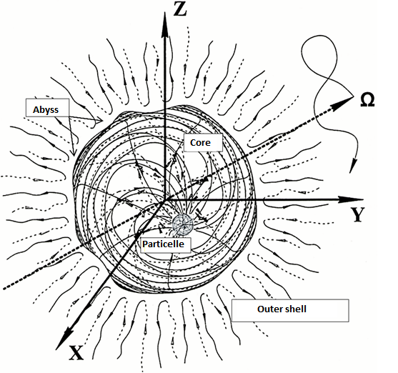



**Fig. 2.1.** 3D-image of a free «electron», where, in line with the terms of the hierarchy (6.20) of [2]:

– The core of the «electron» is a closed spherical vacuum formation with radius *r*6 ~1.7·10–13 cm;

– The outer shell of the «electron» is a radially deformed spherically symmetric vacuum formation, extending from the «electron's» core to the boundary of inner core of the Universe with radius

*r*1 ~ 3.4·1039 cm;

– The internal particle is the core of a “protoquark” (a minuscule analogue of the «electron's» core) with radius *r*7 ~ 5.8·10–24 cm, which is located inside the core of the «electron»;

– The abyssis a multilayer boundary between the outer shell and the core of the «electron»;

– The scope is a kind of memory of the undeformed state of the vacuum area considered here.

Chaotic motion of the internal “particelle” is incessant since its total mechanical energy, *Eр,* remains, on the average, constant [1]:

*<Ер*> = *<Tр* (*x,y,z,t*)> + *<Uр* (*x,y,z,t*)> = *const*, (2.2)

where

*<Tр*(*x,y,z,t*) > – average kinetic energy of the internal “particelle” associated with its speed;

*<Uр*(*x,y,z,t*) > – average potential energy of the internal “particelle” associated with the vacuum's elastic properties; the zero potential is in the center of the «electron's» core.

Analysis of the internal particelle's chaotic motion in [1] led to the derivation of the Schrödinger equation

 (2.3)

where  – a wave function, the squared modulus of which is a function of the probability density of the location of a wandering internal “particelle”;

 *<Uр*(*x,y,z,t*)> – average potential energy of an internal “particelle”;

= 1.055·10-34 J·s – Planck's constant;

*mp* – mass of the internal particelle.

Within the framework of fully geometrized physics it is not possible to introduce the notion of mass expressed in kilograms [7]. Therefore, the Algebra of Signatures tries to completely exclude this notion from geometrophysics. As was demonstrated in [1], the /*mp* ratio can be replaced with a stable characteristic of a random process under consideration:

 – inertia factor of internal particelle, (2.4)

where  (2.5)

– squared root-mean-square deviation of a chaotically wandering internal “particelle” from the center of the core of the «electron» (Figures 2.1 and 2.2);



– averaged autocorrelation coefficient of the same random process.

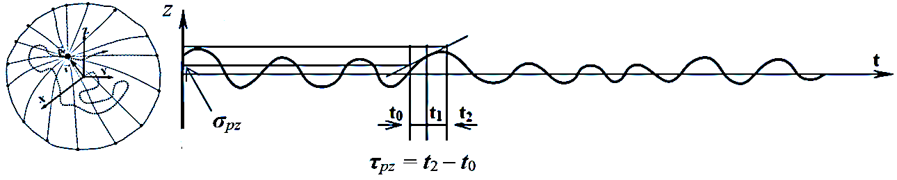

**Fig.** **2.2**. Projections of a chaotically wandering internal “particelle” plotted on the Z axis against time *t*, where *σpz, τpz* are the root-mean-square deviation and autocorrelation radius, resp., of this random process

Furthermore, *Ер*, *Tр* and *Uр,,* i.e. values expressed in terms of mass units, are replaced with the following massless values in the Algebra of signatures:

$ε_{P}=$ $ε_{P}=$– total mechanical *energium* of the internal particelle; (2.6)

$t_{P}=$– kinetic *energium* of the internal particelle; (2.7)

$u_{P}=$– potential *energium* of the internal particelle. (2.8)

In that case, equation (2.2) can be rewritten as follows:

*<εр* = *<tр* (*x,y,z,t*)> + *<uр* (*x,y,z,t*)> = *const* , (2.9)

and the Schrödinger equation (2.3), taking (2.4) into account, becomes massless

 (2.10)

In line with the initial condition (2.9), we consider a stationary case where an internal “particelle” is moving around the center of the core of the «electron» and where all average characteristics of this random process, including *σp* and *τp*, are time-independent. Therefore, the wave function of the internal “particelle” can be expressed as follows:

, (2.11)

in this case, the massless Schrödinger equation (2.10) is simplified to

 (2.12)

where is the average time independent potential *energium* of the internal “particelle”.

Equations similar to (2.12) are well known in quantum mechanics. For convenience, we will present its solutions, referring to monographs [3, 13].

**3. Internal “particelle” in a potential well**

Within the framework of the model considered here, an internal “particelle” with radius *r*7 ~ 5.8·10–24 cm is confined inside the core of the «electron» with radius *r*6 ~1.7·10-13 cm (Figure 2.1). Therefore, the average potential *energium* of the internal “particelle” can be expressed as a “potential well.”

$<u_{p }\left(\vec{r}\right)>=\left\{\begin{aligned}0 , for 0≤r≤{2r}_{6}, \\ ∞, for r>0 or r>{2r}_{6} . \end{aligned}\right.$ (3.1)

Analyzing Equation (2.12) by taking (3.1) into account, we obtain the following discrete sequence of eigenvalues of total mechanical *energium* of the internal “particelle” [3]

(Figure 3.1 c)  (3.2)

where *n* = 1, 2, 3, ... is the principal quantum number.

Eigenfunctions for the respective *energium* levels (3.2), i.e. solutions of equation (2.12) with average potential *energium* (3.1), will be the same as in [3]

. (3.3)

Graphs of functions (3.3) and graphs of their squared moduli are given in Figure 3.1 *(а,b)*

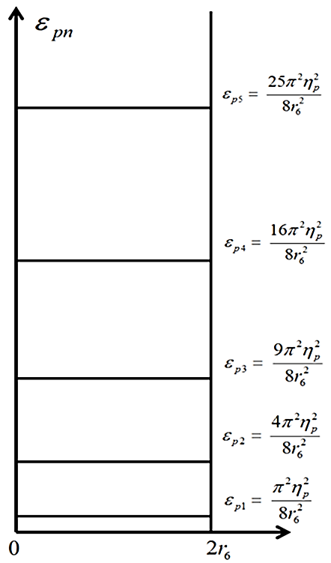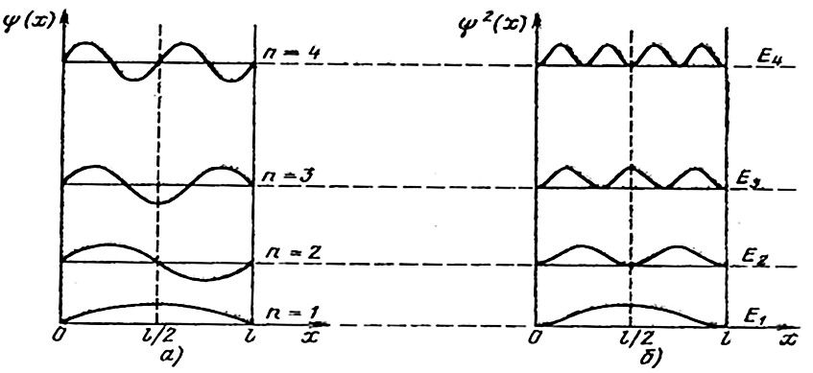

**Fig. 3.1**. а) Wave functions for different excited states of the internal “particelle” in the core of the «electron», where *l* = 2*r*6; b) The squared modulus of the wave function, i.e. the probability density of the internal “particelle's” location inside the core of the «electron» for its different excited states; c) Levels of the internal “particelle's” total mechanical *energium* in a potential well

*c)*

As follows from the functions illustrated in Figure 3.1 *b*, the center of the core of the «electron» is the most probable location of the internal “particelle” for *n* = 1. However, in an excited state (*n* = 2), the internal “particelle” is most likely located at an indefinite distance from the center of the «electron's» core.

**4. Internal particelle in elastically strained vacuum environment**

Now let's consider a case where elastic “tension” develops in the vacuum environment of an internal particelle as it moves away from the center of the “electron's” core (Figure 2.1) pulling the particelle back to the center point.

*In the massless geometrophysics developed herein, the notion of “tension” of a vacuum area corresponds to the post-Newtonian notion of “strain” in a limited area of a continuous medium. It is important to note that the dimensionality of geometrized “tension” does not include a unit of mass (kilogram).* Assume that the elastic vacuum tensions, $σ_{v }$, increase, on the average, proportionally to the “particelle's” distance from the center of the «electron's» core

$<σ_{v }\left(\vec{r}\right)>≈k_{u}r$, (4.1)

where *ku*is a massless factor of the vacuum's elastic tension. Then, the “particelle's” average potential *energium* can be approximated as

$<u_{p }\left(\vec{r}\right)>≈\int{k_{u}}rdr=\frac{1}{2}k_{u}r^{2}.$ (4.2)

Substituting (4.2) into (2.12), we obtain the well-known “quantum harmonic oscillator” equation

 (4.3)

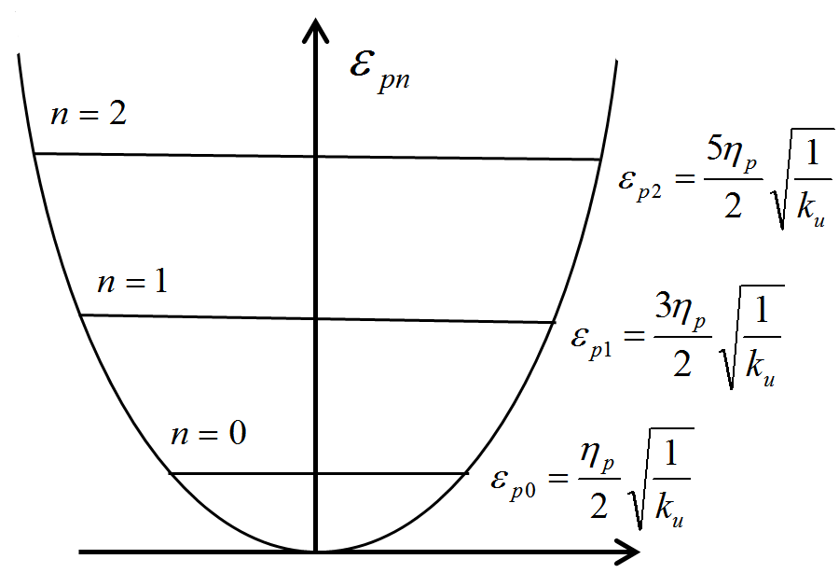

**Fig. 4.1**. Equidistant levels of the total mechanical energy of the *εpn* quantum harmonic oscillator

Study of that equation leads to the following discrete expansion of eigenvalues of the “particelle's” total mechanical *energium* [3, 13]:

, (Fig. 4.1) (4.4)

where *n* = 1, 2, 3, ... is the principal quantum number. Corresponding to each discrete value of total mechanical energium (4.4) is a specific eigenfunction [3, 13]:

, (4.5)

where  (4.6)

is a *n*th degree Chebychev-Hermite polynomial, where *λ*0 is equal to

. (4.7)

Now, let's define several eigenfunctions (4.5), describing various average behaviors of a randomly wandering “particelle”, whose deviations from the center of the «electron's» core (Figure 2.1) cause elastic tensions in the surrounding vacuum [3, 13]

 (4.8)

 (4.9)

 (4.10)

Function forms *ψn* (4.9) – (4.10) and their squared moduli |*ψn*|2 are shown on Figure 4.2.

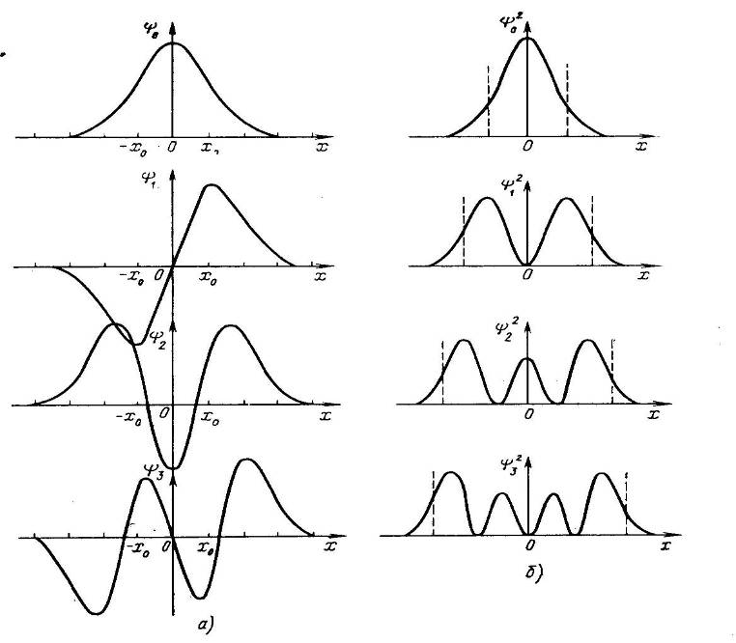

**Fig. 4.2.** a) wave functions for various average states of the “particelle's” wandering within an elastically-deformed vacuum; b) probability distribution densities of “particelle” locations in the vicinity of the «electron's» core center in the case considered here [3, 13]

It follows from Equation (4.4), in this particular case, that even in a non-excited state (i.e. with *n =* 0), the “particelle's” total mechanical *energium* is not equal to zero:

, (4.11)

the “particelle” will be permanently wandering around the «electron's» core center, and, therefore, the probability distribution density of finding it in that area will be described by a Gaussian function

 (4.12)

(Figure 14.3 *b*, upper plot).

Consequently, the root-mean-square deviation of a “particelle”, which wanders chaotically around the «electron's» core center, by taking (4.7) into account, is equal to:

 (4.13)

By comparing (4.13) with (2.4), we discover that the massless factor of vacuum elastic tension, *kn,* is inversely proportional to the average autocorrelation factor of the random process examined here:

, (4.14)

which corresponds to the eigenfrequency of this “quantum harmonic oscillator” *kn* = *f*0 *.*

**5. Angular quantum characteristics of a wandering “particelle”**

While moving chaotically around the «electron's» core center, a “particelle” permanently changes the direction of its movement (Figures 2.1 and 2.2). Therefore, from the viewpoint of classical mechanics, such a “particelle” possesses a certain angular momentum

$\vec{L}=\vec{r}×\vec{p},$ (5.1)

where *r* is the distance between the “particelle” and the «electron's» core center (the “particelle's” own radius is neglected here, and $\vec{p}=m_{p}\vec{v}$ is the “particelle's” immediate momentum value. Now let's present vector equation (5.1) in component form:

 (5.2)

In classical mechanics, the squared modulus of the “particelle's” momentum will be equal to

 (5.3)

Applying a well-known quantum mechanics procedure, let's re-write the operators of the “particelle's” momentum components (5.2) [13, 15]

 (5.4)

Now, in order to obtain massless operators, let's divide both members of (5.4) by *mp*

 (5.5)

As a result, by taking (2.4) into account, we obtain

 (5.6)

where  are components of the “particelle's” specific relative angular momentum operator, since .

In the spherical system of coordinates, massless operators (5.6) are expressed as follows

 (5.7)

The operator corresponding to the square of the modulus of the specific relative angular momentum, that is, corresponding to expression (5.3), is equal to

 (5.8)

where . (5.9)

The generalized Schrödinger equation (2.12) can be presented in the following form [13, 15]

 (5.10)

where the Laplace operator, ∇2, takes the following form in spherical coordinates

****,(5.11)

while the  operator is defined by Equation (5.9).

Substituting (5.11) into the massless Schrödinger equation (5.10), and assuming

, (5.12)

we obtain

****.(5.13)

Since the left and the right members (5.13) depend on different independent variables when considered separately, they should be equal to one and the same constant, *λ*.

Therefore, we have two separate equations for the radial function *R*(*r*) and the spherical function *Y*(*θ,ϕ*), [13, 15]

 (5.14)

****.(5.15)

The appearance of the radial function *R*(*r*) and the eigenvalues of the “particelle's” total mechanical energium, *εpn,* are determined by the specific kind of the average potential energium,. Shown here above, for instance, were radial functions (3.3) and (4.5), where  is determined by (3.1) or (4.2), respectively.

Solutions of equation (5.15) is well-known in quantum physics; they take on the following appearance: [13, 15]

 (5.16)

where  are the associated Legendre functions,

*l* and *m* are the orbital and magnetic quantum numbers respectively, and *ξ* = cos*θ*.

Functions (5.16) are suitable for describing the average orbital component of the motion of a “particelle” that moves chaotically around the «electron's» core center, for any average potential energium  distributed symmetrically around the center.

Given in Table 5.1 are several functions *Ylm*(*θ,ϕ*) from (5. 16) together with their corresponding probability densities of the angular distribution of a “particelle’s” location in the vicinity of corresponding “electron's” core center |*Ylm*(*θ,ϕ*)|2 [13, 15].

Table 5.1

|  |  |  |
| --- | --- | --- |
| Quantum  numbers | *Ylm*(*θ,ϕ*) | |*Ylm*(*θ,ϕ*)|2 |
| *l* = 0, *m* = 0 | *Y*00 *=* [1/(4π)]1/2 | |*Y*00)|2 = 1/(4π) |
| *l* = 1, *m* = 0 | *Y*10 *=* [3/(4π)]1/2cos *θ* | |*Y*10)|2 = [3/(4π)] cos2 *θ* |
| *l* = 1, *m* = 1 | *Y*11 *=* – [3/(8π)]1/2sin *θ eiϕ* | |*Y*11)|2 = [3/(8π)]sin2*θ* |
| *l* = 1, *m* = – 1 | *Y*1–1*=* [3/(8π)]1/2sin *θ e*– *iϕ* | |*Y*1–1)|2= [3/(8π)] sin2*θ* |
| *l* = 2, *m* = 0 | *Y*20 *=* [5/(4π)]1/2[(3/2) cos2*θ* – 1/2] | |*Y*20)|2 =[5/(4π)][(3/2) cos2*θ* – 1/2]2 |
| *l* = 2, *m* = 1 | *Y*21 *=* – [15/(8π)]1/2sin *θ* cos *θ* *e**iϕ* | |*Y*21)|2 =[15/(8π)] sin2*θ* cos2*θ* |
| *l* = 2, *m* = – 1 | *Y*2–1*=* [15/(8π)]1/2sin *θ* cos *θ* *e*– *iϕ* | |*Y*2–1)|2 =[15/(8π)] sin2*θ* cos2*θ* |
| *l* = 2, *m* = 2 | *Y*22 *=* [15/(32π)]1/2sin2*θ e*2*iϕ* | |*Y*22)|2 = [15/(32π)] sin4*θ* |
| *l* = 2, *m* = – 2 | *Y*2–2 *=* [15/(32π)]1/2sin2*θ e*–2*iϕ* | |*Y*2–2)|2 =[15/(32π)] sin4*θ* |

Types of angular distributions |*Ylm*(*θ,ϕ*)|2 for different values of orbital *l* and magnetic *m* quantum numbers are shown on Figure 5.1

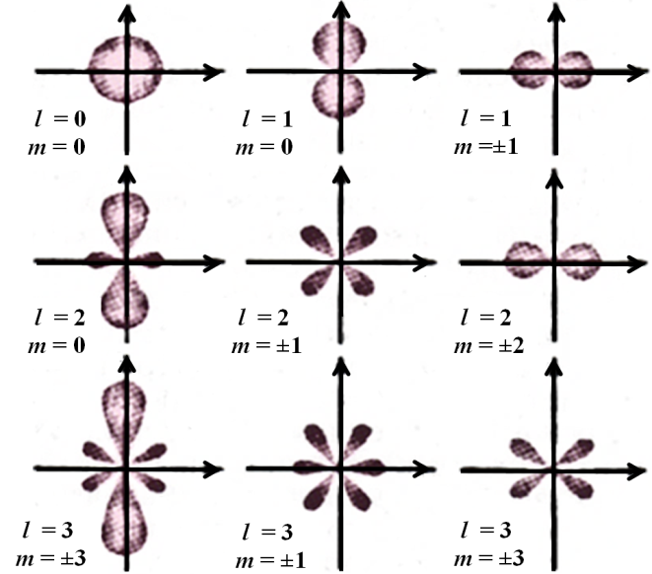

**Fig.** **5.1**. Probability densities of angular distribution of “particelle’s” location in the vicinity of the «electron's» core center |*Ylm*(*θ,ϕ*)|2 for different values of orbital, *l*, and magnetic, *m*, quantum numbers

In terms of the Algebra of Signatures, the average behavior of a chaotically wandering “particelle” described by a probability distribution density  leads to the curving of the vacuum area around such “particelle” with the formation of stable convex-concave features inside the core of the “electron” (Figure 5.2).

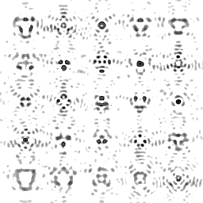

**Fig.** **5.2**. Examples of averaged convex-concave features of the vacuum area within the «electron's» core connected with various probability distribution densities of the “particelle” location  associated with different values of the three quantum numbers *n, m* and *l*.

Therefore, without going beyond classical logic, the geometric and quantum mechanics presentations appear to be closely interrelated within a common statistical (quantum) geometrophysics.

Such considerations of the averaged discrete (quantum) sets of metric-dynamic “particelle” states within the «electron's» core may carry over into considerations of other similar local vacuum formations of various scales. Therefore, the logical and mathematical apparatus of statistical (quantum) geometrophysics proposed here can be applied to the study of the following phenomena, among others: the wobbling of a biological «cell’s» inner core, the oscillation of a «planet's» inner core, motions of an «embryo» in a womb, behavior of a fly in a jar or a tiger in a cell, a «galaxy» within a «metagalaxy», etc.

Let's select as example any set of two nested spherical vacuum formations from the hierarchy (6.20) in [2]:

*core:* – a biological «cell’s» inner core with *r*5 ~ 4.9·10–3 сm;

*“particelle”:* – the core of an «electron» with *r*6 ~1.7·10–13сm,

or

*core:* – the core of a «galaxy» with *r*3 ~ 4·1018 сm;

*“particelle”:* – the core of a «star» or a «planet» with *r*4 ~ 1.4·108 сm,

or

*core:* – a core of a «metagalaxy» with *r*2 ~ 1.2·1029 сm;

*a “particelle”:* – a core of a «galaxy» with *r*3 ~ 4·1018 сm.

For each of these mutually mobile “core-particelle” combinations it is possible to derive discrete (quantum) sets of averaged metric-dynamic states similar to the states of a “particelle” within the core of an «electron». The difference between them will lie basically in the value of the “particelle's” inertial factor, , (2.4), which depends on the scale of the phenomenon under consideration.

As an example, let's evaluate the inertial factor of the core of the «electron» wandering chaotically around the core of a “hydrogen atom” (Figure 5.3, paragraph 11 in [2]).

 (5.32)

where *σer, τer* are theroot-mean-square deviation and autocorrelation radius, respectively, of a random process related to the chaotic wandering of the «electron's» core around the «atom's» core.

The following equation is known in modern physics:

1.055·10–34 Js / 9.1·10–31kg ≈ 10–4 m2/s, (5.33)

where *mе* is the mass of an electron. According to (2.4), the “electron's” core inertial factor can be assigned the value

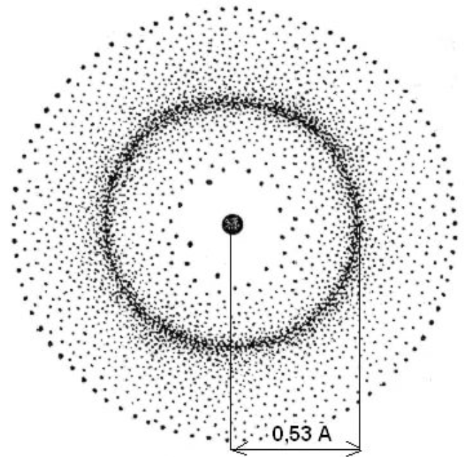

Fig. 5.3. Probability density distribution of the location of the «electron's» core center inside a hydrogen atom. The maximum of this distribution is known to correspond to *r*~0.5А=0.5·10 –10m

 ≈ 10–4 m2/s. (5.34)

Assuming that the root-mean-square deviation *σer* of the «electron's» core’s chaotic motion in the vicinity of the «hydrogen atom» center is roughly equal to *σer* ~10–10 m (Figure 5.3), it follows from equation (5.34) that

/10–4 ≈ 2·10–20/10–4 = 2·10–16 s. (5.35)

Now it is possible to derive the average velocity of the «electron's» core motion in the case under consideration: <v*e*> = *σer* /*τer* = 10–10/2·10–16 = 0.5·106 m/s.

For comparison, let's evaluate the inertial factor of a fly, *ηm*, moving chaotically inside a 3-liter closed glass jar. In that case, the root-mean-square deviation of the fly from the jar's center, *ηm*, and the correlation factor of this random process, *τmr*, will be roughly equal to: *σmr* ~ 5 cm = 0.05 m, *τmr* ~ 1.3 s, respectively. Therefore

 (5.36)

while the average velocity of its chaotic motion <v*m*> ≈ *σmr* /*τmr* ≈ 0.05/1.3≈ 0.038 m/s.

Eigenvalues of the total mechanical energium of a fly confined in a jar (potential well) can be defined by equation (3.2)

 (5.37)

where *rb* = 0.12 m is the jar's radius, while the eigenfunctions for the total *energium* levels (5.37) are expressed by (3.3)

. (5.38)

*This conclusion is experimentally verifiable. If we film a fly in a jar and play the film back at a higher speed, we will be able to see the distribution of the fly's average positions in the jar. Then the experiment can be repeated with different input conditions, such as temperature or pressure. In that case, under the predictions of Alsigna, different average distributions of the fly's locations will be obtained. Of course, such atrocious treatment of animals, even for research purposes, is not in line with the moral principles of the Algebra of Signatures [5].*

In our third example, let's consider a biological “cell.” Chaotic movements of its “core” may have the following average characteristics: *σhr* ~ 3.5·10–5 m, *τhr* ~ 1.2·10–3 s, and, consequently, *ηh* ≈ 20.4·10–2 m2/s. In this example, however, the oscillating “core” is linked with the “cell's” cytoplasm. Therefore, the “core's” deviation from its initial position in the cytoplasm leads to the buildup of elastic tensions pulling it back. Therefore, the eigenvalues of such a biological “cell's” total mechanical *energium* can be approximately defined by expression (4.4)

, (5.39)

while the eigenfunctions for these *energium* levels are described by Expressions (4.5)

, (5.40)



Fig. 5.4. Discrete set of 3D

Lissajous curves

where , where *kh* is the massless factor of elastic tension of a biological “cell's” cytoplasm.

It is also known that tree boughs move according to the Lissajous curves under the influence of wind (Figure 5.4).

Therefore, the Algebra of Signatures argues that the average behavior of macro objects is basically similar to that of microworld objects provided that conditions are equal, which means that in certain cases the methods and mathematical tools of quantum physics can be applied for describing discrete sequences of average states of macroscopic objects.

There are five quantum numbers, *f*, *n*, *l*, *m*, *s,* in statistical (quantum) geometrophysics that largely determine the scale and discrete variants of average manifestations (configurations) of each stable spherical vacuum formation since all of them are in permanent chaotic motion (Figure 5.6).

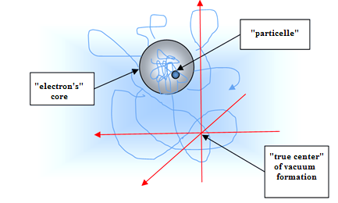

**Fig.** **5.6.** Chaotically wandering “core” of a vacuum formation with

a “particelle” chaotically wandering inside the core

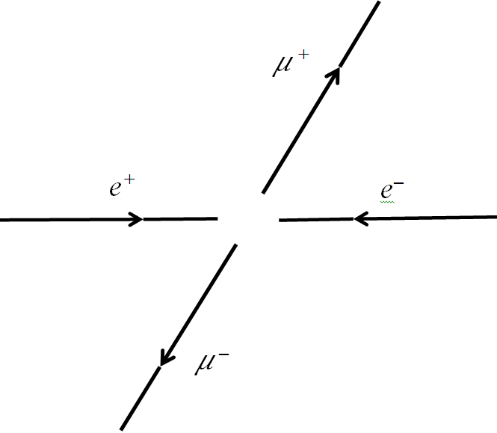

Fig. 6.1. Collision of accelerated electron and positron sometimes leads to the birth of muon-antimuon or *τ+* - lepton – *τ –*-antilepton pair

6. «Muons», *τ* -«leptons» and *с*, *s*, *t*, *b*-«quarks»

It is part of modern physics that collisions of particles moving at high velocities result in the birth of new particle-antiparticle pairs.

For example, let's consider the birth of a muon-antimuon pair (Figure 6.1) and a *τ+*-lepton-*τ –*-antilepton, which form upon the collision of an electron and a positron:

*е+е– → μ+μ –,  е+е – → τ +τ –*. (6.1)

The muon and *τ-*lepton are different from electrons only in terms of mass:

*mе* = 0.511 MeV, *mμ*= 105.658 MeV, *m*τ = 1.984 GeV, (6.2)

while all their other characteristics (charge, spin, lepton number, etc.) remain the same.

Many researchers considered muons and *τ-*leptons so“redundant” in the structure of material world that they could not help asking: “Why did nature need those participles at all?”

According to the Algebra of Signatures (Alsigna), «muons», *τ+-*«leptons», «antimuons» and *τ* –-«antileptons» are not at all new particles, but are the same very «electrons» and «positrons», but with their “cores” being in an excited state. In other words, in terms of Alsigna, the “muon” and *τ+*-“lepton” are, respectively, the first (*n* = 1) and the second (*n* = 2) excited states of a free «electron», while the «antimuon» and *τ –-*«antilepton» are, respectively, the first (*n* = 1) and the second (*n* = 2) excited states of a free «positron».

The same refers to «quarks», introduced in [2] and (2.10) of [8]: in Alsigna, *с-* and *t*-«quarks» are the first and the second excited states of a *u*-«quark», while *s-* and *b*-«quarks» are the first and the second excited states of a *d*-«quark».

*In order to prove these hypotheses, Alsigna proposes the following experiment. If we keep a certain amount of electron plasma in a magnetic trap under hard radiation, then, in line with Alsigna, the congested «electron» cores may undergo transition into excited states. In the latter case, the whole volume of irradiated electron plasma may acquire different physical properties.*

*Another confirmation for the basics of quantum geometrophysics proposed here could be the acquisition of «leptons» and «quarks» of the fourth, fifth and higher generations, since under (3.2) and (4.4) there are more than 3 levels of the «particelle's» energium levels, εpn.*

The reason for the higher “interance” [in massless quantum geometrophysics, the analogue of mass (6.2)] of «muons» and *τ-*«leptons» is likely to be related to the complication of the average metric-dynamic configuration of the vacuum area both inside and outside of their excited cores. Metric-dynamic aspects of inertance of elementary “particles” will be considered in the following article of the series “Alsigna”.

*It is interesting to experimentally check whether the «muon» and «antimuon» created by the collision of an «electron» and a «positron» (Figure 6.1) remain in an “entangled” state. For this purpose it will be necessary to find out if the «muon's» transition into «electron» automatically leads to the «antimuon's» transition into a “positron”, or whether nature allows asymmetry in the number of simultaneously existing «muons» and «antimuons».*

**7. Conclusions**

Article [2] introduced (in terms of Alsigna) metric-dynamic models of 16 types of «quarks» (to be more precise, 8 «quarks» and 8 «antiquarks»), of which it turned out to be possible to “construct” all kinds of «leptons», «mesons» and «baryons» known in the Standard Model. This article takes into account the omnipresent vacuum fluctuations and attempts to study regularities in the chaotic behavior of the cores and “particelles” of the abovementioned local vacuum formations.

Vacuum fluctuations are non-removable in principle. This means that the axiomatic probability of quantum physics is as primary as is the determinism of differential geometry, which derives from the presumption of continuity of the vacuum.

The equal coexistence of probabilistic and deterministic principles is forcing Alsigna to develop “statistical geometrophysics,” which leads to an average description of discrete (quantum) geometric structures. The reason is that discrete sets of average states of chaotically wandering “particelles” (Figure 2.1) are inevitably manifested in the average metric-dynamic (convex-concave) configurations of vacuum areas both inside and outside of the cores (Figures 5.2 and 5.6).

Now let's outline the basic notions of the Alsigna's “statistical (quantum) geometrophysics,” which are presented in [1, 2, 5 – 11] as well as in this work:

1). The notion of mass with the dimensionality of “kilogram” cannot be introduced into the completely geometrized physics, in principle. Therefore, the notion of mass has to be excluded from all geometrophysical perceptions. Instead of point particles with mass, charge, spin, etc., the Alsigna's geometrophysics considers spherical cores of local vacuum formations (Figure 7.1). Introduced in a similar way are such geometrized notions [5–11, 2] as the core “inertance” *(analogue of a point particle's inert mass),* “intensity of a source of radial vacuum flows” around the core *(analogue of a point particle's charge)*, averaged angular velocity of core motion *(analogue of a point particle's spin)*, “displacement of vacuum layers” around the core *(analogue of a point particle's gravitational mass)*, the core's “*energium*” *(a massless analogue of a point particle's energy)*, “tension” of a vacuum continuum *(a massless analogue of elastic tensions in a solid medium*), “effect” *(a massless analogue of force)*, etc.

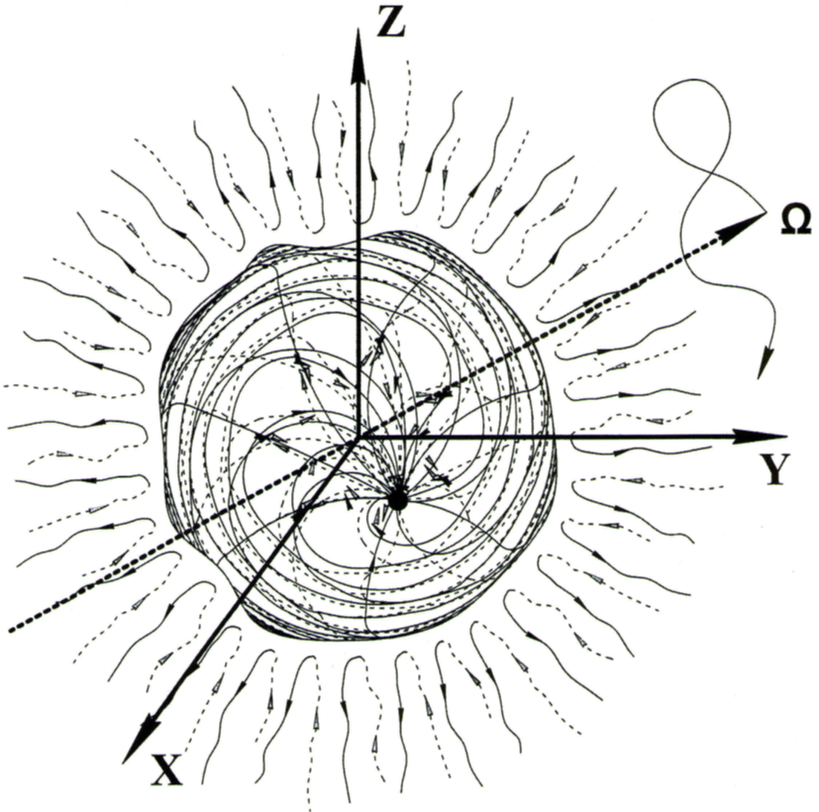

**Fig. 7.1**. The core of an Alsigna local vacuum formation is the analogue of a point material particle in the post-Newtonian physics.

*Masslessness of the Alsigna's geometrophysics is arousing most vehement criticism from the school of post-Newtonian researchers. However, those who have already grown aware of the impossibility to resolve the problem of geometrizing the notion of “mass” join the ranks of Alsigna supporters.*

2). The vacuum state is provisionally considered as a continuous elastic-plastic pseudo-space. No actual substantiality of this pseudo-space is in any way manifested (i.e. it is not observed in any experiments). At the same time, such consideration of the vacuum allows: first, to objectify this subject of research; and secondly, to apply the methods of differential geometry and continuum mechanics to the vacuum state.

3). The vacuum state is not a single continuous pseudo-space, but a result of additive overlapping of 16 continuous pseudo-spaces, i.e. 4D spaces with different signatures or topologies [7]. The overlapping (superposition) of the 4D information is such that on the average the values in the signature for the vacuum state are zero. In other words, during their additive superposition these 16 continuous pseudo-spaces completely compensate each other's manifestations down to the full absence of characteristics. In the same manner, the fluctuations of the vacuum state are such that are, on the average, identical to their compete absence. Each of these 16 continuous pseudo-spaces can be described as a superposition of another 7 sub-spaces with different signatures (topologies), and such identification of sub-spaces can be indefinitely continued [7]. Therefore, the Alsigna's vacuum state is an infinitely overlapping, continuous, all-fluctuating pseudo-space, which is, on the average, “nonexistent.” For that reason, the Alsigna's vacuum state is also called the “Void” [7, 11].

4). If anything appears out of the Void (i.e. the vacuum state) it should necessarily appear in two mutually opposite forms: “particle” (local convexity) – “antiparticle” (local concavity); wave – antiwave; motion – antimotion; deformation – antideformation; dimension – antidimension, etc. These pairs of “features” and “antifeatures” are absolutely symmetrical in relation to the Void, but they can be phase-twisted and/or rotated against one another at different angles. These rotations and phase-shifts of vacuum features and antifeatures predetermine the existence of worlds and effects acting within them. The development of these worlds is a gradual process of increasingly sophisticated entanglement of the features and antifeatures inhabiting them. But no matter how these worlds can be intermixed and interrelated, the global averaging of each one of them is identical to the original Void.

5). If we view a vacuum state as an objective feature (a continuous pseudo-space) that is located outside of the observer, it turns out that the notion of “time” is not attributable to such a state (an attribute of the external reality). In that case, “time” is only an “arithmetization” of the feeling of duration, which is only an attribute of an external observer. In other words, there is no space and no time external to the observer’s reality (these are only mathematical abstractions generated by the observer's consciousness); only a continuous pseudo-space and its movements exist. Therefore, Alsigna had to change the approach to interpreting the components of the metric tensor. In this situation, nonzero components of metric tensor *gαβ* determine the curving of the 3D local area of vacuum state (or any of its 3D sub-spaces), while zero components of metric tensor *g*00, *gα*0,*g*0*β* are related to the accelerated linear or rotational motions of the same curved local vacuum area. Therefore, in the Alsigna formalism, a vacuum state (as well as all its sub-spaces and sub-sub-spaces) is identified as a continuous 3D elastic-plastic pseudo-space, where any curving of its local area inevitably gives rises to accelerated linear (laminar) or rotational (turbulent) motion in the same area. Therefore, Alsigna “sees” that intravacuum (pseudo-substantial) flows, which are called “intravacuum currents” form in any curved area of vacuum (or in any region of one of its sub-spaces). Any curvatures of any local area of a 3D vacuum state give rise to intravacuum currents, and, conversely, the formation of an intravacuum current inevitably leads to a local curving of the respective 3D sub-space of the vacuum state. Moreover, interrelations between the zero and nonzero components of metric tensor *gij* are determined by the Einstein field equations. The four-dimensionality of the Einstein mathematical apparatus (to be more precise, Riemannian differential geometry) is connected not with the curvature of space-time (*which, according to Alsigna, does not exist in external reality as it is only an attribute of the observer's logical thinking),* but with the simultaneous inclusion of the curvature of the local 3D area of pseudo-substantial space and its own velocity and acceleration. Let's also note that in Alsigna, intravacuum currents are described with the help of quaternions, and the currents (flows) of various intravacuum sub-spaces are added together by the rules of Clifford Algebra.

6). The vacuum state is in the permanent process of extremely sophisticated and multifaceted fluctuations, which are present everywhere. These fluctuations are connected with enormously complex overlappings inside vacuum spaces, sub-space and sub-sub spaces of various topologies as well as with chaotic vibrations of each of these spaces and sub-spaces. The multifaceted vacuum fluctuations may be caused by the Colossal Determined (or Predetermined) Processes related to the Global Formation of the Universe. However, these Processes are so ''entangled” on the local level of the vacuum state that Alsigna is forced to treat these processes as random ones and apply the methods of probability theory and mathematical statistics to their study. The attitude toward the vacuum state as an extremely complicated fluctuating and overlapping continuous pseudo-space is forcing Alsigna into developing a statistical (quantum) geometrophysics. Stable features and antifeatures “woven” of that multifaceted pseudo-space and their stable metric-dynamic configurations are identified through the extremality of its action and entropy.

7). The condition for the existence of the average stable vacuum formations is determined by the “Action Extremum Principle”, which is closely related to the “Entropy Extremum Principle” the “Principle of the Conservation of the Integrals of the Averaged Motion of Local Vacuum State Regions” and the “Principle of the General Invariance of the Statistical Geometrophysics in Respect to Random Transformations in Four Coordinates”. From the above principles it follows that the average (frozen) geometric “frame” of the stable local vacuum formations must satisfy the Einstein Field Equations (which are second order differential equations) [2], while the averaged behavior of the cores of these vacuum formations must satisfy the Dirac Relativistic Equation, which, in the condition of low (compared to the speed of light) velocities (i.e. wave propagation velocity through the vacuum state) simplifies down to the Schrödinger equation [1]. Altogether, the deterministic Einstein vacuum equations and the probabilistic Dirac or Schrödinger equations, derived from the above common Action Extremum Principle, Entropy Extremum Principle, Principle of the Conservation of Integrals of the Average Motion of the Vacuum State Local Areas and Principle of the General Invariance of Statistical Geometrophysics in Respect to Random Transformations in Four Coordinates, form the basis of massless statistical (quantum) geometrophysics and thus ensure the completeness of the Alsigna's logical apparatus.

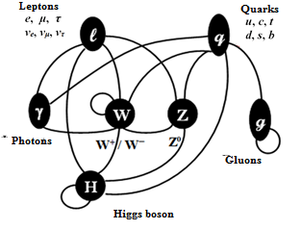

**Fig. 7.2.** Elements of the Standard Model

The presumptions of the statistical (quantum) geometrophysics, Alsigna, as outlined above, call for a radical revision of the standard physics paradigm, which can be justifiable only in case of resolving certain problems of modern physics and predicting new effects.

The solution of one such problem is proposed in this work. Within the framework of statistical (quantum) geometrophysics, Alsigna, «muons» and tau-«leptons» may be interpreted as the first and the second excited states of «electrons» and «positrons» respectively; *с-* and *t*-«quarks» are, respectively, the first and the second excited states of a *u-*«quark», while *s-* and *b*-«quarks» are the first and the second excited states of a *d*-«quark».

Therefore, Alsigna is able to explain metric-dynamic models of all «quarks», «mesons», «baryons» and «bosons», which are included into the Standard Model [2] (Figure 7.2), including the metric-statistical models of «muons», tau-«leptons» as well as *s,* *b, с,* *t* -«quarks».

Still remaining, but beyond the scope of this work, are all kinds of «neutrinos»: *νe* , *ν𝜇* , *ντ*, the metric-dynamic models of which are planned to be considered in the following article in this series.

The author would like to thank V.A. Lukyanov and S.V. Przhigodsky for reading the draft and making valuable remarks.

The author would like to thank V.A. Lukyanov and S.V. Przhigodsky for reading the draft and making valuable remarks, and David Ried and Alexander Kondorsky for the highly professional and creative translation of the text into English.

The Appendix (Glossary of special notation and terminology) was compiled by David Reid, who also collaborated in the introduction of several new terms.

**Appendix**

**Glossary of special notation and terminology**

Algebra of Signatures , also “Alsigna”. The structure developed by the author to designate a space consisting of a variable metric or pseudometric.

Signature: A class of metrics, designated by a 4-tuple (*b*0, *b*1, *b*2, *b*3), such that for 0 < *i* < 3, *bi* ∈{  0, +}. This designates the metric or pseudometric induced by an equation of the form [*ds*]*i*2= *a*0*f*1(*s*,*p*)*dx*02 + *a*1*f*2(*s*,*p*)*dx*12 + *a*2*f*3(*s*,*p*)*dx*22 + *a*3*f*3(*s*,*p*)*dx*32, where *ai* ∈{0,1,1}, *s*∈*S*, *p* is a fixed parameter, *fi*(*s*,*p*) are positive definite functions defined on *S*×{*p*}, and *S*, *p*, and *xi* are specified further in the designated metric or pseudometric. Further details are elucidated in [2] and other papers of the Alsigna series.

Use of quotation marks. Elsewhere in the Alsigna series, two types of quotation marks are used. Besides the usual “...”, guillemets **«** ... **»** are used for each of a class of particles which are defined as structures of the background vacuum. (See “vacuum formations”). In this work, both types of quotation marks are represented by the usual ones, as no confusion is likely to ensue.

Vacuum formations: also “spherically symmetric vacuum formations”, or “spherical vacuum formations”. Particles defined in terms of a class of metrics or pseudometrics on the structure of the vacuum. The primary aim of the Alsigna series is to elucidate the structure of these particles. The image of a bubble serves as a rough intuitive picture.

Particelle: one of the substructures of the vacuum formations.

«Electron», «muon», etc. Structures of the vacuum which form a basis for explanations of the particles of the Standard Model; the name chosen indicates the standard particle most directly connected to the structure.

Inertance: one of several characteristics of the vacuum formations which are analogues of similarly named characteristics of standard particles. E.g, “inertance” is meant to evoke “intertial mass”. Other quantities are named in the text.

*n*th generation of particles: an extension of the classification of elementary particles used in the Standard Model.

Vacuum state: not to be confused with the vacuum state as usually defined. Also termed “void”. Details are outlined in the text.

**References**

[1] Batanov, M.S. (2017) *Vyvod Uravneniya Shredingera Dlya Mikroskopicheskikh I*

*Makroskopicheskikh Sistem* (Derivation of Schrödinger's equation for microscopic and macroscopic systems) in *Inzhenernaya fizika* (Engineering Physics), No. 3, 2016 pp. 3-19. English version: Batanov, M. “Derivation of Schrödinger’s equation”, DOI: <https://arxiv.org/abs/1702.01880> .

[2] Batanov, M.S. (2017) *Rasshirennoye vakuumnoye uravneniye Eynshteyna* (Extension of an Einstein field equation.) in *Obrazovaniye i nauka: sovremennyye trendy*  (Education and Science: contemporary trends). *Interaktivnaya nauka* (Interactive science publishers), Cheboksary, Russia. pp 5-61. DOI: 10.21661/r-462204, [https://interactive-plus.ru/article/462204/discussion_platform](https://interactive-plus.ru/ru/article/462204/discussion_platform?utm_source=ticket&utm_medium=email&utm_campaign=request_onsite&utm_term=ru&utm_content=discussion_platform)accessed 10 June 2017**.**

[3] Blokhintsev, D.I. (1964) *Osnovy kvantovoy mekhaniki* (The fundamentals of quantum mechanics) Vysshaya SHkola. Moscow, 1963. Translation into English: Blokhintsev, D.I. *Quantum Mechanics*. Springer. Dordrecht, Netherlands.

[4] Vladimirov, Yu.V. (2015) *Geometrofizika* (Geometrophysics) Binom. Moscow, Russia.

[5] Gaukhman, M. Kh. (2004) *Algebra signatur* (Krasnaya Alsigna) [Algebra of signatures (Red Alsigna).] – Moscow, Russia (available in [www.alsignat.narod.ru](http://www.alsignat.narod.ru) ) [In Russian].

[6] Gaukhman, M. Kh. (2007) *Imena* (oranzhevaya Alsigna). [Names (Orange Alsigna)]. In Algebra signatur [Algebra of signatures] – Moscow, Russia (available in [www.alsignat.narod.ru](http://www.alsignat.narod.ru) ) [In Russian].

[7] Gaukhman, M. Kh. (2007) *Pustota* (Zheltaya Alsigna) [Void (Yellow Alsigna)]. In Algebra signatur [Algebra of signatures] – Moscow, Russia (available in www.alsignat.narod.ru.) [In Russian].

[8] Gaukhman, M.Kh. (2008) *Chastitsy* (Zelenaya Alsigna) [Particles (Green Alsigna)]. In Algebra signatur [Algebra of signatures] – Moscow, Russia: Librokom (available in [www.alsignat.narod.ru](http://www.alsignat.narod.ru) ) [In Russian].

[9] Gaukhman, M.Kh. (2009) *Gravitatsiya* (Golubaya Alsigna) [Gravity (Light blue Alsigna). In Algebra signatur [Algebra of signatures]– Moscow, Russia: Librokom (available in [www.alsignat.narod.ru](http://www.alsignat.narod.ru)) [In Russian].

[10] Gaukhman, M.Kh. (2015) *Kosmogenezis* (Sinyaya Alsigna) [Cosmogenesis (Blue Alsigna). In Algebra signatur [Algebra of signatures] – Moscow, Russia: MIG (Media Info Group) (available in [www.alsignat.narod.ru](http://www.alsignat.narod.ru) ) [In Russian].

[11] Gaukhman, M.Kh. (2017) *Bezmassovaya fizika* (Fioletovaya Alsigna) [Massless physics (Violet Alsigna). In Algebra signatur [Algebra of signatures] – Moscow, Russia: Filin Publishing House (available in [www.alsignat.narod.ru](http://www.alsignat.narod.ru) ) [In Russian].

[12] Landau, L.D., Livshchits, Ye.M. (1988) *Teoriya polya* (Field Theory). Vol 2. Nauka. Moscow, USSR. [In Russian] English translation of earlier edition: Landau, L.D., Livshchits, Ye.M. (1971) *The Classical Theory of Fields*, 3rd edition. Pergamon Press. Oxford, UK.

[13] Griffiths, D.J. (1994) Introduction to quantum mechanics, Prentice Hall Upper Saddle River, New Jersey 07458, ISBN 0-13-12405-1

[14] Novikov, S.P., Taimanov, I.A. (2014) *Sovremennyye geometricheskiye struktury i polya*. (Modern Geometrical Structures and Fields) MTSNMO, Moscow, Russia. [In Russian] Translated from the English: Novikov, S.P., Taimanov, I.A. (2006) *Modern Geometrical Structures and Fields*. American Mathematical Society. Providence, RI.

[15] Matveyev, A.N. (1989) *Atomnaya fizika* (Atomic Physics). Vyshchaya SHkola. Moscow, Russia. [In Russian]

1. [alsignat@yandex.ru](mailto:alsignat@yandex.ru)